RICHMOND PUBLIC HEALTH
Public Health Outcomes Framework Analysis – August 2019 Data Update

GLOSSARY
PHOF: Public Health Outcomes Framework
TB: Tuberculosis
STAR-PU: Specific Therapeutic group Age-sex weightings Related Prescribing Unit

SUMMARY
Below is a summary of Richmond’s performance regarding the high priority indicators as well as the other indicators that have been updated in this report:
High priority indicators
- Chlamydia detection rate in 15-24-year olds in Richmond increased by 18% from 1653/100,000 in 2017 to 1949/100,000 in 2018.This was similar to London and England’s benchmark goal of 1900 to <2300 and was in the 2nd quartile compared to the outer London boroughs.
- The three-year incidence of TB in 2016-18 remained the same from the previous 3-year average of 6/100,000. This was lower than the London and England averages of 21.9/100,000 and 9.2/100,000 respectively. Richmond was in the 1st quartile compared to the outer London boroughs.

Other indicators
- Improvement was seen within the cumulative percentage of eligible population aged 40-74 who received an NHS health check; as well as the cumulative percentage of eligible population aged 40-74 offered an NHS health check who received an NHS health check. Improvement was also seen in the adjusted antibiotic prescribing in primary care by the NHS.

- Richmond’s performance worsened on the following indicator: cumulative percentage of the eligible population aged 40-74 offered an NHS health check. (This indicator is based on the cumulative five-year cycle and is affected by historical performance. In 2018-19, Richmond’s performance was successful in meeting both corporate and national in year target for checks delivered).
- Richmond’s performance remained the same on other indicators presented in the table below.

INTERPRETATION NOTES
- The latest update to the Public Health Outcomes Framework was published by Public Health England in may. The PHOF contains a range of indicators covering:
  - Overarching health (e.g. life expectancy)
  - The wider determinants of health (e.g. education, employment, housing)
  - Health improvement (e.g. smoking, physical activity)
  - Health protection (e.g. vaccination)
  - Healthcare and premature mortality (e.g. hospital emergency readmission)
- The full list of new and updated indicators is available online. The online tool allows trends, maps and comparisons with national, regional and other similar local authorities to be viewed.
- The appended table identifies the current level of performance in Richmond and compares it to the borough’s previous year’s performance showing absolute and relative changes. The relative performance is now reported both as Outer London rank position and quartile position.
- All comparisons made below are to Outer London boroughs. Where Richmond is “1st or 2nd quartile” its performance is good, where it is “ 3rd quartile” its performance is borderline , and where it is “4th quartile” its performance is worse compared to the other Outer London boroughs.

Prepared by Sally Bahri, Business Intelligence Analyst
Reviewed by Salman Klar, Manager Business Intelligence Team and Public Health Senior Management Team

Appendix
Public Health Outcome Framework- Indicator updates
August 2019

Recent Trend | Higher/Getting  worse | Higher/ Getting  better | No significant  change
 | Lower/ Getting  worse | Lower/ Getting  better | Could not be  calculated
Borough quartile positioning
Quartile 1- best/top ranking compared to London /outer London boroughs
Quartile 2
Quartile 3
Quartile 4- worst/lowest ranking compared to London/outer London boroughs

CATEGORY | INDICATOR | TIME PERIOD | LOCAL | REGION | ENGLAND | PREVIOUS VALUE | TREND/CHANGE FROM PREV. VALUE |  | LONG-TERM TREND | LONDON QUARTILE | INNER LONDON QUARTILE
Wider determinants of health | Sickness absence - the percentage of employees who had at least one day off in the previous week - % | 2015 - 17 | 1.3 | 2.2 | 2.1 | 1.4 |  | -7.1% |  | 1 | 1
Most recent time period that data is available.
Overarching
domain
Comparing the indicator value against London and inner London boroughs. This shows the local value quartile positioning.
Percentage change from previous time period.
Previous indicator value
This shows the region and England values. The colour of the box shows whether the local value is statistically significant to London/England.
Indicator full name and unit of measurement.
The direction the local value is going over the time series.

Arrow colour shows whether the local value is statistically significant to the previous time period ; direction of the arrow shows whether the local value has increased or decreased or stayed the same from the previous time period. Where there is a dashed line shows that the value cannot be compared to the previous time period.

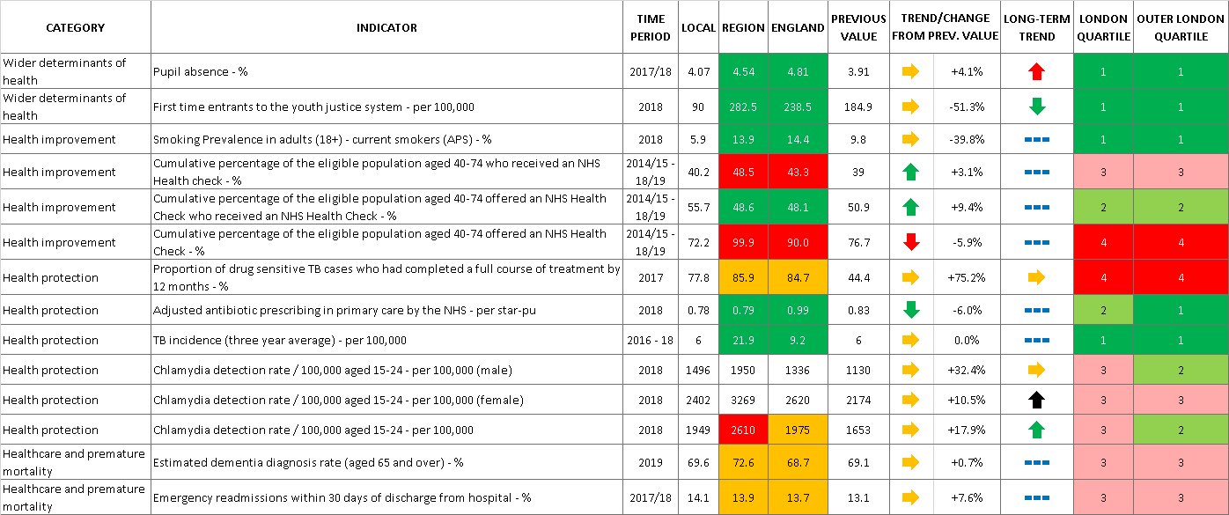

Chlamydia detection rate: is defined as all chlamydia diagnosis in 15-24 year olds attending a sexual health services. This is a measure of chlamydia control activity, aimed at reducing the incidence of reproductive sequelae of chlamydia infection and interrupting transmission to others. An increased detection rate is indicative of increased control activity. PHE recommends that LA should be working towards achieving a detection rate of at least 2,300/100,000 population aged 15-24. This encourages high volume screening and diagnoses.
Percentage of eligible population aged 40-74 offered an NHS health check who received an NHS health check uses the denominator of all those aged 40-74 eligible for NHS health check who were offered an NHS health check in the 5-year period. The service was in-housed in September 2017. Prior to this, programme efforts were focused on invitations. The annual target for completed NHS Health was not being met. Subsequent to the in-housing efforts were centered on uplifting the number of completed NHS Health Checks, which has been achieved.
This is the total number of antibiotic items prescribed in practices located within the area. Reductions in antibiotic consumption is a well-recognised target in AMR (Antimicrobial Resistance) policies across PHE (Public Health England), the NHS (National Health Service), DH (Department of Health) and internationally, including WHO (World Health Organisation). In order to fully appreciate antimicrobial prescribing, it is necessary to take into consideration demographic characteristics of the population as it may influence levels of prescribing. For that reason STAR-PU is adjusted for both age and sex.

