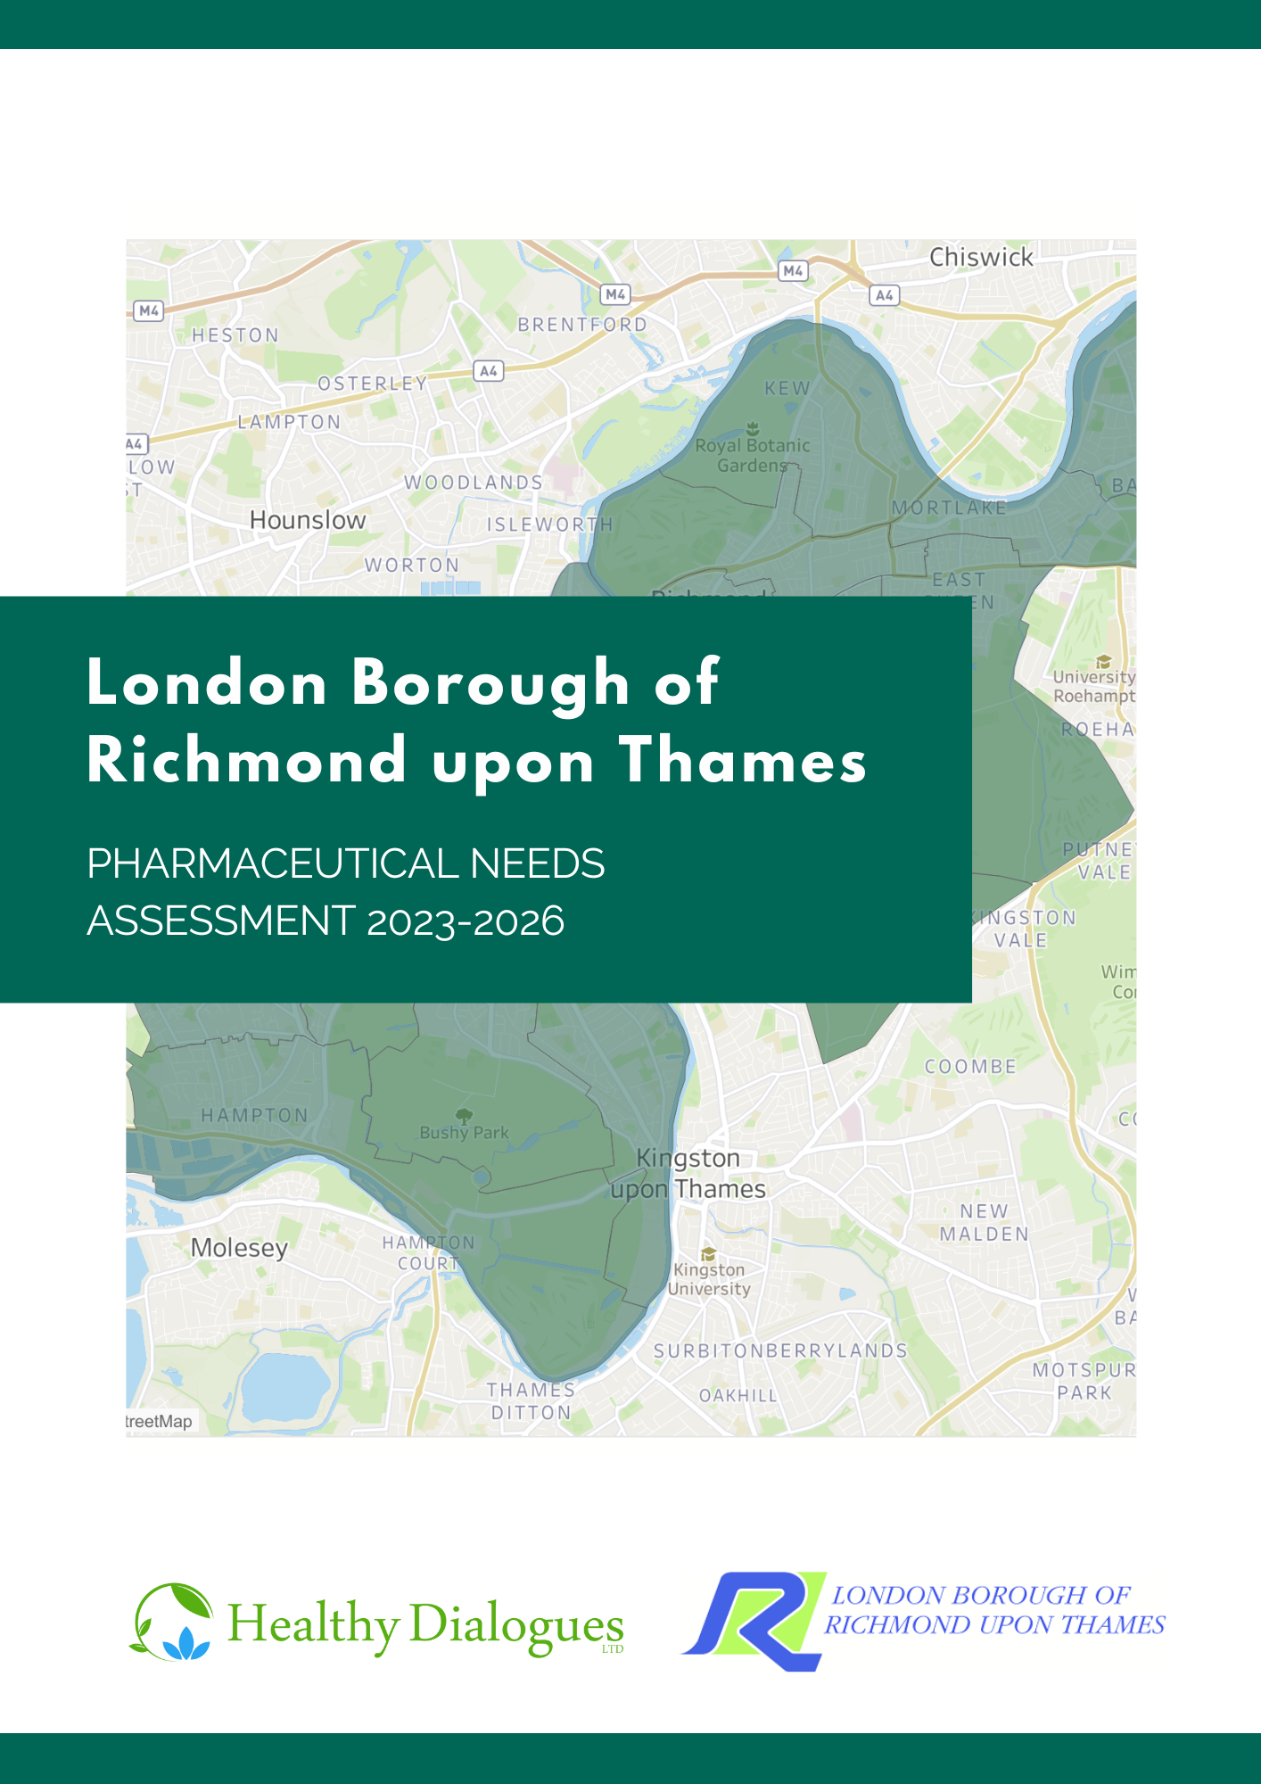
The London Borough of Richmond upon Thames Pharmaceutical Needs Assessment 2023-2026

Executive Summary

Introduction
All Health and Wellbeing Boards (HWB) have a statutory responsibility to publish and keep up to date a statement of needs for pharmaceutical services for their population every three years. This is called the Pharmaceutical Needs Assessment (PNA). The purpose of the PNA is twofold:
- support NHS England in their decision-making related to applications for new pharmacies, or changes of pharmacy premises and/or opening hours.
- support local commissioners in decisions regarding services that could be delivered by community pharmacies to meet the future identified health needs of the population
This PNA provides an overview of the demographics and health and wellbeing needs of the Richmond population. It also captures patient and public views of pharmacy services they access. It assesses whether the current provision of pharmacies and the commissioned services they provide meet the needs of the Richmond residents and whether there are any gaps, either now or within the lifetime of the document, from the date of its publication to the 15th March 2026. It assesses current and future provision with respect to:
- Necessary Services, i.e., current accessibility of pharmacies and their provision of Essential Services
- Other Relevant Services and Other Services including Advanced and Enhanced Pharmacy Services. These are services commissioned by NHS England, South West London ICB, or the London Borough of Richmond upon Thames.

Methodology
In July 2022, a steering group of key stakeholders was established to oversee the development of the PNA with overall responsibility of ensuring it met the statutory regulations. The process included:
- a review of the current and future demographics and health needs of Richmond population determined on a locality basis
- a survey to Richmond patients and the public on their use and expectations of pharmacy services and an equality impact assessment
- a survey to Richmond pharmacy contractors to determine their capacity to fulfil any identified current or future needs
- an assessment of the commissioned essential, advanced, and enhanced pharmacy services provided in Richmond.
The PNA consultation draft was published for a 60-day formal consultation between the period of 14th December 2022 to the 13th February 2023. Responses to the consultation were considered by the steering group before final publication of the PNA in March 2023.

Findings

Key population demographics of Richmond
The London Borough of Richmond upon Thames is a South West London borough with an estimated population of 197,363. This population is projected to increase by 0.3% to 198,052 in the lifetime of this PNA. The largest increases in population size is likely to be seen in Heathfield (Housing-led population projections, 2021).
Richmond is a relatively affluent borough in comparison with the rest of England and just one of the boroughs 115 lower super output areas are within among the most deprived 20% in England (Ministry of Housing, Communities & Local Government).

Key population health needs of Richmond
Overall, life expectancy and healthy life expectancy for both males and females in Richmond is better than the national picture. However, a number of reported high health-risk behaviours were identified. These include: low screening coverage for cervical and breast cancer, smoking in routine and manual workers, hospital admissions for mental health conditions and hospital admissions as a result of intentional self-harm and low flu vaccination coverage for the ‘at risk’ in Richmond (OHID, Public Health Outcomes Framework, 2022).
COVID-19, external causes and circulatory diseases were the biggest causes of life expectancy gap between the most and least deprived in the borough.

Patient and public engagement
A patient and public survey was disseminated across Richmond to explore how people use their pharmacy and their views on specific ‘necessary’ pharmaceutical services. A total of 213 people responded.
Overall respondents chose their pharmacy because it is in a good location, it is where their GP sends their prescriptions, and they are happy with the overall experience provided by the pharmacy. Most respondents can reach their pharmacy in 20 minutes or less. No substantial differences or identified needs were found amongst protected characteristics groups and pharmacy usage.

Health and Wellbeing Board statements on service provision
There are 45 community pharmacies and three distance selling pharmacy located within the London Borough of Richmond. There is also a further 90 pharmacies located within a mile of Richmond’s borders.
The PNA steering group, on behalf of the Health and Wellbeing Board has assessed whether the current and future pharmacy provision meets the health and wellbeing needs of the Richmond population. It has also determined whether there are any gaps in the provision of pharmaceutical service either now or within the lifetime of this document, from the date of its publication to the 15th March 2026.
The London Borough of Richmond is well served in relation to the number and location of pharmacies. The Health and Wellbeing Board has concluded that there is good access to Essential, Advanced, Enhanced and Other pharmaceutical services for the residents of Richmond with no gaps in the current and future provision of these services identified.

Contents
Executive Summary 1
Introduction 1
Methodology 1
Findings 2
Key population demographics of Richmond 2
Key population health needs of Richmond 2
Patient and public engagement 2
Health and Wellbeing Board statements on service provision 3
Glossary of terms 10
Chapter 1 - Introduction 11
Context 11
Purpose of the Pharmaceutical Needs Assessment 11
The minimum requirements of the PNA 12
Circumstances under which the PNA is to be revised or updated 13
Consultation 13
Chapter 2 - Strategic context 15
National context 15
Integration and Innovation. Department of Health and Social Care’s legislative proposals for a Health and Care Bill: 15
The NHS Long Term Plan (2019) 15
Next Steps for Integrated Primary Care: Fuller Stocktake Report 2022 16
2.5 The Fuller stocktake report commissioned by NHS chief executive Amanda Pritchard, outlines a vision for primary care and provides practical steps that integrated care system leaders should take, to create a shift that will build more resilience within general practice. The vision focuses on four main areas: neighbourhood teams aligned to local communities, streamlined and flexible approaches for people who require same-day urgent care, proactive and personalised care from a multi-disciplinary team in neighbourhoods for people with complex needs, and more joined-up approaches to prevention at all levels. The report also recognises what is already working well in general practice and areas for improvement. 16
Health Equity in England: Marmot review 10 years on 16
Public Health England (PHE) Strategy 2020-2025 16
Community Pharmacy Contractual Framework (CPCF) 2019/20-2023/24 17
Pharmacy Integration Programme 17
Local Context 17
Joint Strategic Needs Assessment (2021) 17
Healthy Eating, Weight and Nutrition Plan (2022-2026) 18
Richmond upon Thames Suicide and Self-Harm prevention strategy (2019-2022) 18
Adult Physical Activity Plan (2021-2031) 18
Summary of the strategic context in Richmond 19
Chapter 3 - The development of the PNA 20
Geographical coverage 20
Patient and Public Survey 22
Pharmacy contractor survey 22
Governance and Steering Group 22
Regulatory consultation process and outcomes 23
Chapter 4 - Population demographics 24
About the area 24
Demography 24
Population size and density 24
Age and Gender Structure 25
Ethnicity and diversity 27
Population growth 30
Wider determinants of health 33
Poverty 34
Air quality/climate change 35
Summary of Population Demographics 36
Chapter 5 - Population health needs 37
Life expectancy and healthy life expectancy 37
Major risk factors 39
Improving healthy weight 40
Physical activity 41
Smoking 41
Sexual health 41
Teenage conceptions 42
Alcohol consumption 42
Substance misuse 42
Mental health and wellbeing (including loneliness and isolation) 43
Vaccinations 46
Cancer screening 46
Major health conditions 47
COVID-19 48
External causes 49
Circulatory diseases 50
Patient groups with specific needs 51
Dementia 51
Learning Disabilities 51
Summary of population health needs 53
Chapter 6 - Patient and public survey 54
Richmond communications engagement strategy 54
Survey Results 55
Equality impact assessment 61
Age 61
Ethnicity 61
Gender 62
Pregnancy and Breastfeeding 63
Employment status 63
Disability or impairment 64
Sexual Orientation 65
Relationship Status 66
Summary of the patient and public engagement and equality impact assessment 67
Chapter 7 - Provision of pharmaceutical services 68
Pharmaceutical service providers 68
Community Pharmacies 69
Dispensing appliance contractors 70
GP dispensing practices 70
Distance selling pharmacies 70
Local pharmaceutical services 70
Accessibility 70
Distribution and choice 70
Opening Times 76
Essential services 83
Dispensing 83
Summary of the accessibility pharmacy services and of essential services 83
Advanced pharmacy services 83
New medicines service 84
Community pharmacy seasonal influenza vaccination 86
Community pharmacist consultation service 88
Hypertension case-finding service 90
Community pharmacy hepatitis C antibody testing service 90
Community pharmacy smoking cessation service 90
Appliance use reviews 90
Stoma appliance customisation service 91
Summary of the Advanced Pharmacy Services 91
Enhanced pharmacy services 92
London seasonal influenza vaccination service 92
Bank holiday rota service 92
COVID-19 vaccination service 93
Summary of other NHS pharmacy services 93
Other NHS pharmacy services 93
Needle exchange service 94
Supervised consumption service 95
Emergency contraception service 97
Chlamydia screening service 99
Chlamydia treatment service 101
Out of hours palliative care dispensing & medicines advice 103
Summary of other NHS pharmacy services 103
Additional considerations from Contractor Survey Responses 104
Languages spoken in pharmacies 104
Chapter 8 - Conclusions and statements 105
Current provision 105
Current access to essential services 105
Current access to advanced services 106
Current access to enhanced pharmacy services 107
Current access to Other NHS pharmacy services 108
Future Provision 108
Future access to essential services 109
Future access to advanced services 109
Future access to enhanced services 110
Future access to other NHS pharmacy services 110
Improvements and better access 110
Current and future access to essential services 110
Current and future access to advanced services 111
Current and future access to enhanced pharmacy services 111
Current and future access to other NHS pharmacy services 111
Appendix A - PNA Steering Group ToR 113
Appendix B – Pharmacy provision within Richmond and one mile of its border 116
Appendix C - Consultation report 132

Glossary of terms
A&E – Accident and emergency
AF – Atrial fibrillation
AUR – Appliance use review
BAME – Black, Asian and minority ethnic
COPD – Chronic obstructive pulmonary disease
COVID-19 – Coronavirus disease 2019
CPCF – Community Pharmacy Contractual framework
CPCS – Community Pharmacist Consultation Service
CVD – Cardiovascular disease
DAC – Dispensing appliance contractor
DHSC – Department of Health and Social care
DSP – Distant selling pharmacy
GLA – Greater London Authority
GP – General Practitioner
HEWNP – Healthy eating, weight, and nutrition plan
HIV – Human immunodeficiency virus
HWB – Health and wellbeing board
IAPT – Improving access to psychological therapies
ICB – Integrated care board
ICS – Integrated care system
IMD – Index of Multiple Deprivation
JSNA – Joint strategic needs assessment
LA – Local authority
LMC – Local medical committee
LPC – Local pharmaceutical committee
LPS – Local pharmaceutical services
LSOA – Lower super output area
MSM – Men who have sex with men
NHS – National Health Service
NMS – New medicines service
ONS – Office for national statistics
PCN – Primary care network
PHE – Public Health England
PhIF – Pharmacy integration fund
PSNC – Pharmaceutical Services Negotiating Committee
PNA – Pharmaceutical needs assessment
QOF – Quality Outcomes Framework
SAC – Stoma appliance customisation
STI – Sexually transmitted infection
SWL – South West London

Introduction

Context
              - Community pharmacies are key in providing quality healthcare in the centre of local communities. As one of the most frequented healthcare settings in England, they are often patients first point of contact and, for some, their only contact with a healthcare professional.
              - This PNA was conducted at a time of substantial change within the health and social care landscape with the creation of the South West London Integrated Care Board. This includes an increased use and acknowledgement of community pharmacies within newly developed primary care networks, ensuring greater opportunities for patient engagement.
              - It was also conducted at a time of a drop of staffing levels across the sector in England. Provision of services can be affected by a lack of available and suitably accredited pharmacists. Pharmacy contractors are often struggling to ensure that their pharmacy has enough appropriately skilled and qualified staff to provide safe and effective pharmacy services to the public.

Purpose of the Pharmaceutical Needs Assessment
              - The provision of NHS Pharmaceutical Services is a controlled market. All pharmacists and dispensing appliance contractor who wish to provide NHS Pharmaceutical Services, must apply to NHS England to be on the Pharmaceutical List of the Health and Wellbeing Board.
              - The purpose of the Pharmaceutical Needs Assessment (PNA) is to plan for the commissioning of pharmaceutical services and to support the decision-making process in relation to new applications or change of premises of pharmacies. This includes:
- Supporting the ‘market entry’ decision making process (undertaken by NHS England) in relation to applications for new pharmacies or changes of pharmacy premises.
- Inform local plans for the commissioning of specific and specialised pharmaceutical services
              - The PNA can also be used by the HWB to:
- Inform interested parties of the pharmaceutical needs in the borough and enable work on planning, developing and delivery of pharmaceutical services for the population
- Inform discussions with pharmacy contractors to provide services within areas where they are needed and limit duplication of services in areas where provision is adequate.

The minimum requirements of the PNA
              - This PNA covers the period between the date of its publication to 15th March 2026. It replaces the PNA published by Richmond HWB in 2018. The development and publication of this PNA has been carried out in accordance with regulations and associated guidance, including:
- The NHS Pharmaceutical Services and Local Pharmaceutical Services Regulations 2013
- Department of Health Information Pack for Local Authorities and Health and Wellbeing Boards
              - As outlined in the 2013 regulations, this PNA must include a statement of the following:
- Necessary Services – Current Provision: services currently being provided which are regarded to be “necessary to meet the need for pharmaceutical services in the area”. This includes services provided in the county as well as those in neighbouring counties.
- Necessary Services – Gaps in Provision: services not currently being provided which are regarded by the HWB to be necessary “in order to meet a current need for pharmaceutical services”.
- Other Relevant Services – Current Provision: services provided which are not necessary to meet the need for pharmaceutical services in the area, but which nonetheless have “secured improvements or better access to pharmaceutical services”.
- Improvements and Better Access – Gaps in Provision: services not currently provided, but which the HWB considers would “secure improvements, or better access to pharmaceutical services” if provided.
- Other Services: any services provided or arranged by the local authority, NHS England, the ICB, an NHS trust or an NHS foundation trust which affects the need for pharmaceutical services in its area or where future provision would secure improvement, or better access to pharmaceutical services specified type, in its area.
- Future need: the pharmaceutical services that have been identified as services that are not provided but which the health and wellbeing board is satisfied need to be provided in order to meet a current or future need for a range of pharmaceutical services or a specific pharmaceutical service.
              - Additionally, the PNA must include a map showing the premises where pharmaceutical services are provided and an explanation of how the assessment was made. This includes:
- How different needs of different localities have been taken into account
- How needs of those with protected characteristics have been taken into account
- Whether further provision of pharmaceutical services would secure improvements or better access to pharmaceutical services
- A report on the 60-day consultation of the draft PNA.

Circumstances under which the PNA is to be revised or updated
              - The PNA will be updated every three years so that it reflects the need for pharmacy services and any changes as they arise.
              - The Health and Wellbeing Board are also required to revise the PNA publication if they deem there to be significant changes in pharmaceutical services before 15th March 2026.
              - Not all changes in a population or an area will result in a change to the need for pharmaceutical services. If the HWB becomes aware of a minor change that means a review of pharmaceutical services is required, the HWB will issue supplementary statements to update the PNA.

Consultation
              - A draft PNA must be put out for consultation for a minimum of 60 days prior to its publication. The 2013 Regulations list those persons and organisations that the HWB must consult, they include:
- Any relevant local pharmaceutical committee (LPC) for the HWB area
- Any local medical committee (LMC) for the HWB area
- Any persons on the pharmaceutical lists and any dispensing GP practices in the HWB area
- Any local Healthwatch organisation for the HWB area, and any other patient, consumer and community group, which in the opinion of the HWB has an interest in the provision of pharmaceutical services in its area
- Any NHS Trust or NHS Foundation Trust in the HWB area
- NHS England
- Any neighbouring Health and Wellbeing board.
              - The draft PNA was presented for consultation between the 14th December 2022 to the 13th February 2023. All comments received were considered in the final PNA report.

Strategic context
              - This section summarises key policies, strategies and reports which contribute to our understanding of the strategic context for community pharmacy services at a national level and at a local level.

National context

Integration and Innovation. Department of Health and Social Care’s legislative proposals for a Health and Care Bill:
              - With the population growing in size, people living longer, but also suffering from more long-term health conditions, and challenges from the COVID-19 pandemic, there is a greater need for the health and social care system, including pharmacies, to work together to provide high quality care. This paper sets out the legislative proposals for the Health and Care Bill which capture the learnings from the pandemic.

The NHS Long Term Plan (2019)
              - As health needs change, society develops, and medicine advances, the NHS needs to ensure that it is continually moving forward to meet these demands. The NHS Long Term Plan (2019) (NHS LTP) introduces a new service model for the 21st century.
              - Community pharmacists will play a crucial role in supporting people with high-risk conditions such as atrial fibrillation (AF) and cardiovascular disease (CVD). The NHS will support community pharmacists to case-find, e.g., hypertension case-finding. Pharmacists within PCNs will undertake a range of medicine reviews, including educating patients on the correct use of inhalers, and supporting patients to reduce the use of short acting bronchodilator inhalers and to switch to clinically appropriate, smart inhalers. As part of preventative healthcare and reducing health inequalities, community pharmacists will support patients to take their medicines as intended, reduce waste, and promote self-care.

Next Steps for Integrated Primary Care: Fuller Stocktake Report 2022
              - The Fuller stocktake report commissioned by NHS chief executive Amanda Pritchard, outlines a vision for primary care and provides practical steps that integrated care system leaders should take, to create a shift that will build more resilience within general practice. The vision focuses on four main areas: neighbourhood teams aligned to local communities, streamlined and flexible approaches for people who require same-day urgent care, proactive and personalised care from a multi-disciplinary team in neighbourhoods for people with complex needs, and more joined-up approaches to prevention at all levels. The report also recognises what is already working well in general practice and areas for improvement.

Health Equity in England: Marmot review 10 years on
              - The objectives outlined in the Marmot review are intended to ensure that the healthy life expectancy gap between the least deprived and most deprived are reduced. More specifically to health, community pharmacists are uniquely placed at the heart of communities to support patients to provide the public a range of public health interventions, weight management services, smoking cessation services and vaccination services. At present the role of community pharmacies provide a pivotal role in promoting healthier lifestyle information and disease prevention.

Public Health England (PHE) Strategy 2020-2025
              - The Office for Health Improvement and Disparities (OHID) have pledged to promote a healthier nation by taking action on working to reduce preventable risk factors for ill health. Community pharmacies have an important role in driving and supporting these objectives as they provide the public with services around healthy weight and weight management, smoking cessation, and can provide information and advice around healthy start for children and families.

Community Pharmacy Contractual Framework (CPCF) 2019/20-2023/24
              - This is an agreement between the Department of Health and Social Care (DHSC), NHSE&I and the Pharmaceutical Services Negotiating Committee (PSNC) and describes a vision for how community pharmacy will support delivery of the NHS Long Term Plan. The CPCF highlights and develops the role of pharmacies in urgent care, common illnesses, and prevention. It aims to “develop and implement the new range of services that we are seeking to deliver in community pharmacy”, making greater use of Community Pharmacists’ clinical skills and opportunities to engage patients.

Pharmacy Integration Programme
              - The pharmacy integration fund (PhIF) was established in 2016 to accelerate the integration of pharmacy professionals across health and care systems to deliver medicine optimisation for patients, and for clinical pharmacy services to be integrated into primary care networks. The Pharmacy Integration Programme is currently providing support to various workstreams whereby pharmacy professionals thrive within an integrated multi-disciplinary team across primary and community settings.

Local Context

Joint Strategic Needs Assessment (2021)
              - The Joint Strategic Needs Assessments (JSNA) analyse the health needs of populations to help inform the commissioning decisions around health, well-being, and social care services within local authority areas. The JSNA is often split into three sections; start well, live well and age well, along with population and localised data. This can be found on the Richmond JSNA.

Healthy Eating, Weight and Nutrition Plan (2022-2026)
              - This is the first healthy eating, weight, and nutrition plan (HEWNP) for Richmond, and is a 5-year plan to promote a healthy weight and lifestyle to tackle health inequalities in the borough. Based on evidence-based approaches, the plan has three stands: restricting advertising and promotion of high fat, sugar and salt, promoting procurement and catering of healthy food and localities, and, promoting healthier eating and drinking initiatives based on best practice, resident insights and evidence.

Richmond upon Thames Suicide and Self-Harm prevention strategy (2019-2022)
              - The suicide rate in Richmond is 9.2 per 100,000 and remained below the England average, but above the London average when this strategy was compiled. The objectives of this strategy are to improve understanding of local needs, challenge stigma and discrimination associated with mental disorder, improve access to information and access to services, improve crisis responses and pathways, and preventing self-harm amongst young people. Among its objectives are to improve access to information and ‘postvention’ support through primary and secondary care.

Adult Physical Activity Plan (2021-2031)
              - This plan focuses on a whole systems approach for Richmond by creating active people, active communities, and active environments. The council and its partners will seek to increase the number of knowledgeable, motivated, skilled residents creating regular physical activity habits, to create opportunities for inactive families and people facing health inequalities, to create equitable access for all residents to engage in physical activity, and to support the councils aim to become carbon neutral and greenest inner-London council by 2030.

The Richmond Sexual Health Story 2020: Service delivery in primary care settings
              - This is a report of the sexual health services delivered by GP practices and pharmacies in Richmond. The report focuses on service demand and provision during 2018-2019, and will help to inform procurement of services in primary care settings from 2020 and beyond. The report found that sexual health services should continue to be delivered within primary care settings but commissioning from 2020 should look to strengthen the accessibility of services and the equity of access across areas where they are needed the most.

Summary of the strategic context in Richmond
- Community pharmacies have a unique place with the potential to work with local residents and communities to meet some of the ambitions outlined within the national and local public health strategies. For example, promoting healthier life choices, improving and increasing access to local services, and contributing to the development of prevention and early interventions around specific health conditions can be supported by community pharmacies through advice giving and signposting. The role of community pharmacies in supporting these strategies are also referred to throughout this PNA.

The development of the PNA
              - The London Borough of Richmond upon Thames HWB commissioned delivery of its PNA to Healthy Dialogues through a competitive tender process. The governance of the production of this PNA was managed by the PNA steering group and the Directorate of Adult Social Care and Public Health of Richmond Council. The decisions in the production of this PNA have been delegated by the HWB to the steering group.
              - This PNA has been developed using a range of information sources to describe and identify population needs and current service provision from the network of community pharmacies (see Table 3.1). This includes:
- Nationally published data
- The Richmond Joint Strategic Needs Assessment
- Local policies and strategies
- A survey to Richmond pharmacy providers
- A survey to the patients and public of Richmond
- Local Authority and SWL ICB commissioners

              - These data have been collated to illustrate the Richmond population, current and future health needs and how pharmaceutical services can be used to support the HWB to improve the health and wellbeing of our population.
              - This PNA will be published for public consultation between the 14th December 2022 to the 13th February 2023. All comments received will be considered for the final PNA publication. They will be summarised in a consultation report in the Appendix.

Geographical coverage
              - PNA regulations require that the HWB divides its area into localities as a basis for structuring the assessment. A ward-based structure was used as it is in-line with available data at ward level such as demography, health needs and service provision commissioned by both the London Borough Richmond and NHS commissioners.
              - As of May 2022, new ward boundaries came into effect, resulting in some name and boundary changes, as well as an increase in the overall number of wards. These new ward boundaries are presented on the council website: https://www.richmond.gov.uk/council/open_richmond/ward_map_of_the_borough. All ward-level data presented in this PNA are aligned to the ward boundaries prior to May 2022 as demographic and health data is not yet available for these new ward boundaries. Both previous and current ward boundaries are showing in Figure 3.1 below.
Figure 3.1: London Borough of Richmond electoral wards, previous and current
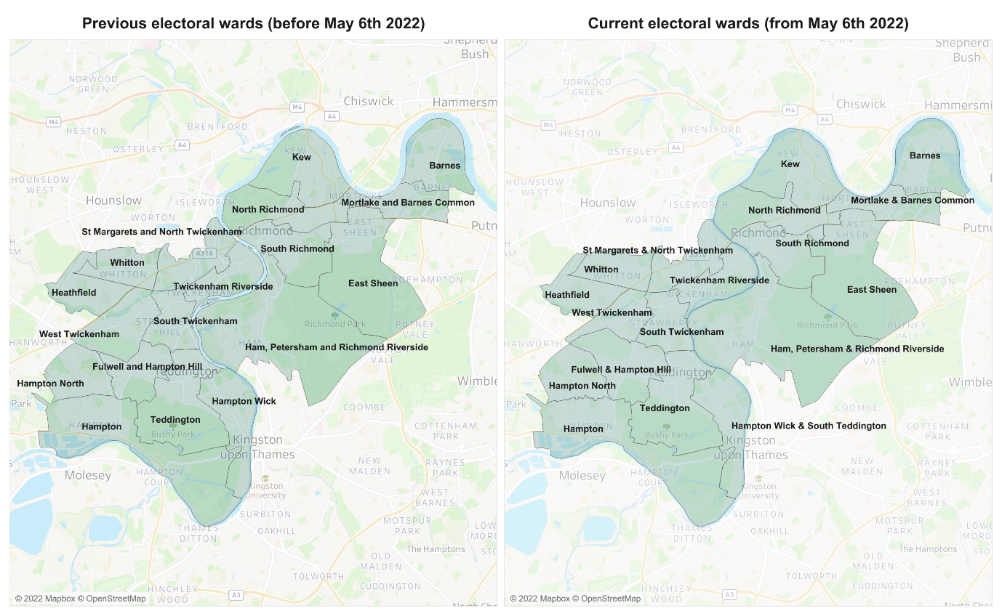

              - Provision and choice of pharmacies is determined by using 1-mile radius from the centre of the postcode of each pharmacy. This is approximately a 20-minute walk from the outer perimeter of the buffer zone created. The 1-mile radius approach illustrates where there is pharmacy coverage and areas without coverage (for example, see Figure 6.1).
              - In addition, 20-minutes travel time by public transport is also considered as being a reasonable measure to identify variation and choice. Where the population are within 1-mile of a pharmacy or can reach a pharmacy within 20-minutes travel time by public transport then the pharmacy provision is considered ‘good’.
              - Other factors are considered when determining if there is sufficient pharmacy provision. These include: proximity to GP practices, current and future population density, housing developments, changes in healthcare provision, deprivation levels and opening times.

Patient and Public Survey
              - Patient and public views and experiences were collated in the form of a survey to understand how people use their pharmacies, what they use them for and their views of the pharmacy provision. 213 Richmond residents and workers responded to the survey, their views were explored, including detailed analysis of the Protected Characteristics. The findings from the survey are presented in Chapter 6 of this PNA.

Pharmacy contractor survey
              - The contractor survey was sent all to the community pharmacies within Richmond to capture data on services provided and opportunities for future commissioning. Twenty-six out of 46 (57%) pharmacy contractors responded. The results from this survey are referred to throughout this document.

Governance and Steering Group
              - The development of the PNA was advised by a Steering group whose membership included representation from:
- The London Boroughs of Richmond Public Health Team
- London Borough of Wandsworth Public Health Team
- South West London Integrated Care Board
- Wandsworth, Merton and Sutton LPC
- Kingston and Richmond LPC
- Healthwatch Richmond
- Healthwatch Wandsworth
- Healthy Dialogues

              - The Terms of Reference of the Steering Group presented in Appendix A.

Regulatory consultation process and outcomes
              - This PNA will be shared for statutory consultation on the 14th December 2022 for 60 days. All comments will be drafted into a consultation report for the steering group and will be considered and incorporated into the final PNA report to be published in March 2023.

Population demographics
              - This chapter presents an overview of the demographics of Richmond, with particular emphasis to aspect that are likely to impact on the need for pharmaceutical services. It includes an exploration of the characteristics of its residents, expected population growth and the wider determinants of health.
              - All the maps contained in this chapter present the size/proportion of the population in relation to different factors such as population density, deprivation, and life expectancy. The maps are displayed in gradients, where the lower the marker, the lighter the colour. The gradients are further displayed as legends on each map.

About the area
              - The borough, which is located in southwest London and is a part of greater London, is the only one in the capital to be situated on both banks of the river Thames.
              - Among the heritage sites in Richmond include the Royal Botanic Gardens at Kew and Hampton Court Palace. Additionally, the borough features two royal parks with free-roaming deer.
              - Richmond has the longest section of the river Thames, which flows through the borough for more than 10 miles and connects Hampton Court Palace, Richmond Town Centre, and Kew Gardens with London. It also has the largest area of public open space per head of population of any London borough.

Demography

Population size and density
              - The Greater London authority estimates that there are 197,363 residents in Richmond in 2022 (Housing-led Population Projections).
              - Richmond’s population density is one of the lowest in London (35.7 people per hectare), with only four London boroughs having lower population densities.
              - Mortlake and Barnes Common is the ward with the highest population density (64.1 people per hectare), but majority of the more densely populated wards are towards the central regions of the borough (Figure 4.1). Ham Petersham and Richmond Riverside has the lowest population density.
Figure 4.1 Population Density of Richmond per hectare by Ward
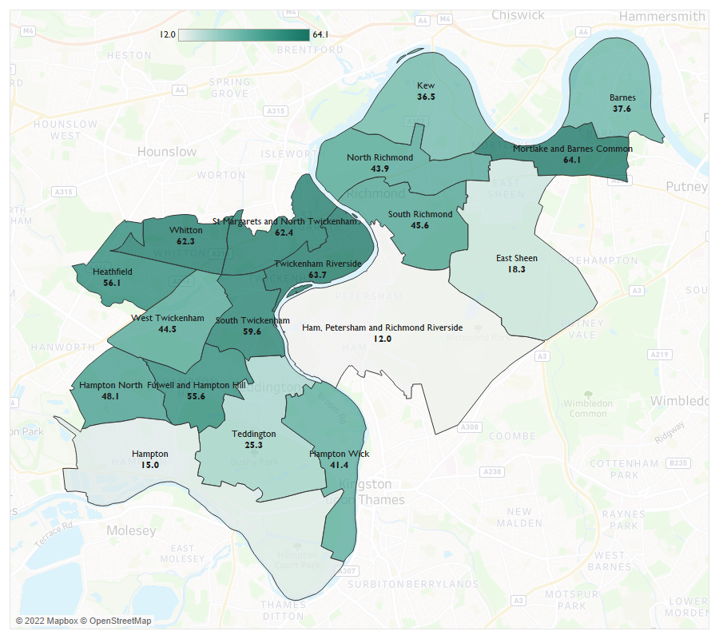
Source: GLA (Population Density & Housing-led Population estimates)

Age and Gender Structure
              - Overall, there is similar numbers of males and females living in the borough (51% female and 49% male). There are however a greater number of older women, likely due to longer life expectancy for females. The average age of the population is 40 years, an age higher than the London overall average age (37 years) (GLA Population estimates).
              - 19.8% of the Richmond population are under 16 years of age, which is very similar to England’s figure (19.2%).
              - 63% of the population in Richmond are of a working-age (16-64 years).
              - 16.9% of Richmond residents are aged 65 and over. This is above London’s overall number (12.5%). Figure 4.2 presents a breakdown of the age and gender of Richmond residents.
Figure 4.2: Proportion of resident population by age-band and gender, Mid-year 2020 estimates for Richmond
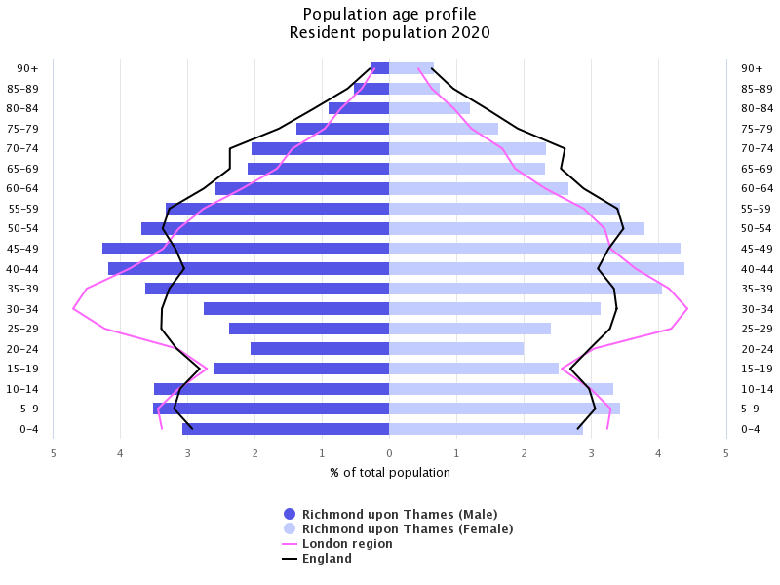
Source: PHE, 2022 (based on mid-2020 population estimates)

              - East Sheen has the greatest representation of those aged 15 and under, while Hampton has the highest proportion of older adults (Figure 4.3).
Figure 4.3: Population Age Groups by Ward
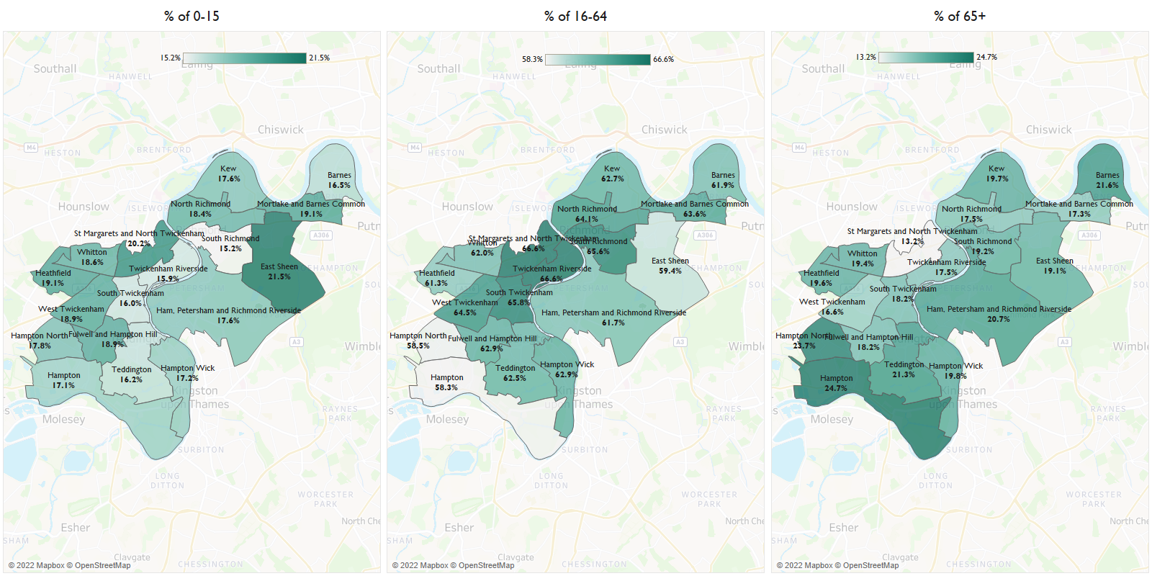
Source: GLA (Housing-Led Population Projections)

Ethnicity and diversity
              - Areas where diversity is higher correlate with areas of higher levels of deprivation and poorer health. Pharmacy staff often reflect the social and ethnic backgrounds of the community they serve making them approachable to those who may not choose to access other health care services.
              - NICE guidance¹⁶ highlight that community pharmacies can impact on health equalities in several ways. For example, it recommends that community pharmacists take into consideration how a patient’s personal factors may impact on the service they receive. Personal factors would include, but are not limited to, gender, identity, ethnicity, faith, culture, and any disability. It also recommends that community pharmacists make use of any additional languages staff members may have.
              - Just below 13% of the Richmond resident population are from Black, Asian and Minority Ethnic Groups. The largest of these populations are from a mixed ethnic background (see Table 4.1).
Table 4.1: Ethnic population breakdown for Richmond, London and the UK
Area | White | Asian | Black | Mixed/ Other
Richmond upon Thames | 87.2% | 5.6% | 0.0% | 7.2%
London | 59.2% | 18.4% | 11.9% | 10.6%
United Kingdom | 85.9% | 7.3% | 3.3% | 3.5%
Source: ONS Annual Public Survey, 2019

              - At a ward level, the western wards of Heathfield (30.4%), Whitton (21.5%) and Hampton North (16.3%) have the highest representation of Black, Asian and Minority Ethnic groups. Teddington has the lowest representation with 8.9%.
Figure 4.3: Percentage of black and ethnic minority groups by wards in Richmond, 2011
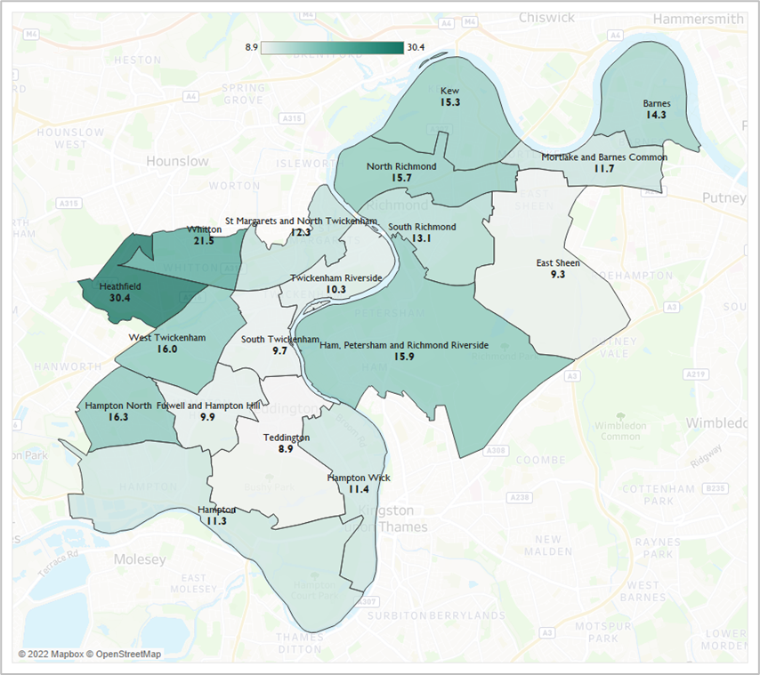
Source: ONS, Census 2011

              - 10.4% of the borough’s residents who are aged 3+ state that their main language is not English (2011census). This is considerably lower than the London average which stands at 22.1%.
              - Polish and German are the most commonly spoken languages after English (Table 4.2).
Table 4.2: Proportion of languages spoken in Richmond – Top 10
Language | Percentage
English | 89.6%
Polish | 1.0%
German | 0.9%
Spanish | 0.7%
French | 0.7%
West/Central Asian Language: Persian/Farsi | 0.6%
Italian | 0.5%
Arabic | 0.4%
South Asian Language: Panjabi | 0.4%
Portuguese | 0.4%
Source: ONS Census, 2011
              - Figure 4.5 shows a breakdown of the population who do not speak English well or at all. As can be seen, wards with the greatest population of residents not proficient in English, such as Heathfield, are also those with the greatest representation of Black, Asian and Minority Ethnic groups.
Figure 4.4: Percentage of people that cannot speak English well or at all by ward in Richmond in 2011
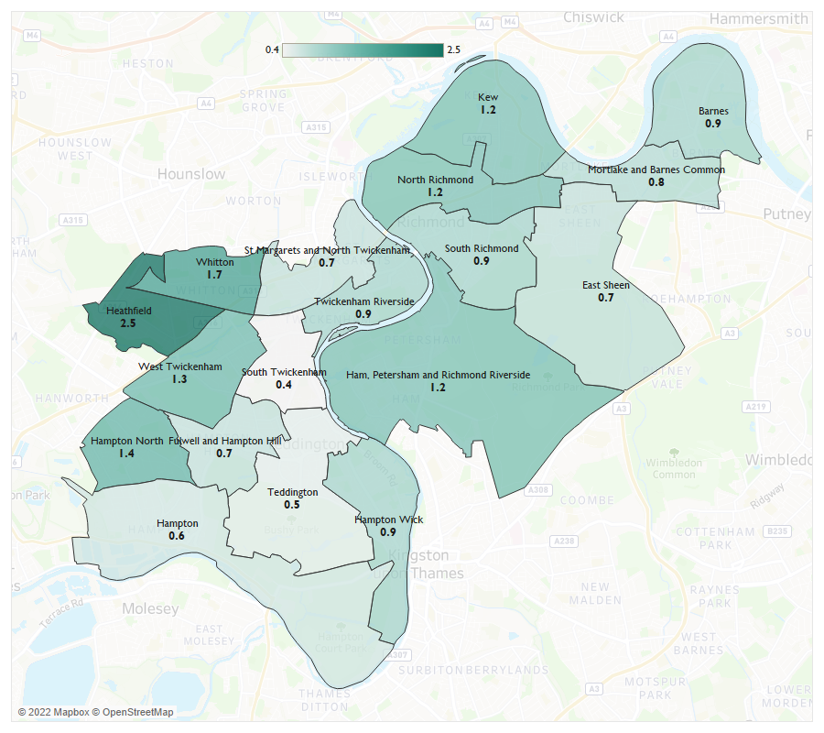Source: ONS, Census 2011

Population growth
              - Any population increases sustained in the lifetime of this PNA need to be taken into consideration. Population increases will likely place increased demands on community pharmacy services with different population groups having different needs.
              - The population of Richmond is expected to increase by 0.3% during the lifetime of the PNA (2022 to 2025) to stand at 198,052 by 2025 (GLA, Housing-led population projections – Identified Capacity Scenario, 2021). These figures are based on mid-year population estimates and assumptions such as births, deaths, and migration.
              - Mortlake and Barnes Common will experience the largest increase in its population size, expanding from 11,778 in 2022 to 12,192 by 2025, a 3.5% increase (see Figure 4.6 and Table 4.3). Barnes, on the other hand, will see a 1.3% decrease in its population.
Figure 4.5: Population of Richmond resident by Ward – 2022 vs 2025
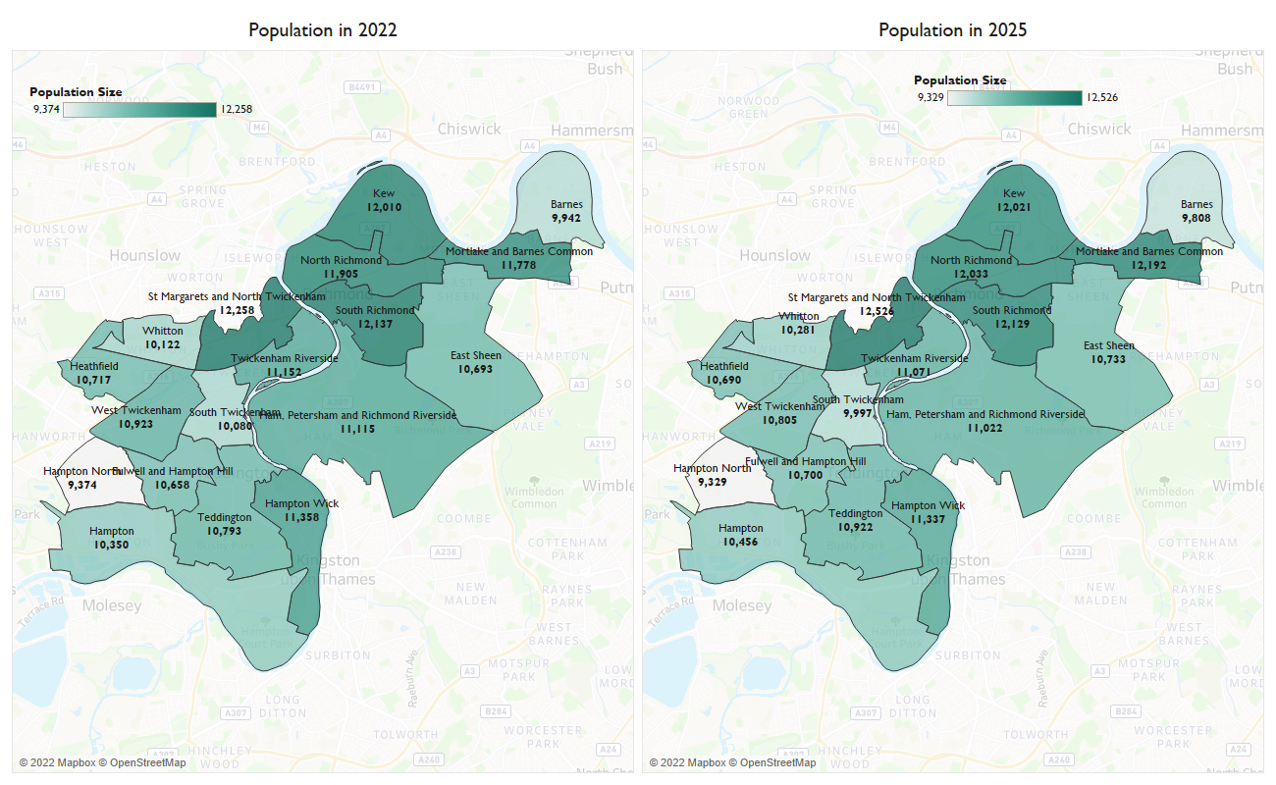
Source: GLA, Housing-led population projections – Identified Capacity Scenario, 2021

Table 4.3: Projected population changes by ward between 2022 - 2025
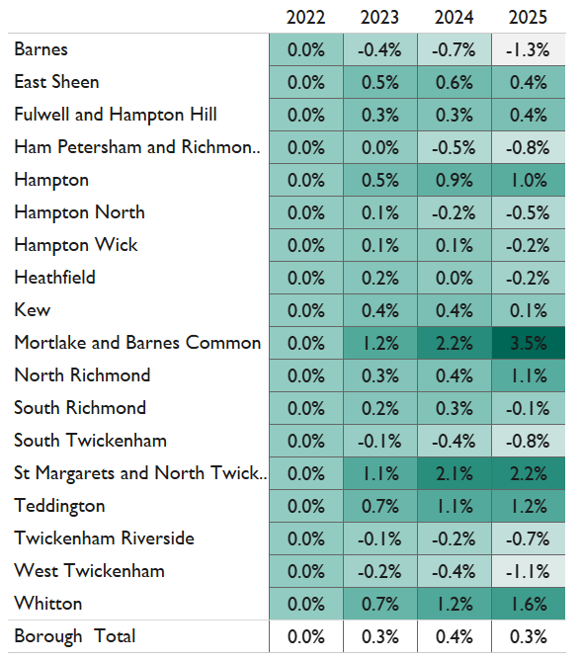
Source: GLA, Housing-led population projections – Identified Capacity Scenario, 2021
              - The London Borough of Richmond is expected to deliver 1,510 new housing units over the plan period (2021/22-2025/25). The wards with the largest number of proposed new developments are St. Margarets and North Twickenham Ward with 218 development units and Mortlake and Barnes Common Ward with 205 proposed development units (see table 4.4).
Table 4.4: Proposed number of housing developments in Richmond by ward, 20/21 to 2025/26.
 | 2021/22 | 2022/23 | 2023/24 | 2024/25 | 2025/26
Barnes | 1 | 3 | 1 | 1
East Sheen | 13 | 8 | 8 | 8 | 4
Fulwell and Hampton Hill | 13 | 20 | 46 | 15 | 11
Ham, Petersham and Richmond Riverside | 3 | 0 | 0 | 0 | 50
Hampton | 19 | 17 | 15 | 12 | 10
Hampton North | 1 | 8 | 6 | 2 | 1
Hampton Wick | 46 | 23 | 8 | 8 | 1
Heathfield | 2 | 11 | 2 | 2 | 2
Kew | 2 | 96 | 62 | 3 | 2
Mortlake and Barnes Common | 8 | 45 | 45 | 4 | 103
North Richmond | 3 | 43 | 40 | 4 | 99
South Richmond | 12 | 6 | 6 | 2 | 1
South Twickenham | 13 | 2 | 9 | 29 | 20
St. Margarets and North Twickenham | 34 | 1 | 61 | 61 | 61
Teddington | 36 | 12 | 3 | 3 | 21
Twickenham Riverside | 7 | 27 | 27 | 14 | 13
West Twickenham | 0 | 3 | 3 | 1 | 1
Whitton | 2 | 2 | 1 | 34 | 33
Grand Total | 214 | 325 | 341 | 199 | 431
Source: London Borough of Richmond upon Thames, 2022
              - It should be noted that many of these developments are proposed developments. Not all the units will be complete in the anticipated time.

Wider determinants of health
              - There are a range of social, economic and environmental factors that impact on an individual’s health behaviours, choices, goals and ultimately health outcomes. These are wider determinants that are outlined in Fair Society, Healthy Lives: (The Marmot Review) and later The Marmot Review 10 Years On . They include factors such as deprivation, education, employment and fuel poverty.
              - The Index of Multiple Deprivation (IMD) is a well-established combined measure of deprivation based on a total of 37 separate indicators that encompass the wider determinants of health and reflect the different aspects of deprivation experienced by individuals living in an area. The 37 indicators fall under the following domains: Income Deprivation, Employment Deprivation, Health Deprivation and Disability, Education, Skills and Training Deprivation, Barriers to Housing and services, Living Environment Deprivation and Crime.
              - Richmond has 115 neighbourhoods (LSOAs). The borough’s overall average IMD decile figure is 8.3 compared to the national one of 5.5. This means that there is considerably less deprivation in Richmond than in England as a whole.
              - As seen in figure 4.6 the pockets of relative deprivation in the borough are small, with just one of the borough’s 115 LSOAs among the most deprived 20% in all of England (deprivation deciles of 1 or 2).
Figure 4.6: IMD deciles in Richmond by LSOA, 2019
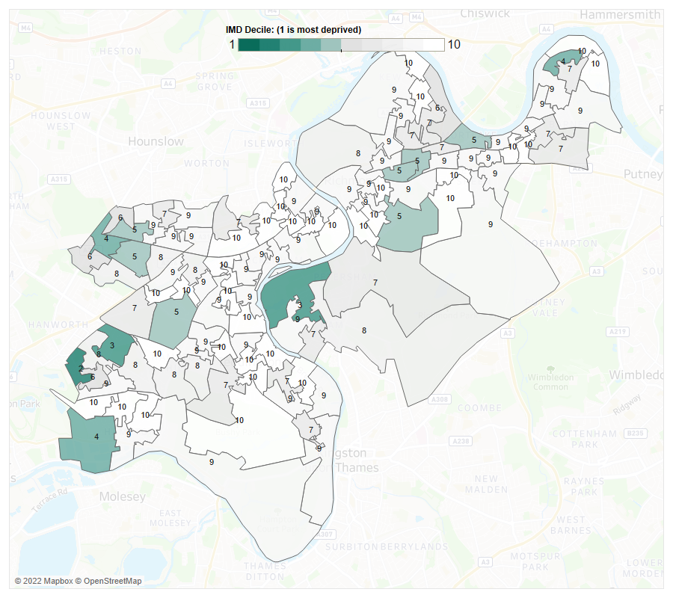
Source: Ministry of Housing, Communities & Local Government

Poverty
              - Richmond has the 3rd lowest rate of long-term unemployment within the working-age population in the region. 0.9 per 1,000 people of the working-age population of the borough are long-term unemployed in 2021/22. This equates to 113 individuals and is substantially lower than the England rate of 1.9 per 1,000 respectively (OHID, Public Health Outcomes Framework, 2022).
              - 2,569 (6.2%) children residing in the borough were from relative low-income families in 2020/21. This is the 2nd lowest rate for the region substantially lower than the national rate of 18.5%. (OHID, Public Health Outcomes Framework, 2022).
              - In 2021, 7.5% of people did not have enough income to afford sufficient fuel. This is lower than the regional rate of 11.5% and the national rate of 13.2% (OHID, Public Health Outcomes Framework, 2022).

Air quality/climate change
              - While air pollution is not often perceptible, the risks it causes are correlated to a lower life expectancy and a range of health conditions thus quality of life and wellness could be significantly and negatively impacted by it. There is strong evidence that air pollution cause stroke, exacerbates asthma, increased risk of cardiovascular disease, and poor lung development. Furthermore, individuals with lower incomes are more likely to live in densely populated areas with greater levels of noise and air pollution and pre-existing medical conditions. NO2 and Particle Matter (PM) are two of the most harmful pollutants to human health. PM is a mixture of solid and liquid droplets that is produced as a result of burning fuel, smokestacks, vehicles, and building sites. Following from the Air Pollution and Health Richmond Brief, one of the biggest threats to health is PM with a diameter of less than 10 micrometres (PM2.5). PM2.5 may penetrate deeply into the lungs and can even enter the bloodstream, which can have a variety of adverse consequences on health and wellbeing. The average human hair has a diameter of roughly 70 micrometres, whereas PM2.5 and 10 are smaller.
              - In 2020, the annual concentration of fine particulate matter in Richmond, adjusted to account for population exposure was 9.1 μg/m3. This is higher than London, 9.6 μg/m3 but higher than England 7.5 μg/m3 thus placing the borough within the 2nd worst quintile in England (Public Health Profiles, 2020).
              - Moreover, within the same year the fraction of mortality attributable to particulate air pollution in Richmond was 6.7%. These rates were lower than regional figures, 7.1% but higher than that national, 5.6% (Public Health Profiles, 2020).

Summary of Population Demographics
The London Borough of Richmond upon Thames is a Southwest London Borough. It has a population of 197,363 residents, a number which is expected to increase by 0.3% in the lifetime of this PNA. The largest population increases are expected in Mortlake and Barnes Common, and St Margarets & North Twickenham wards.

Overall, there is less deprivation in Richmond than England overall and long-term unemployment, fuel poverty and the proportion of children living in relative low-income families are among the lowest in London.

Population health needs
              - This chapter presents an overview of the health and well-being needs of the population of Richmond upon Thames, with a particular focus on topics that community pharmacies can support. It looks at life expectancy and healthy life expectancy in Richmond and includes an exploration of major risk factors and major health conditions. It also includes an overview of patient groups with specific needs as identified by the steering group.

Life expectancy and healthy life expectancy

              - Life expectancy is a statistical measure of how long a person is expected to live. In the Borough of Richmond upon Thames, life expectancy is better national figures. The 2018-2020 life expectancy for males at birth in the borough is 82.2 years and 86.4 years for females. These figures are the fifth and fourth highest in London respectively. They higher than the national figures of 79.4 and 83.1 (OHID, Public Health Profiles, 2022).
              - Healthy life expectancy at birth is the average number of years an individual should expect to live in good health considering age-specific mortality rates and the prevalence of good health in their area. The healthy life expectancy for males in the borough is 70.2 and for females, it is 68.9 (2018-20, OHID, Public Health Profiles, 2022). Both figures are substantially higher than the London and England values, meaning that residents could live in good health for longer (see figure 5.1).

Figure 5.1: Life expectancy and healthy life expectancy in years for males and females in Richmond in 2018-20
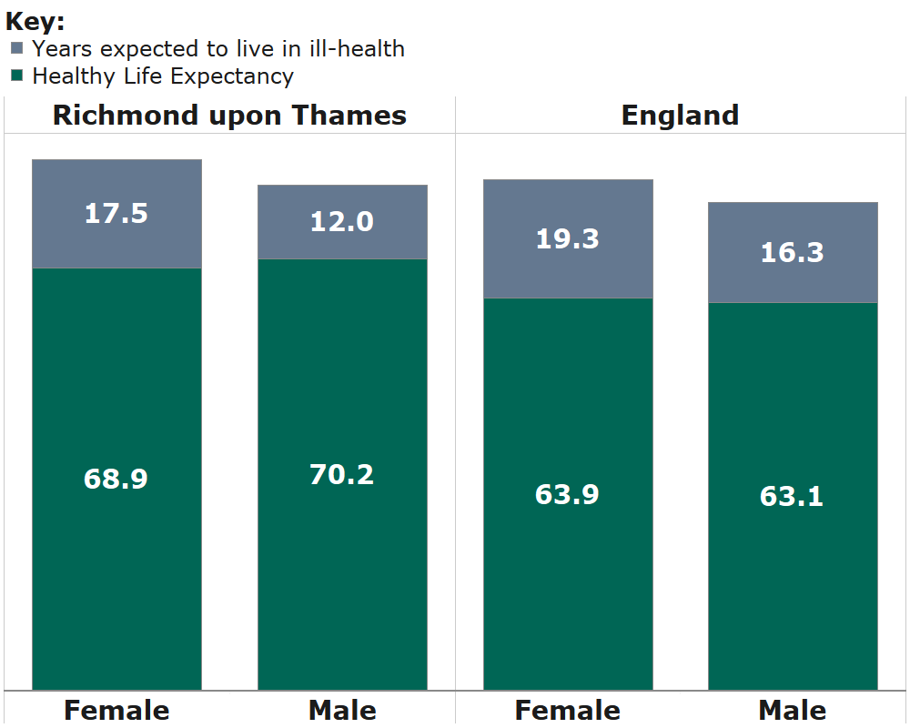
Source: OHID, Public Health Profiles, 2022
              - The variation in life expectancy across Richmond low in comparison to the rest of England. The inequality in life expectancy at birth is the measure of the absolute difference in life expectancy between the most and least deprived areas. In Richmond, there is a 5.3-year life expectancy gap for men and a 1.2-year gap for women between those who live in the most deprived areas and the least deprived areas (2018-20), these are the 4th and 2nd lowest in London respectively. In comparison to the national figures of 9.7 and 7.9 for males and females.
              - As shown in Figure 5.2, life expectancy is highest in for both females and males in East Sheen ward (91.3 and 85.9 respectively) and lowest in Fulwell & Hampton Hill ward (83.8 and 79.7).
Figure 5.2: Life expectancy at birth of Males and Females by Ward in Richmond, 2015-19 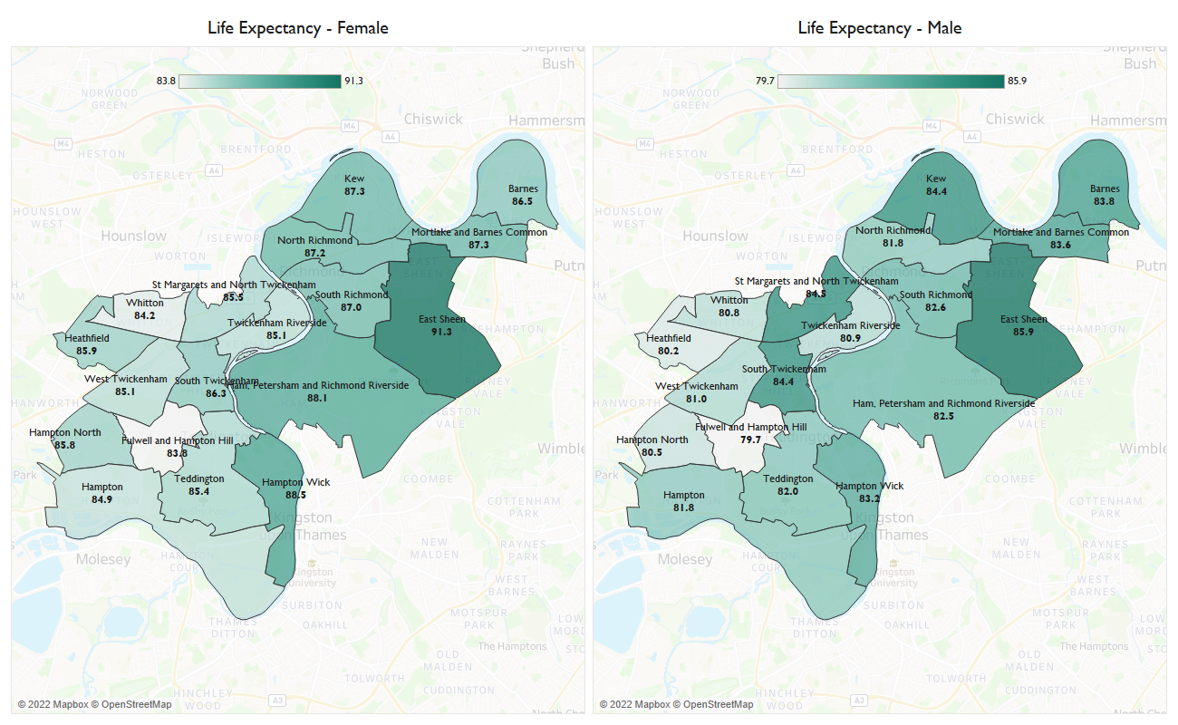
Source: OHID, Local Authority Health Profiles, 2022

Major risk factors
              - Community pharmacies often sit within the heart of communities. They provide a ‘walk-in’ access to their service provision making them ideally placed to offer opportunistic screening and brief interventions for better health and wellbeing.
              - The Healthy Living Pharmacy framework requires community pharmacies to have trained health champions in place to deliver interventions on major risk factors such as smoking cessation and weight management and provide well-being and self-care advice. The interventions are about engaging members of the public, by using every interaction as an opportunity for health promotion, making every contact count, and signposting to other relevant services.
              - London Borough of Richmond upon Thames and the South West London Health and Care Partnership have committed to promoting prevention and identification of long-term conditions and risk factors. As part of the essential services they provide, pharmacies can support this agenda by support public health campaigns and offer signposting for patients to local health, wellbeing, and social care support services.
              - This next section of the chapter explores lifestyle factors that can impact on a person’s health and wellbeing that pharmacies can support through the Healthy Living Pharmacy framework and signposting. It includes, improving healthy weight, physical activity, smoking, sexual health, alcohol consumption and substance misuse.

Improving healthy weight

              - The London Borough of Richmond upon Thames and the South West London Health and Care Partnership have committed to working with communities to increase awareness of risk factors and increase uptake of weight management services.
              - The Pharmacy Quality Scheme (PQS) 2022/2023 ensures that pharmacies have undertaken training to enable them to understand management of obesity. They must also proactively provide weight management advice and onward referral to local weight management support such as tier 2 services or the NHS Digital Weight Management Programme.
              - Obesity is recognised as a major determinant of premature mortality and avoidable ill health. The estimated proportion of adults who are overweight or obese in Richmond in 2020/2021 was 45.5%, placing it as the third lowest borough in London. Richmond figures are significantly better than England average where 63.5% of adults are overweight or obese (OHID, Public Health Profiles, 2022).

              - Between 2017 to 2021, 925, 16.3%, 4- to 5-year-olds were classified as overweight or obese, which places Richmond as one of the lowest boroughs in London. In comparison to previous years, the figures have remained amongst the lowest and have been decreasing slowly. (OHID, Public Health Profiles, 2022).
              - 22% of Year 6 children in Richmond are overweight or obese in that same timeframe, placing the borough the lowest in the region. Richmond is significantly better than the London average of 38.2% and the national average of 35.2% (OHID, Public Health Profiles, 2022).

Physical activity
              - Nearly three quarters of adults (74%) residing in the borough are considered physically active, meaning they engage in 150 minutes or more of moderate physical activity per week. This is higher than the national figure of 65.9%. This places the borough as the 3rd best in the region. People who have a physically active lifestyle reduce their risk of obesity, diabetes, osteoporosis and some cancers, and enjoy improved mental health (OHID, Public Health Profiles, 2022).

Smoking
              - Smoking is the leading cause of preventable death in the world. Pharmacies can support people to stop smoking by providing advice, dispensing of nicotine replacement therapy products, and signposting to local stop smoking services. 6.2% of adults surveyed in Richmond smoke. In comparison to London and England rates of 11.1% and 12.1% adults who smoke respectively, Richmond has the lowest rate in the region (OHID, Public Health Profiles, 2022).
              - However, smoking in routine and manual workers is of concern. In 2019, 29% of adults aged 18 – 64 years who work in routine or manual occupation were surveyed to be current smokers in the group. Substantially higher than the London rate of 20.7% and similar to the England rate of 24.5%.

Sexual health
              - In 2021, 836 (422 per 100,000) residents under 25 years received a new diagnosis of an STI (excluding chlamydia). This is lower than the London rate of 935 per 100,000 and similar to the England rate of 394 per 100,000 (OHID, Public Health Profiles, 2022).
              - Chlamydia was detected in 1,155 per 100,000 population 15 - to 24-year-olds in 2021s. This is similar to the England rate of 1,334 per 100,000 and the London rate of 1,673 per 100.000 (OHID, Public Health Profiles, 2022).
              - There were 252 residents in Richmond living with an HIV diagnosis in 2021. This equates to 2.16 per 100,000 people which is similar to London and England rates. Between 2019-2021, 40% of cases were diagnosed late, similar to the London proportion of 38.6%.
              - Late diagnosis carries an increased risk of poor health and death, and the chance of onward transmission. 72.7% of those newly diagnosed with HIV start antiretroviral therapy within 91 days of diagnosis (2019-21 figures), similar to England figures. 98.3% achieve virological success meaning they have achieved an undetectable viral load (OHID, Public Health Profiles, 2022).

Teenage conceptions
              - In 2020 there were nineteen under-18 conceptions in the borough in 2020, equating to a rate of 5.7 per 1,000 population, the 4th lowest in London (OHID, Public Health Profiles, 2022).

Alcohol consumption
              - Alcohol consumption contributes to morbidity and mortality from a diverse range of conditions. 21.5 per 100,000 deaths in the region are alcohol-related, which is below the London and England rates of 32.2 and 37.8 per 100,000 deaths respectively (OHID, Local Alcohol Profiles for England, 2022).
              - 313 admissions per 100,000 hospital admissions in 2020/21 were alcohol related, this is a lower rate than England’s rate of 456 admissions per 100,000 hospital admissions and London, 348 per 100,000 (OHID, Local Alcohol Profiles for England, 2022).
              - In 2020, Richmond ranked the 5th most prosperous borough in London for individuals successfully completing alcohol treatment. 47.4% of alcohol users completed their structured treatment successfully and did not re-present to treatment within 6 months, this outcome has been consistent over the past decade.

Substance misuse
              - Substance misuse is linked to mental health issues such as depression, disruptive behaviour and suicide. In Richmond, 62.4 per 100,000 hospital admissions for 15- to 24-year-olds in the period 2018/19 to 2020/21 were due to substance misuse, this is similar to the rate in London with 56.5 and England with 81.2 per 100,000 hospital admissions (OHID, Public Health Profiles, 2022).
              - Where there is a local need, pharmacies can be commissioned to provide needle and syringe exchange services to reduce the risk of infections in those who inject drugs. Pharmacies can also be commissioned to provided supervised consumption of medicines to treat addiction, for example, methadone.
              - The proportion of opiate users in Richmond who have successfully completed drug treatment is similar to national figures. 3.8% of users had successfully completed treatment in the borough, this is the lowest figure within the past decade. London has a success rate of 5.5% and England 4.7% (OHID, Public Health Profiles, 2022).

Mental health and wellbeing (including loneliness and isolation)
              - The Richmond Mental Health Need Assessment identified a large growing mental health need in the borough. Improving mental health and wellbeing being a priority for Richmond. The needs assessment recommended to improve integrated working for people with co-occurring mental health and substance misuse conditions with key stakeholders including Public Health, Local Authority commissioners and South West London St George's Mental Health NHS Trust.

Common mental health disorders
              - Common mental illnesses include depression, general anxiety disorder, panic disorder and phobias etc. in 2020/21, 9.3% of GP register patients (18+) in Richmond are recorded to have depression. This is higher than regional figures but lower than national figures of 8.7% and 12.3% respectively (OHID, Common Mental Health Disorders, 2022).

Serious mental health disorders
              - Severe mental illnesses include disorders that produce psychotic symptoms and severe forms of other disorders such as depression and bipolar disorder. Premature mortality in adults with severe mental illness was 62.8 per 100,000 population in 2018-20. This is the lowest figure in London, and low in comparison to the England rate of 103.6 per 100,000. This premature mortality rate has significantly better that the national figures within the past decade (NHS Digital Mental Health Services Data Set, 2022).
              - However, during 2020/2021, Richmond had the highest rate of hospital admissions for mental health conditions in the region. 120.1 per 100,000 under 18s were admitted to hospital, this was the highest rate in almost over a decade (see figure 5.3). The average rate in London was 61.3 per 100,000 and England, 87.5 per 100,000 (OHID Public Health Profiles, 2022).
Figure 5.3: Hospital admissions for mental health conditions (<18 yrs) in Richmond, London and England, 2012/13 to 2020/21
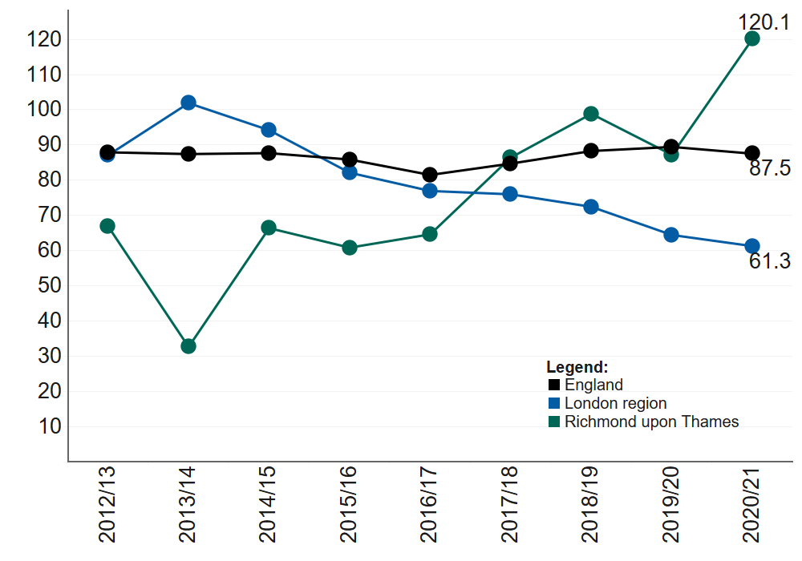
Source: OHID, Public Health Profiles, 2022.
              - Within the same year, Richmond had the second highest rate of hospital admissions as a result of intentional self-harm in 10 – 24-year-olds. The rate, 367.8 per 100,000 was higher in comparison to the previous year, and to London 210.5 per 100,000 (see figure 5.4). However, lower that the national figure 421.9 per 100,000 (OHID Public Health Profiles, 2022).
Figure 5.4: Hospital admissions as a result of self-harm (10-24 years) in Richmond, London and England 2011/12 to 2020/21
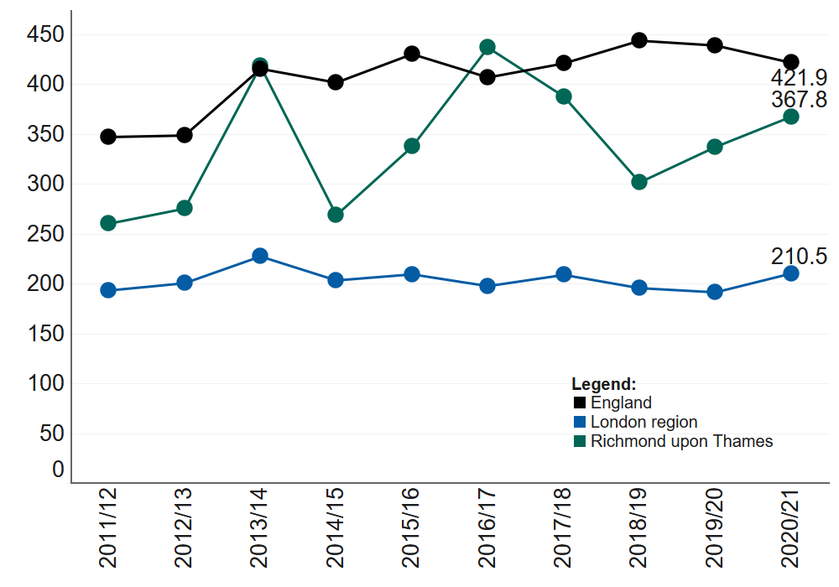
OHID Public Health Profiles, 2022

Isolation and loneliness
              - In 2018 the issue of loneliness was highlighted by the prime minister, revealing a minister for loneliness, and pledging to develop a national strategy to help tackle loneliness and the national measure. In 2019/2020, 16.91% of adults responded to “Always / often” or “Some of the time” feeling lonely. This was lower than the London rate of 23.69% and the England rate of 22.26% (Active Lives Adult Survey, Sport England 2019).
              - In 2019/2020,when asked "Thinking about how much contact you've had with people you like, which of the following statements best describes your social situation?" with the answer "I have as much social contact as I want with people I like", 48.9% of over 18-year-old social care users within Richmond reported to have as much social contact as they would like. This is similar to the regional and national rates of 42.9% and 45.9% respectively (Adult Social Care Outcomes Framework, 2022).
              - Similarly, when asked adult social care users over 65 years, 430, 46.8% responded with the answer "I have as much social contact as I want with people I like. This was similar to the regional and national rates 40.1% and 43.4% respectively. (Adult Social Care Outcomes Framework, 2022).

Vaccinations
              - Due to their flexibility of opening hours and convenient locations pharmacies are well placed to support efforts to improve uptake of some vaccinations such as the flu and COVID-19 vaccinations.

Flu vaccinations
              - Influenza, usually referred to as the flu, is a virus-based sickness that spreads by droplet infection. People who are more likely to experience major side effects from contracting the flu are encouraged to be vaccinated. Flu vaccinations can reduce sickness and hospital admissions in these populations since immunisation is one of the most effective healthcare strategies currently accessible. The demand on primary care services and hospital admissions throughout the winter should be reduced by increasing the adoption of the flu vaccination among these high-risk groups.
- The uptake of flu vaccinations in Richmond is high for over 65s. In 2021/22, 76.8% of Richmond over 65s were vaccinated, the 4th highest in flu vaccinations within this age category in London. This is higher than both the London and England rates of 70.8% and England, 82.3% respectively.
- However, only 48.4% of the ‘at risk’ populations, are vaccinated against flu. While this is higher than the London rate of 42.5% it is lower than the England coverage rate of 52.9%.
- In 2021/22, 69.1% Richmond primary school age children received their flu vaccination, higher than London and England rates of 50.4% and 57.4% respectively (OHID, Public Health Profiles, 2022).

Cancer screening
              - Cancer screening can help find cancer at an early stage which may making it easier to treat or cure a cancer. Often patients will visit their pharmacy with cancer symptoms they may be concerned about. Community pharmacies can support promotions of cancer screening programmes and signpost patients with concerns to their GP for further clinical assessment and diagnosis.
              - Most cancer screening coverages are significantly lower in Richmond in comparison to national figures (OHID, Public Health Profiles, 2022). In 2021:
- 65.8% of women aged 25-49 were screened for cervical cancer compared with 68% nationally. The recent trend shows this figure to be continually decreasing and getting worse.
- 72.1% of women aged 50-64 were screened for cervical cancer compared with 74.7% nationally.
- 52.5% women aged 53 to 70 were screened for breast cancer, compared with 64% nationally.
- 66% of men and women aged 60 to 74 were screened for bowel cancer, higher than the national rate of 65.2%.

Major health conditions
              - A good indicator of what health conditions have a bigger impact in Richmond is the causes of life expectancy gap between the most deprived and least deprived populations within a borough (figure 5.5).
              - It shows that circulatory disease is the biggest cause of the difference in life expectancy between deprivation quantiles in both males and females in Richmond. It accounts for 21.5% and 32.4% of the gap respectively.
Figure 5.5: Life expectancy gap between the most deprived quintile and the least deprived quintile for Richmond, by broad cause of death, 2020-2021
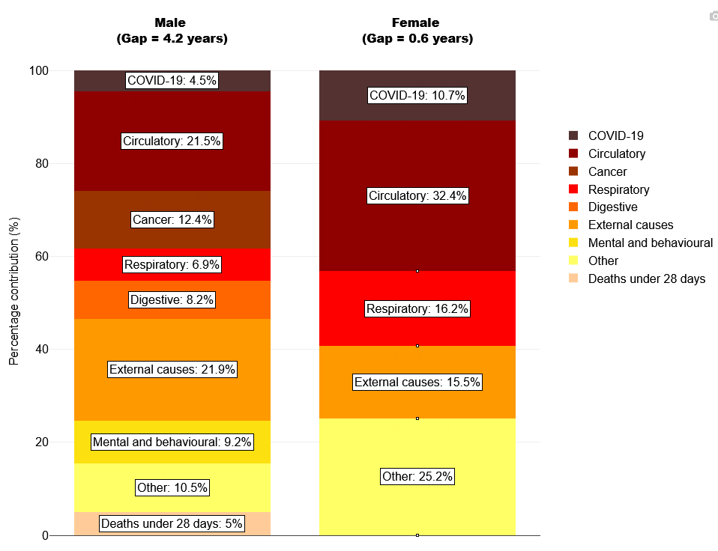
Source: OHID, based on ONS death registration data (provisional for 2021) and 2020 mid-year population estimates, and Department for Levelling Up, Housing and Communities Index of Multiple Deprivation, 2019
              - External causes such as deaths from injury, poisoning and suicide is the 2nd largest cause for males with 21.9% and respiratory diseases are the 2nd largest for women accounting for 16.2% of the gap.
              - COVID-19, external causes and circulatory diseases are explored next in this chapter.

COVID-19
              - COVID-19 was the leading cause of death in England in 2020, but the pandemic had a much greater impact on mortality in some areas than in others. From the 20th of March 2020 to the 21st of November 2022 there were 463 deaths in Richmond where COVID-19 was mentioned on the death certificate.

COVID-19 vaccinations
              - COVID-19 vaccines can reduce the risk of serious illness, hospital admissions and even death from COVID-19. They also reduce the risk of spreading COVID-19 to others.
              - As of 27th June 2022, in 78.5% of residents in Richmond (aged 12 years and over) had received their first vaccine dose, 75.6% received their second dose and 62.6% received their booster or 3rd dose. This is similar to the vaccine uptake in London overall, with 68.9%, 64.8% and 47.3% respectively (COVID data, GOV UK, 2022).

External causes
              - External causes include accidental injuries and suicide. Richmond is amongst the lowest in under 75 mortality rates from injuries in London (2018-20). 10.2 deaths per 100,000 population (under 75) are due to injuries. This is significantly lower than the England rate of 14 deaths per 100,000. (OHID, Public Health Profiles, 2022).

Falls
              - The largest cause of emergency hospital admissions for older people and accident-related mortality in England are falls. Falls can cause loss of independence and confidence, pain and distress. They are also a major precipitant of people moving from their own home to long-term nursing or residential care.
              - In 2020/21 there were 715 emergency hospital admissions due to falls in people aged 65 and over. This equates to 2,152 per 100,000 admissions, similar to England, but higher than London with 1,872 and 2,023 per 100,000 admissions respectively. Within the past 5 years falls in Richmond have significantly worse that the national rate or on par thus placing the borough as the 6th highest in the region (see figure 5.6) (OHID, 2021/22).
              - The suicide rate in Richmond is similar to the regional picture. There were 37 in 2019-21 equating to a rate of 7.1 per 100,000. The London and England figures were 7.2 and 10.4 per 100,000 respectively (OHID, 2022).
Figure 5.6: Trendline of Emergency hospital admissions due to falls in people aged 65 and over for Richmond London and England, 2010/11 to 2020/21
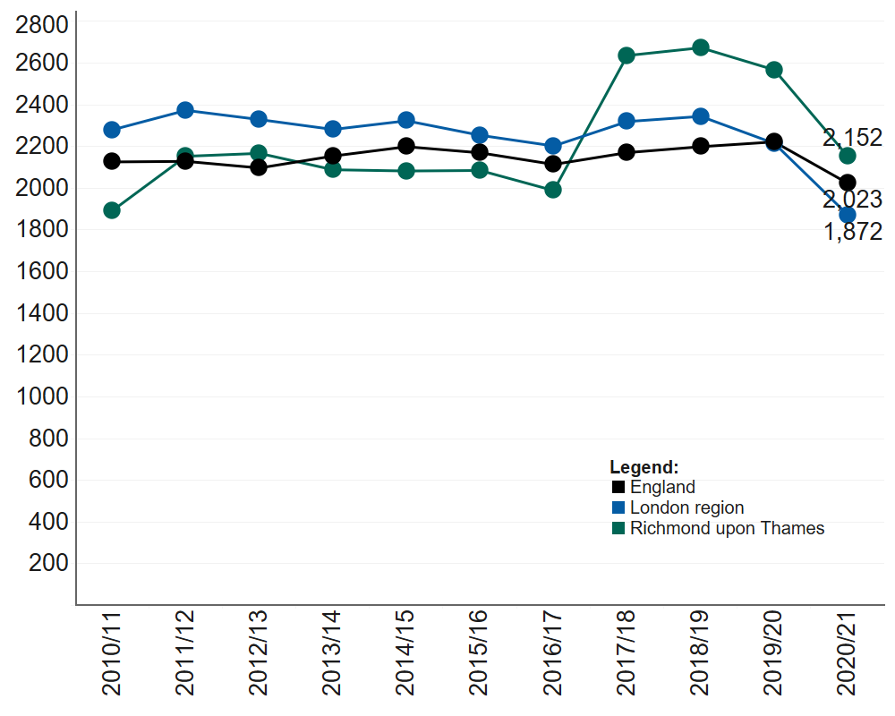
Source: OHID, Public Health Profiles, 2022

Circulatory diseases

Cardiovascular diseases considered preventable
              - Circulatory diseases include cardiovascular diseases such as heart disease and stroke. The under-75 mortality rate for cardiovascular disease considered preventable is 20.3 deaths per 100,000 population (three-year range, 2017-19). This is below the national and regional rates of 27.5 and 28.1 deaths per 100,000 population (OHID, 2022).

Stroke
              - Richmond had the 9th highest stroke prevalence in London in 2020/21. 1.2% of the GP-registered population in Richmond have had stroke or transient ischaemic attack at some point in their lives. The London prevalence is 1.1% and the national prevalence is 1.8% of the GP registered population (QOF, 2022).

Coronary heart disease
              - In 2020/21 1.9%, 4,604, GP registered patients had a heart disease or stroke, similar to the London rate of 1.9% and substantially lower than the England rate of 3% (QOF, 2022).

Patient groups with specific needs

Dementia
              - Between 2020/2021, 1,447 people were registered with dementia in Richmond, this equates to 0.6% of the GP registered population. It is the 7th highest diagnosis rate for dementia in London (0.5%) and is lower than the national rate of 0.7% (OHID, Public Health Profiles, 2022).
              - In comparison to the years prior, Richmond has had slight decrease in the rate of emergency admissions for people living with dementia over 65 years. In 2019/20 there were 1,065 admissions for people with dementia, this equates to 3,254 per 100,000 population. This is lower than the England rate of 3,517 per 100,000 population (OHID, Public Health Profiles, 2022).

Learning Disabilities
              - In 2019/2020, Richmond had the 5th lowest recorded proportion of patients with learning disabilities on the practice disease register with 0.3%. This equates to 695 patients. This figure is lower than the regional rate of 0.4% and national rate of 0.5% (OHID, Learning Disability Profiles, 2022).
              - During the same year it was reported that 3.09 per 1,000 over 18-year-olds in Richmond with a learning disability are provided with long- term support from local authorities. This rate is slightly higher than London, 3.01 per 1,000, but lower than England 3.46 per 1,000 (OHID, Learning Disability Profiles, 2022).
              - In 2020, 533 (18.9 per 1,000) children with autism were known to schools in Richmond. This is significantly lower than the regional and national average however the trend shows to be increasing (OHID, Learning Disability Profiles, 2022).
              - Under the Equality Act 2010, public sector organisations are required to make changes in their approach or provision of services to ensure that they are accessible to disabled people as well as everybody else. This can include, for example, providing people with learning disabilities clear, simple, and possibly repeated explanations of what is happening, and of treatments to be followed, help with appointments and help with managing issues of consent in line with the Mental Capacity Act. The Centre for Pharmacy Postgraduate Education (CPPE) published distance learning materials for pharmacy professionals to support active engagement with people with learning disabilities and their carers.

Summary of population health needs
Overall, the health and wellbeing of Richmond is better than the national picture. Both life expectancy and healthy life expectancy are higher than national figures.

This chapter explores the major risk factors and health conditions that affect Richmond residents. For most risk factors and health conditions explored, Richmond is doing better or similar to national figures. However, there are a few areas of concern:
- Richmond cervical and breast cancer screening coverages were lower than national figures
- Smoking in routine and manual workers was higher than regional and national rates
- Hospital admissions for mental health conditions in Richmond was the highest in the region in 2020/21
- Hospital admissions as a result of intentional self-harm in 10 – 24-year-olds in Richmond was the 2nd highest in the region in 2020/21
- A lower proportion of the ‘at risk’ population in Richmond are vaccinated against the flu than the national comparator.

COVID-19, external causes and circulatory diseases were the biggest causes of life expectancy gap between the most and least deprived in the borough.

Patient and public survey
              - This chapter presents the results of the patient and public engagement survey that was carried out in Richmond between 10th October 2022 and 17th November 2022. From this, an equality impact assessment was conducted by reviewing the use and experiences of pharmacy use specific to protected characteristic groups that were engaged with during this process.
              - A “protected characteristic” is a characteristic listed in section 149(7) of the Equality Act 2010. There are also certain vulnerable groups that experience a higher risk of poverty and social exclusion than the general population. These groups often face difficulties that can lead to further social exclusion, such as low levels of education and unemployment or underemployment.
              - The patient and public engagement survey was used to engage with patients and the public to understand their use and experiences of local pharmacies. The survey was approved for use with the local population of Richmond by the PNA Steering Group.

Richmond communications engagement strategy
              - Working closely with the steering group and the London Borough of Richmond Upon Thames Communications Team, the survey was distributed widely across Richmond over the period of 10th October 2022 until 17th November 2022. In total we engaged with 213 residents, workers and students of Richmond.
              - To promote the survey, the London Borough of Richmond Upon Thames Communications Team shared the link on their website and resident newsletter.
              - Healthwatch Richmond disseminated the survey through posts on their website and social media pages, such as Twitter.
              - The NHS South West London Integrated Care Board shared the survey through their communications channels, including circulating the link among the Community Involvement Group and the Patient Participation Group.
              - To ensure that seldom heard groups and groups who share protected characteristics, such as age, ethnicity and sexual orientation, the community engagement manager for Richmond Council was provided with the survey link and asked to disseminate.
              - Additionally, the survey link was disseminated to the Community Health Champions, who represent and engage with seldom heard groups, through Whatsapp and their newsletter.

Survey Results
              - When asked how often they use their pharmacy, 38.5% of respondents said they use it a few times a month, 31.9% reported using it once a month, a further 13.1% respondents use it once in 3 months, 8% once a week, 4.2% more than once a week, 3.3% once every 6 months, and 0.9% less than once a year (figure 6.1).
Figure 6.1: Survey responses on frequency of pharmacy use, 2022.
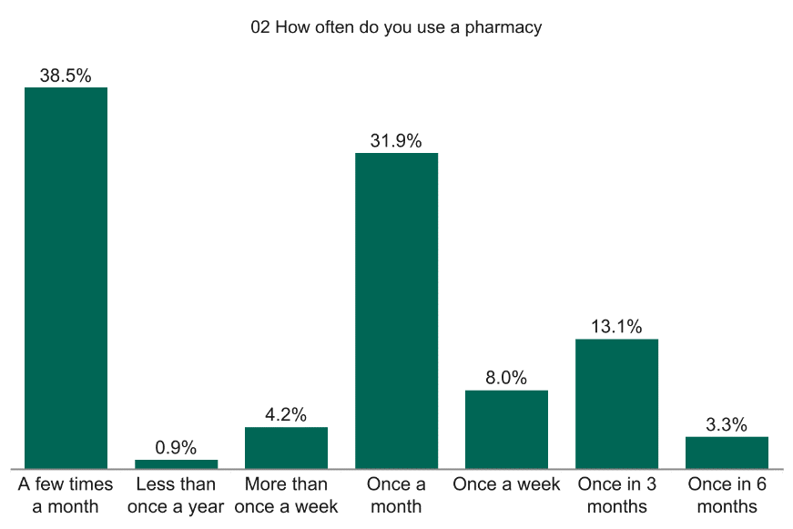
              - When asked to provide their reasons for choosing their pharmacy, 83.6% of respondents said that it is in a good location and close to their work or home, 80.3% reported that it is where their GP sends their prescriptions, and 70% are happy with the overall service provided (figure 6.2).
Figure 6.2: Survey responses on reasons for pharmacy use, 2022.
            - 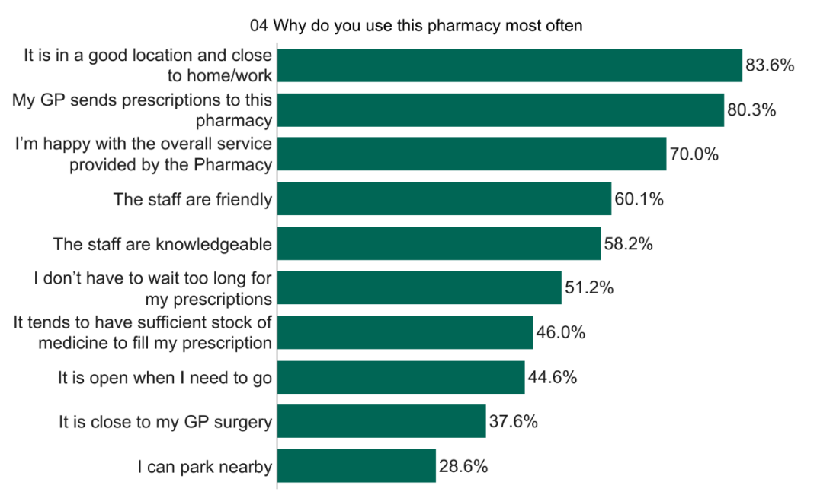
              - The vast majority of respondents (98.6%) reported using a pharmacy for themselves, 34.3% use one for their partner or spouse, while 15.5% use one for their children, 3.8% for another family member, 2.8% for their parent/parents, and 2.8% for their friend or neighbour (figure 6.3).
Figure 6.3: Survey responses on whom the pharmacy is used for, 2022.
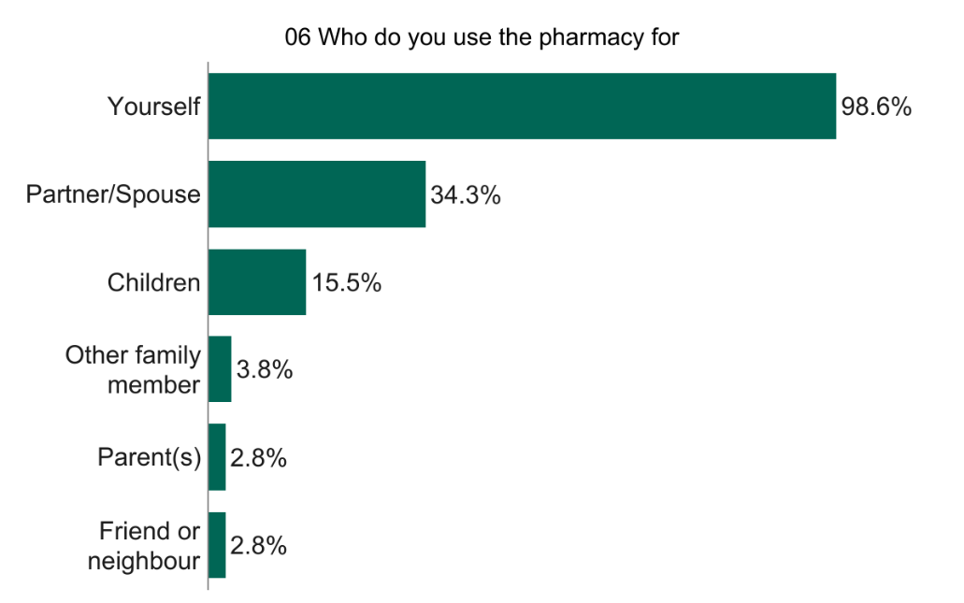
              - When asked how long it takes them to travel to their pharmacy, 128 (60.7%) respondents stated between 5 and 20 minutes, with 74 (35.1%) reporting that it takes them less than 5 minutes and nine (4.3%) spending between 20 and 60 minutes (figure 6.4).
Figure 6.4: Survey responses on length of the journey to travel to their pharmacy, 2022.
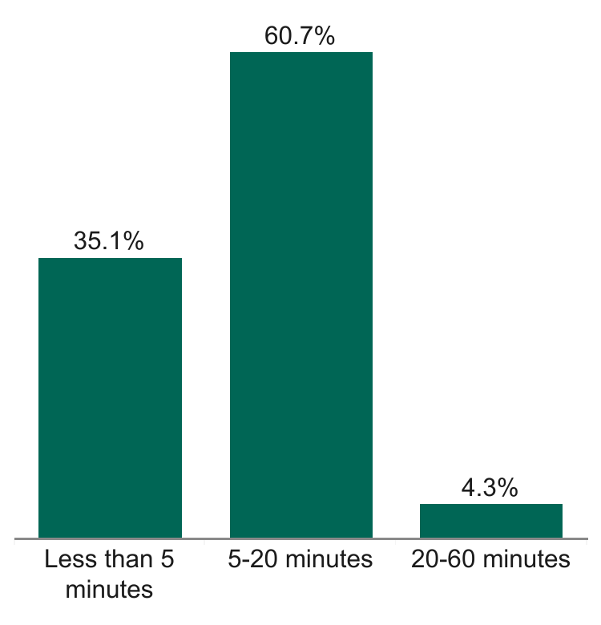
              - Most respondents (83.9%) were very satisfied, and a further 10.4% were somewhat satisfied with their journey to their pharmacy, while 3.8% reported being neither satisfied nor dissatisfied, 0.9% were somewhat dissatisfied and an additional 0.9% were very dissatisfied (figure 6.5).
Figure 6.5: Survey responses on level of satisfaction with the journey to their pharmacy, 2022.
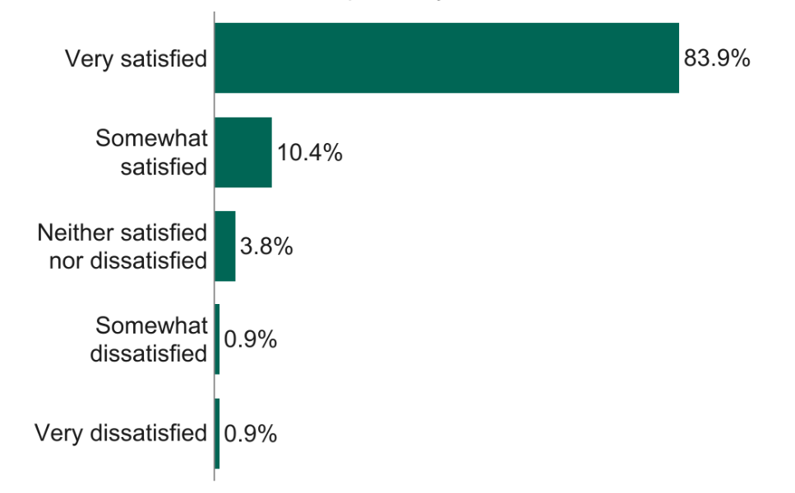
              - The majority of respondents, 77.7%, reported that they walk to their pharmacy, 28.4% use a car, 10.9% use a bus, 5.2% cycle, 0.9% stated ‘other’ while 0.9% use a mobility scooter or wheelchair (figure 6.6).
Figure 6.6: Survey responses on how respondents travel to their chosen pharmacy, 2022.
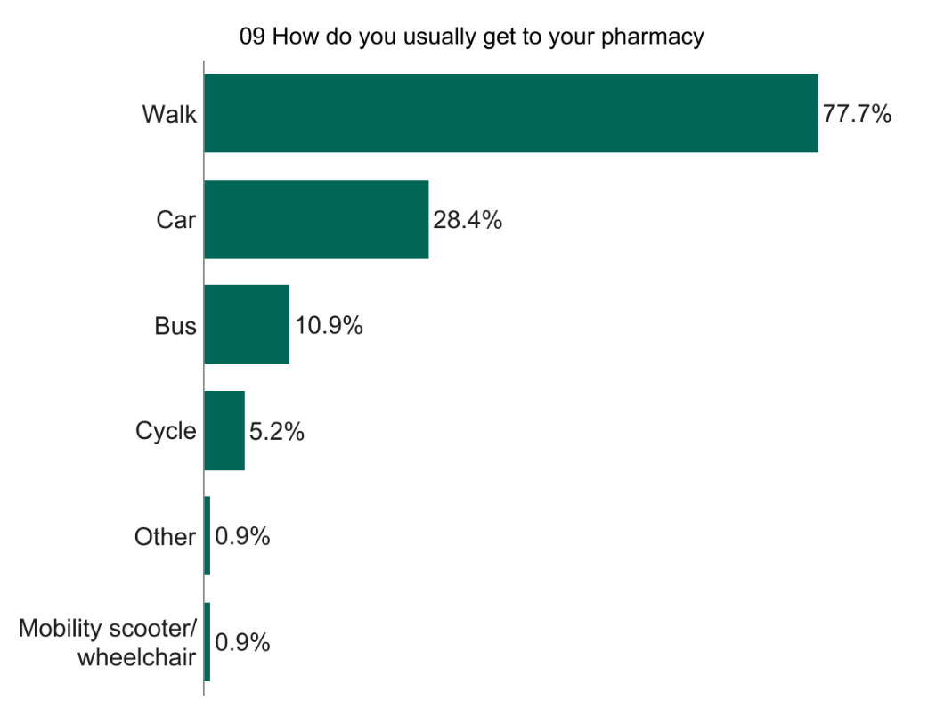
              - Most respondents stated that they prefer to go to their pharmacy on either a weekday or a weekend (52.2%) or a weekday (45.9%), while only 1.9% prefer to go on the weekend (figure 6.7). When asked what times they prefer to use their pharmacy, 65.2% stated between 9am-12pm, another 65.2% prefer between 2pm-5pm, 42.4% reported preferring to go between 12pm-2pm, 21.4% 5pm-9pm, 3.3% 6am-9am and 0.5% prefer using their pharmacy between 9pm-6am (figure 6.8).
Figure 6.7: Survey responses on the preferred day for pharmacy use, 2022.
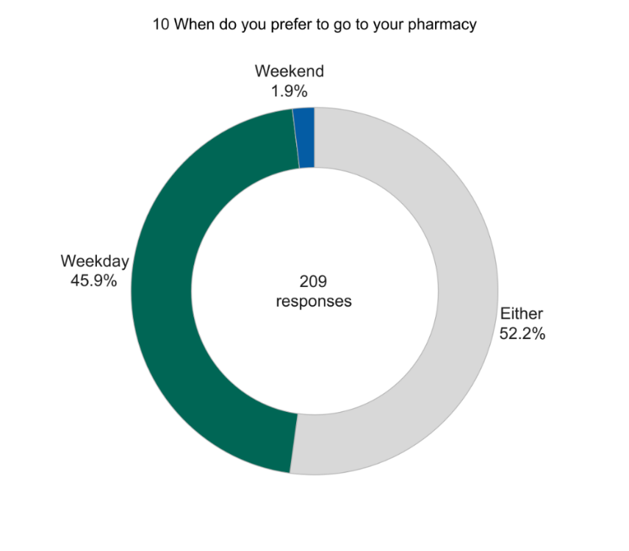
Figure 6.8: Survey responses on the time of day preferred to go to their pharmacy, 2022.
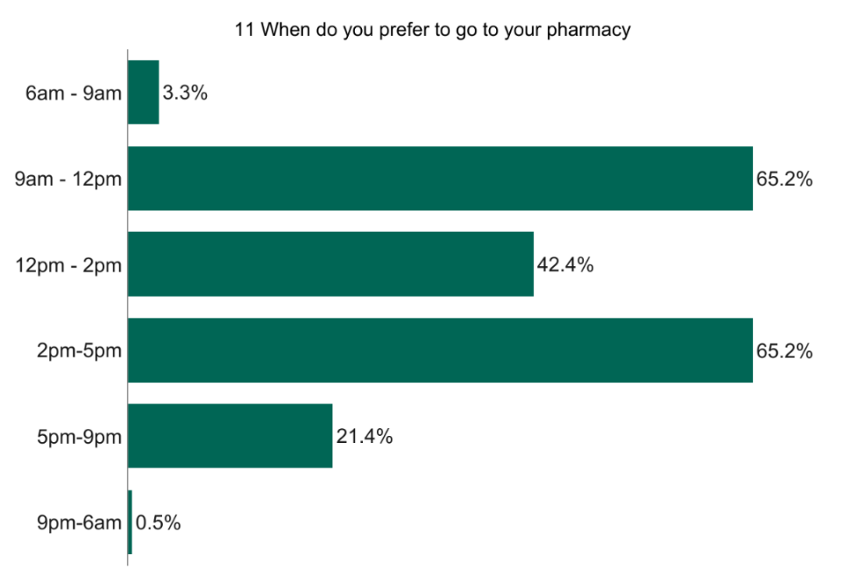
              - When asked what they do if they cannot access their pharmacy to collect a prescription, 59.2% respondents said they collect on another day, 30.1% reported that they can always access their pharmacy to collect prescriptions, 4.4% stated ‘other’, 3.4% said that they go to another pharmacy, and 2.9% stated that they use delivery (figure 6.9).
Figure 6.9: Survey responses on they do if they had no access to collect their prescription from their pharmacy, 2022.
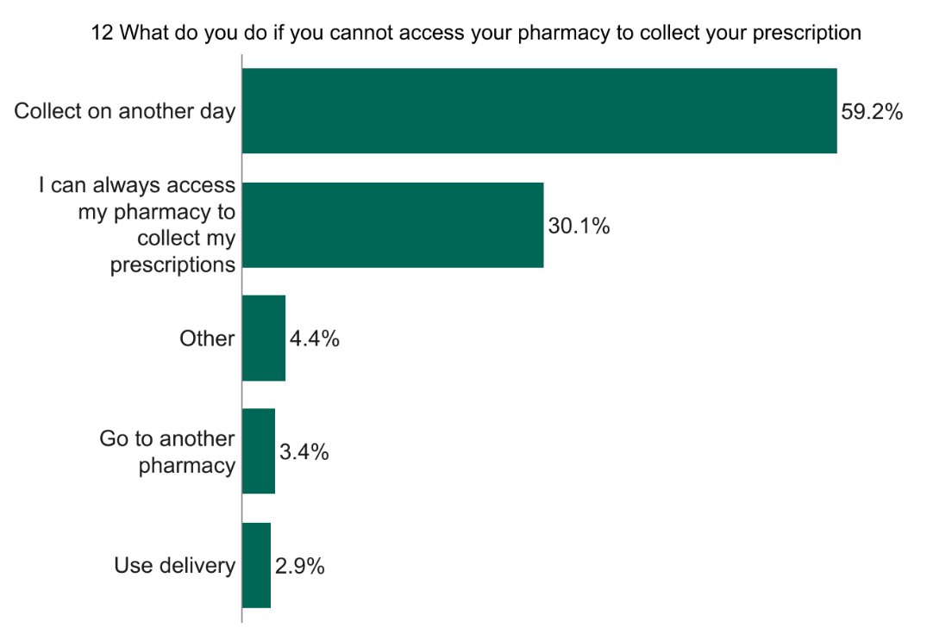
              - When asked what they do if they cannot access their usual pharmacy for minor ailments and or advice, 38.9% of respondents reported that they can always access their pharmacy, 33.5% go to another pharmacy, 16.7% go to a GP or a walk-in clinic, 10.3% call 111, and a further 0.5% go to the hospital (figure 6.10).
Figure 6.10: Survey responses on what they do if they had no access to their pharmacy for minor ailments and/or advice, 2022.
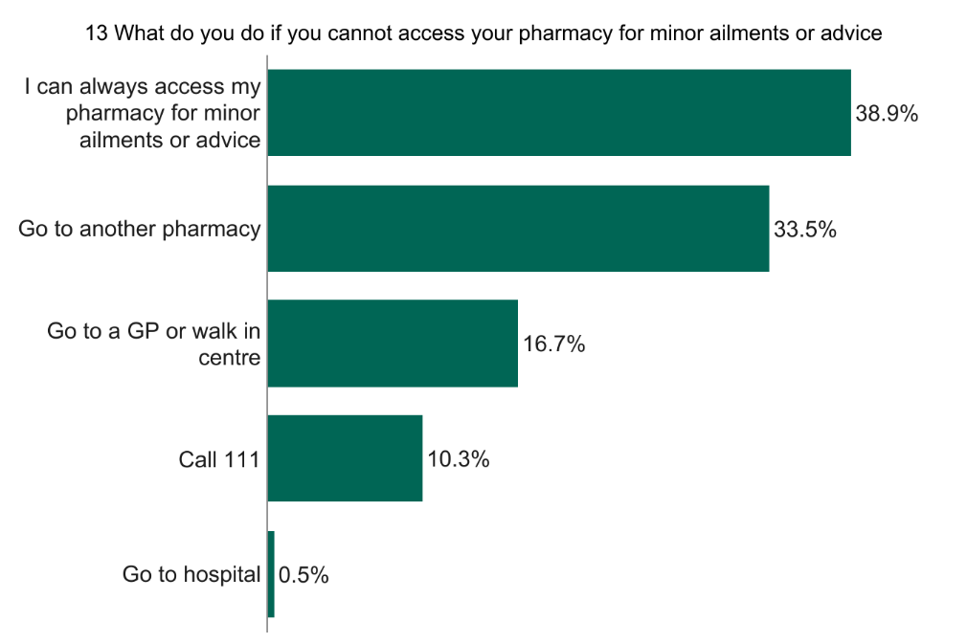
              - Of those who use an online pharmacy, 58.3% stated that they use one for repeat prescriptions, 25% for non-prescribed medications, 8.3% responded with ‘other’ and a further 8.3% use one for one-off prescriptions (figure 6.11).

Figure 6.11: Survey responses on the reason for use of online pharmacies, 2022.
      - 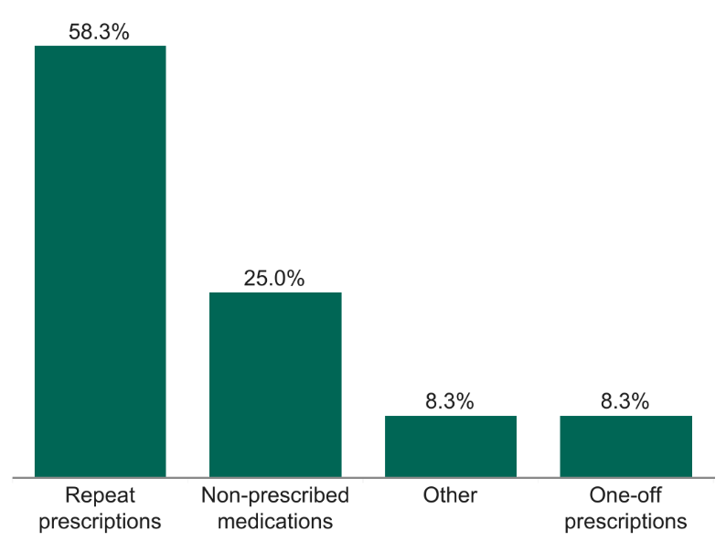
              - Many respondents were happy with the broad range of services available at their pharmacy. Although, when asked whether there are any services that Richmond residents would like to see provided at their pharmacy, their answers included:
- Consultations and medical advice
- Vaccinations, particularly COVID-19 and flu vaccinations
- Health screenings, e.g., blood tests, blood pressure checks, mole checks
- Other health services such as ear wax removal, wellbeing services, stitch removal
- Home delivery
- Prescriptions for minor ailments and repeat prescriptions

Equality impact assessment
              - This next section explores the London Borough of Richmond Upon Thames patient and public survey responses by different groups representing protected characteristics, looking at where there are similarities and differences between groups.

Age
              - To understand any differences between age groups, we compared differences between those aged over 65 (n=130), and individuals aged 65 and under (n=74).
              - There were no differences between age groups in frequency of use of pharmacies, reasons for choosing pharmacies, travel to their pharmacy or preference for day of the week for visiting their pharmacy.
              - Individuals under 65 were more likely to use a pharmacy for children (35.1%) than those who were over 65 (3.1%).
              - Those over 65 were less likely to have a preference for using a pharmacy between 5pm-9pm (11.8%) but were more likely to prefer using a pharmacy between 9am-12pm (73.2%), than those under 65.

Ethnicity
              - Only a small number of respondents were from an ethnic minority background. We compared the survey responses from those from white ethnic groups (89.2%; n=189), mixed ethnic groups (3.3%; n=7), Asian ethnic groups (2.8%; n=6) and Black ethnic groups (0.5%; n=1). Nine respondents (4.2%) preferred not to state their ethnicity (figure 6.12).
Figure 6.12: A breakdown of ethnic groups of respondents in Richmond, 2022.
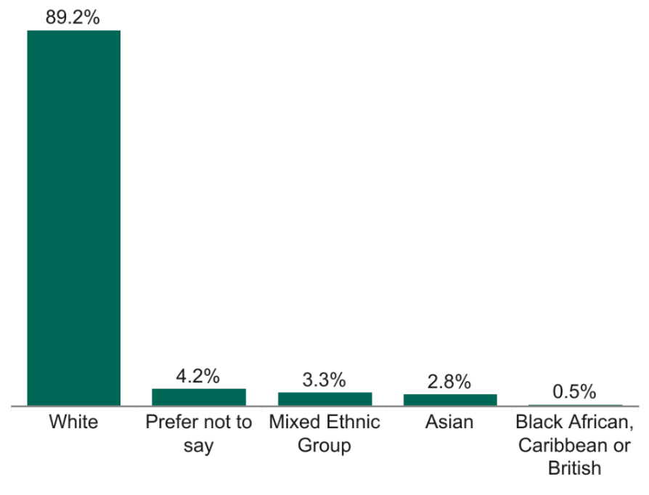

              - There were no differences between ethnic groups in time taken to travel to pharmacy, satisfaction with journey, or preferred day to use a pharmacy.
              - Those from a mixed ethnic group were less likely to report using a pharmacy once a month (14.3%), were less likely to state that they chose their pharmacy because they can park nearby (14.3%) and were more likely to use a bus to get to their pharmacy (57.1%). They were also less likely to report preferring to use a pharmacy between 9am-12pm (14.3%).
              - Those from a white ethnic group were less likely to use a pharmacy for their children (11.6%).

Gender
              - The majority of respondents (70.9%) identified as female (n=151), and 26.3% identifying as male (n=56). Six respondents preferred not to state their gender (2.8%) (figure 6.13).
Figure 6.13: A breakdown of the gender of Richmond respondents, 2022
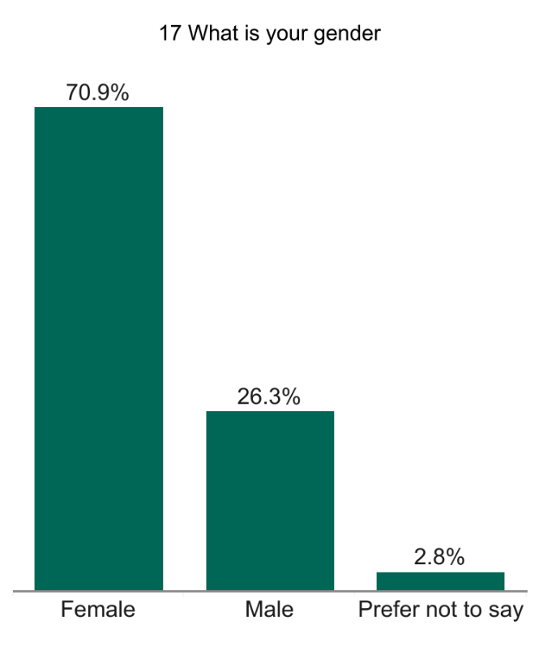

              - There were no differences in gender for frequency of pharmacy use, reasons for choosing a pharmacy, who they are accessing the pharmacy for, their travel or preference for time and day of the week to visit a pharmacy.

Pregnancy and Breastfeeding
              - When asked if they were pregnant, 199 respondents (98%) reported that they were not, while four (2%) preferred not to say.
              - Similarly, 201 respondents (97.6%) stated that they were not breastfeeding, with five preferring not to say (2.4%).

Employment status
              - Most respondents (n=143; 67.1%) were retired, while 13.6% were in full-time employment (n=29), 10.8% were in part-time employment (n=23), 3.8% respondents preferred not to say (n=8), while 2.3% were unemployed (n=5), 1.4% were students (n=3), and 0.9% were full-time or part-time carers (n=2) (figure 6.14).
Figure 6.14: A breakdown of the employment status of respondents in Richmond, 2022
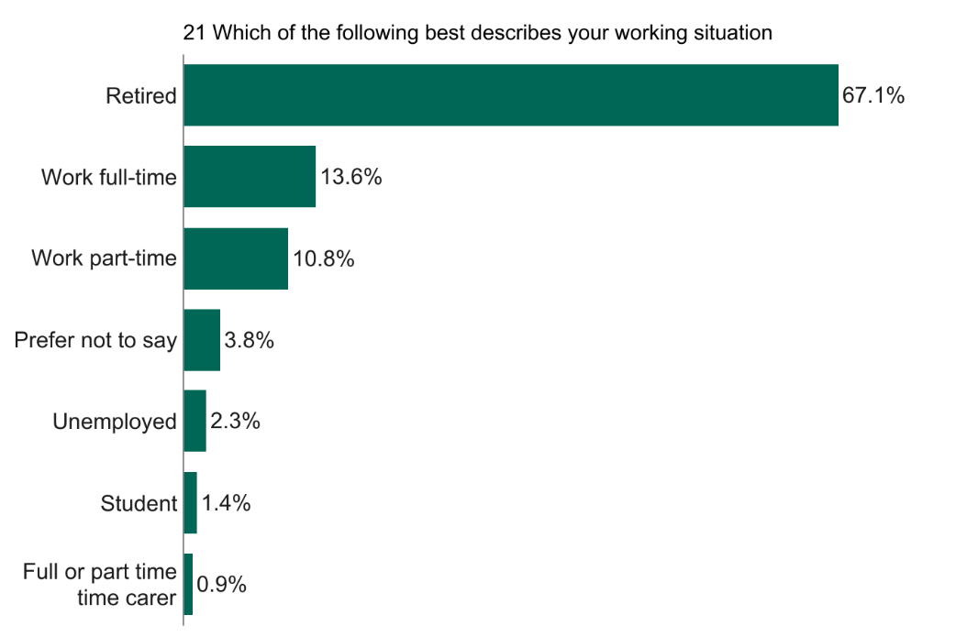
              - There were no differences between employment groups in frequency of pharmacy use, satisfaction with the journey, preference for day of the week or time of day to use a pharmacy.
              - Full-time or part time carers were more likely to report choosing a pharmacy because they can park nearby (100%) and were more likely to use a car to get to a pharmacy (100%).
              - Those who reported being unemployed were more likely to use a pharmacy for a friend or neighbour (40%) and parent(s) (40%) than other employment groups.

Disability or impairment
              - A breakdown of disabilities and impairments among the respondents found that 143 (67.1%) Richmond respondents did not consider themselves to have a disability, while 60 (28.2%) reported that they did and four (4.7%) preferred not to say (figure 6.15).
Figure 6.15: A breakdown of disability of Richmond survey respondents, 2022
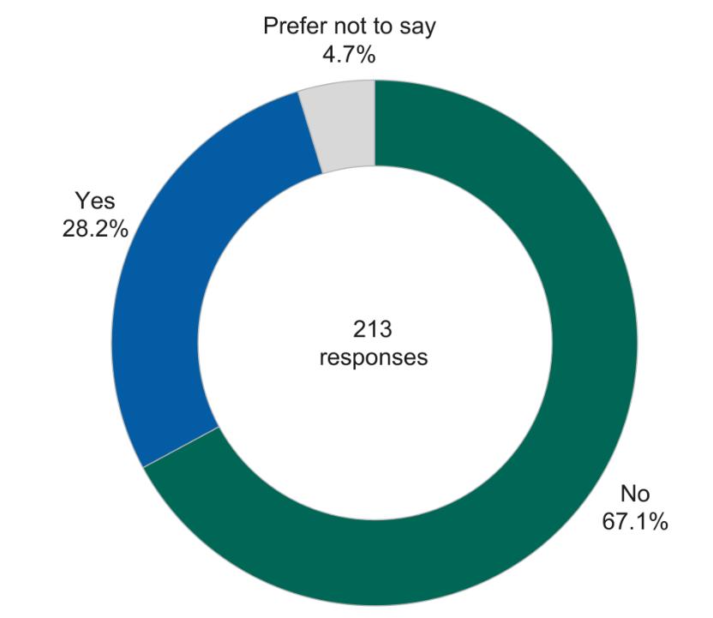
              - There were no differences between those with a disability and those without a disability for frequency of pharmacy use, reasons for choosing their pharmacy, who they use their pharmacy for, travel time and journey satisfaction or preference for when they access their pharmacy.
              - Those with a disability were less likely to walk to their pharmacy (58.3%) than those without a disability (85.2%).

Sexual Orientation
              - The majority of respondents (80.3%) identified as heterosexual/straight (n=171), with 15% preferring not to say (n=32), 2.3% identifying as a gay man (n=5), 1.9% responding as bisexual (n=4) and 0.5% reporting that they were a gay woman/lesbian (n=1) (figure 6.16).
Figure 6.16: A breakdown of sexual orientation of Richmond respondents, 2022.
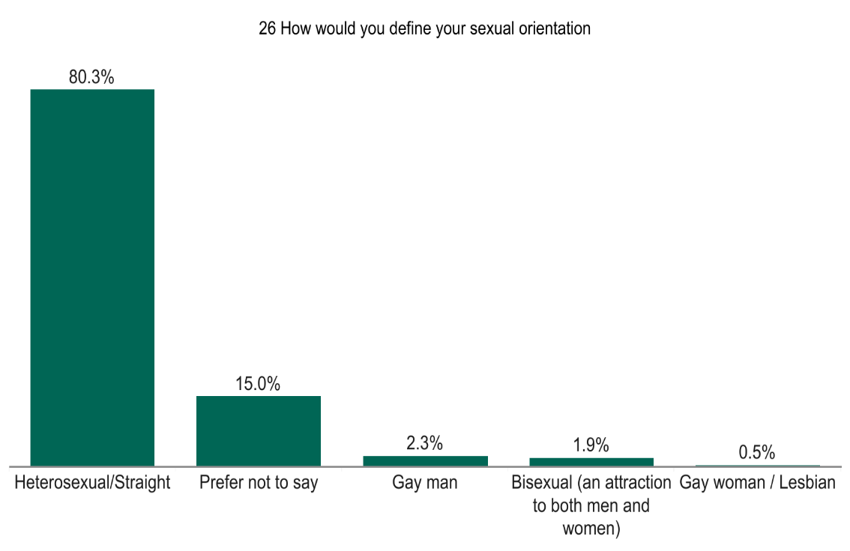
              - There were no differences between reasons for choosing a pharmacy, time taken to travel to pharmacy, method of travel, preference for when they access their pharmacy.

Relationship Status
              - A large proportion (48.8%) of respondents were married (n=104), while 35.7% were single (n=76), 10.3% preferred not to say (n=22), 3.3% were co-habiting (n=7), 0.9% were in a relationship (n=2) and 0.9% were in a civil partnership (n=2) (figure 6.17).
Figure 6.17: A breakdown of relationship status of Richmond respondents, 2022
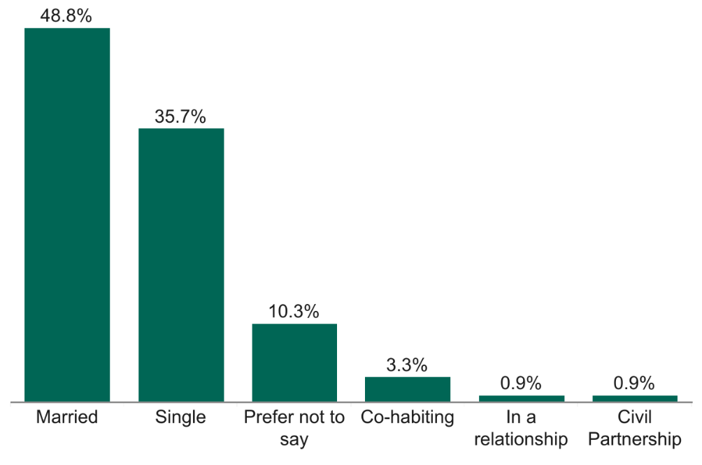
              - There were no substantial differences between relationship statuses for frequency of pharmacy use, reasons for choosing their pharmacy, who they use their pharmacy for, method of travel, travel time and journey satisfaction or preference for when they access their pharmacy.

Summary of the patient and public engagement and equality impact assessment
For patient and public engagement, a survey was carried out across Richmond to understand local people’s pharmacy use. This examined how people use their pharmacies, as well as how and when they access them. An exploration into the health needs of people with protected characteristics and vulnerable groups was also conducted from this survey.
The survey received responses from 213 residents, workers and students of Richmond. Most respondents reported using their pharmacy once a month or a few times a month, which was most commonly for themselves. Respondents typically chose their pharmacies because it is in a good location, it is where their GP sends their prescriptions and they are happy with the overall service provided.
The majority of respondents can reach their pharmacy in 5-20 minutes, with most of them opting to walk there. Most respondents were very satisfied with their journey to their pharmacy. Richmond respondents generally preferred to access their pharmacy on either a weekday or weekend, with the most popular times for this being between 9am-12pm and 2pm-5pm.
No substantial differences or identified needs were found amongst protected characteristics groups and pharmacy usage.

Provision of pharmaceutical services
              - This chapter identifies and maps the current provision of pharmaceutical services to assess the adequacy of provision of such services. The information in this chapter was collected up until February 2023.
              - The chapter assesses the adequacy of the current provision of necessary services by considering:
- Different types of pharmaceutical service providers
- Geographic distribution and choice of pharmacies, both within and bordering the borough
- Opening hours
- Dispensing
- Provision of essential, advanced, enhanced and other NHS pharmacy services

Pharmaceutical service providers
              - As of October 2022, there are 48 pharmacies in Richmond that hold NHS contracts, 45 of which are community pharmacies, and three are distance selling pharmacies. They are presented in the map in Figure 7.1 below. All the pharmacy providers in the borough as well as those within one mile of its borders are also listed in Appendix B.
Figure 7.1: Map of pharmaceutical service providers in Richmond, February 2023
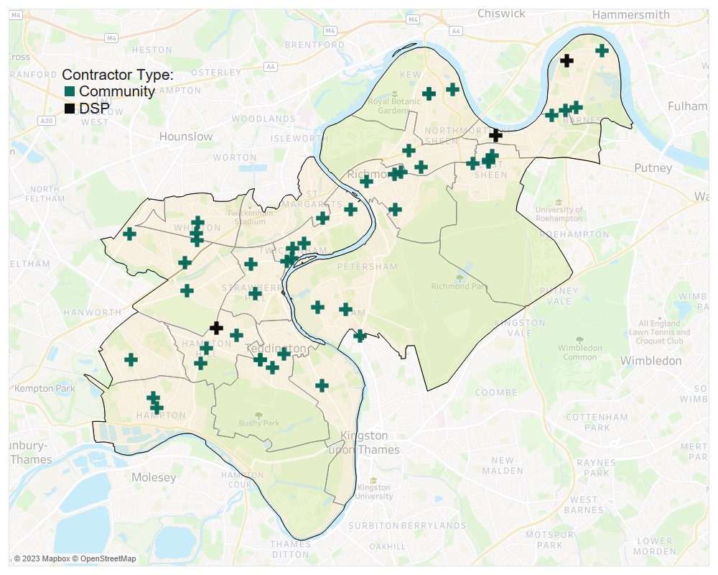
Source: NHS England, 2023

Community Pharmacies
              - The 45 community pharmacies in Richmond equate to 2.3 community pharmacies per 10,000 residents (based on a 2022 population estimate of 197,363). This ratio is above the London and England averages, both of which stand at 2.2 based on 2014 data (LGA, 2022).

Dispensing appliance contractors
              - A DAC (dispensing appliance contractor) is a contractor that specialises in dispensing prescriptions for appliances, including their customisation. They cannot dispense prescriptions for drugs. The are no DACs in Richmond’s pharmaceutical list.

GP dispensing practices
              - There are no GP dispensing practices in Richmond. Dispensing doctors provide services to patients mainly in rural areas and often where there are no community pharmacies or where access is restricted.

Distance selling pharmacies
              - Distance selling pharmacies (DSPs) are pharmacies that receive prescriptions, either electronically or via the post, dispense them at the pharmacy, then deliver them to patients through the mail or using shipping couriers. Under the 2013 regulations, they are not allowed to provide essential services on a face-to-face basis.
              - There is three DSPs in Richmond; Meds & Pills Ltd on Wellington Road, Green Cross Health on Mortlake High Street and Verdun Pharmacy on Verdun Road. Their locations are mapped on Figure 7.1.

Local pharmaceutical services
              - Local pharmaceutical services (LPS) contracts allow NHSE to commission services from a pharmacy, which are tailored to specific local requirements. No areas in Richmond have been designated as LPS areas, therefore there are no LPS contracts within Richmond.

Accessibility

Distribution and choice
              - The PNA Steering Group agreed that the maximum distance for residents of Richmond to access pharmaceutical services, should be no more than one mile. This distance equates to about a 20-minute walk.
              - Figure 7.2 below shows the 45 community pharmacies in Richmond. There are also 90 located within one mile of the borough’s border that can serve Richmond residents. All these pharmacies are listed in Appendix B. Overall, Richmond has very good coverage. The one area without pharmacy coverage, is in greenspace within Richmond Park.
Figure 7.2: Distribution of community pharmacies in Richmond and within 1 mile of the borough boundaries, with their 1-mile coverage
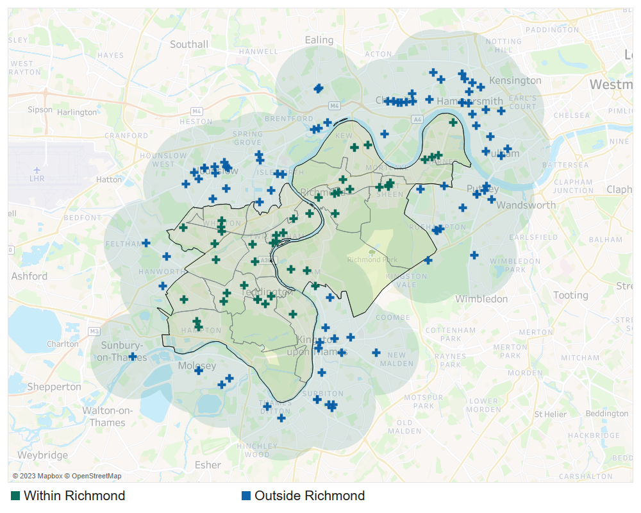
Source: NHS England, 2023
              - Additionally, all residents in Richmond can reach a pharmacy within 20 minutes using public transport, attesting to the accessibility of the pharmacy provision in the borough. Figure 7.3 presents the coverage of the Richmond pharmacies in relation to access using public transport. Coverage of the pharmacies is presented in green while Richmond is presented with an orange border. A total of 690,851 people inside and outside the borough can reach a Richmond pharmacy by public transport within 20 minutes (OHID, SHAPE Atlas Tool, 2022).

Figure 7.3: Areas covered by 20-minute travel time by public transport to a Richmond pharmacy from within and outside the borough
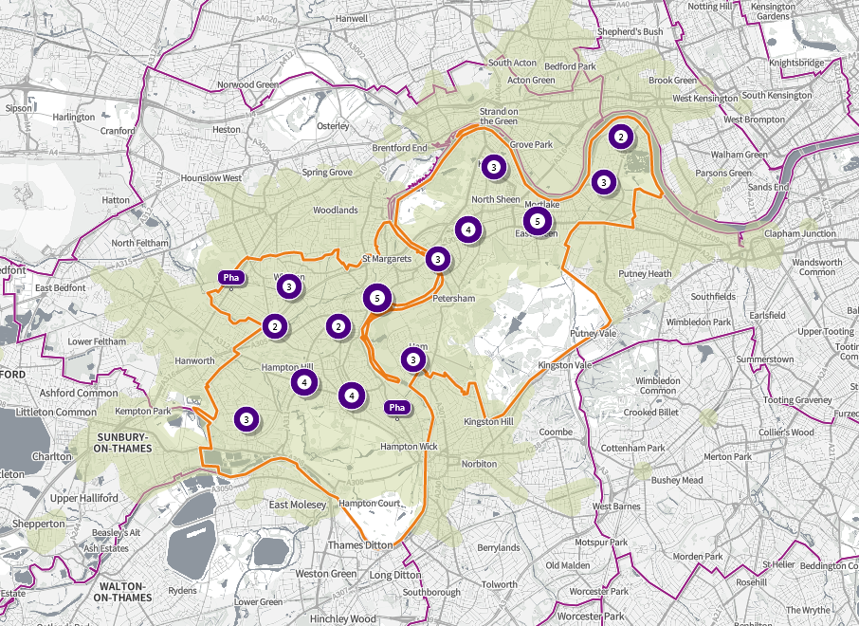
Source: OVID, Strategic Health Asset Planning and Evaluation Atlas Tool, 2022
              - The geographic distribution of the pharmacies by electoral and the pharmacy to population ratio is shown in Table 7.1. As seen, all Richmond wards have a community pharmacy within them.
Table 7.1: Distribution of community pharmacies by ward
Ward | Number of Community Pharmacies | Population Size | Community Pharmacies per 10,000
Twickenham Riverside | 4 | 11,152 | 3.6
Teddington | 4 | 10,793 | 3.7
South Richmond | 4 | 12,137 | 3.3
East Sheen | 4 | 10,693 | 3.7
South Twickenham | 3 | 10,080 | 3.0
Kew | 3 | 12,010 | 2.5
Heathfield | 3 | 10,717 | 2.8
Ham Petersham and Richmond Riverside | 3 | 11,115 | 2.7
Fulwell and Hampton Hill | 3 | 10,658 | 2.8
Barnes | 3 | 9,942 | 3.0
Whitton | 2 | 10,122 | 2.0
North Richmond | 2 | 11,905 | 1.7
Hampton | 2 | 10,350 | 1.9
West Twickenham | 1 | 10,923 | 0.9
St Margarets and North Twickenham | 1 | 12,258 | 0.8
Mortlake and Barnes Common | 1 | 11,778 | 0.8
Hampton Wick | 1 | 11,358 | 0.9
Hampton North | 1 | 9,374 | 1.1
Borough Total | 46 | 197,363 | 2.3
Source: NHSE & GLA, 2023
              - Residents tend to fill their prescriptions at local pharmacies. NHSE data shows that in 2021-22, 79.9% (2,583,278) of items prescribed by GPs in Richmond were dispensed by community pharmacies within the borough. The next largest boroughs where prescriptions from Richmond were dispensed were Hounslow (10.7%) and Surrey (1.3%).

Pharmacy distribution in relation to population density
              - Figure 7.4 shows pharmacy locations in relation to population density. It shows that there is a great amount of choice of community pharmacies in areas where the population density is higher.
Figure 7.4: Pharmacy locations in relation to population density by ward in Richmond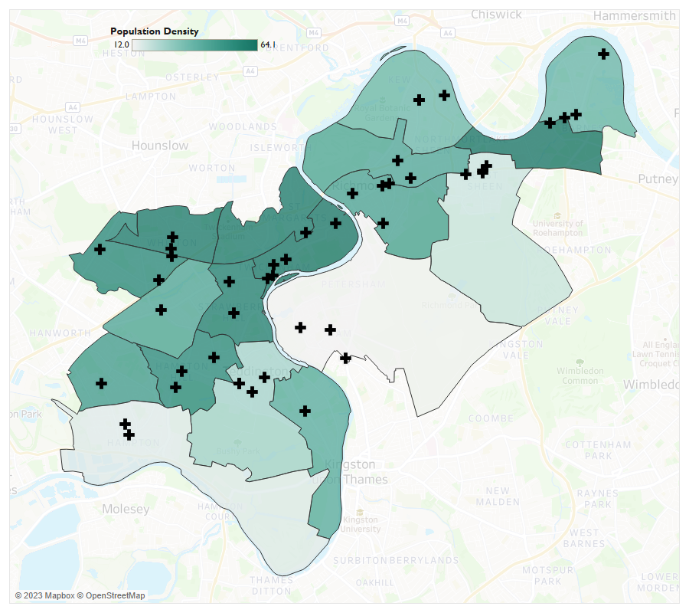

Source: GLA (Land Area, and Population Density and NHSE)
              - There are a number of new dwelling developments planned for within the lifetime of this PNA. The largest are within St. Margarets and North Twickenham Ward with 218 development units and Mortlake and Barnes Common Ward with 205 proposed development units. These are all in areas of good pharmacy provision.

Pharmacy distribution in relation to GP surgeries
              - Primary care networks are local groups of GP practices working closely with community, mental health, social care, pharmacy, hospital and voluntary services in their local areas. There are 27 GP practices within six Primary Care Networks in Richmond.
              - There is a pharmacy within an accessible distance of all GP practices in Richmond as shown in Figure 7.5.
Figure 7.5: GP practices in Richmond and their 1-mile coverage, February 2023 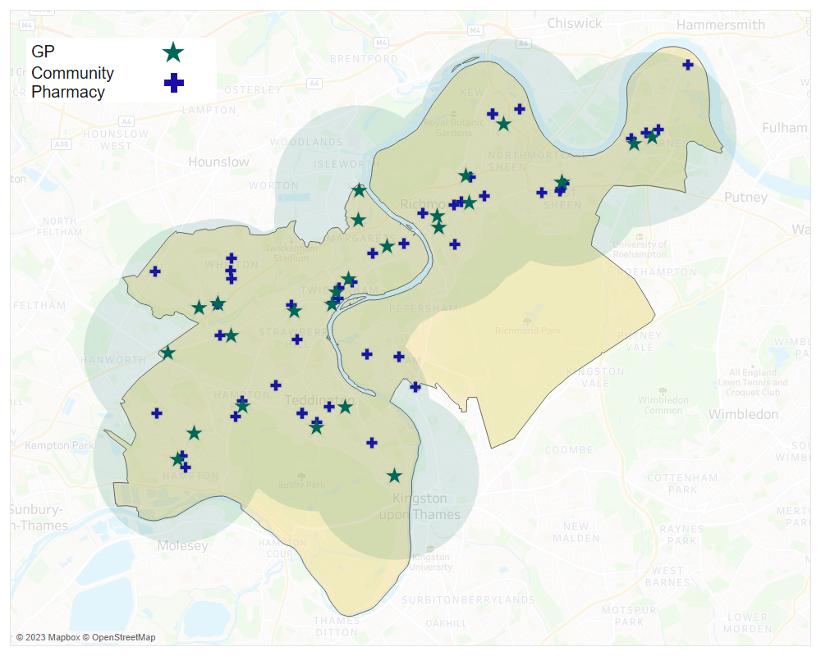
Source: NHSE, 2023
              - The PNA is not aware of any firm plans for changes in the provision of Health and Social Care services within the lifetime of this PNA.

Pharmacy distribution in relation to Index of Multiple Deprivation
              - Figure 7.6 displays pharmacy locations in relation to deprivation deciles. It shows that all areas of relatively higher deprivation are within accessible distance (1-mile) to a pharmacy.
Figure 7.6 Pharmacy locations in relation to deprivation deciles in Richmond, 2023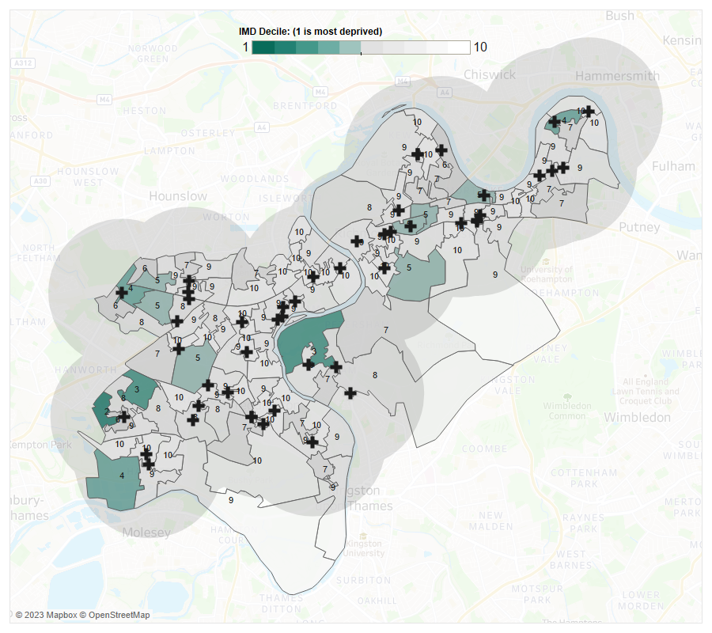
Source: MHCLG & NHSE

Opening Times
              - Pharmacy contracts with NHS England stipulate the core hours during which each pharmacy must remain open. Historically these have been 40-hour contracts (and some recent 100-hour contracts). A pharmacy may stay open longer than the stipulated core opening hours; these are called supplementary hours. Opening hours were obtained from NHS England in October 2022.

100-hour pharmacies
              - NHS England do not have any 100-hour pharmacies (core hours) on their list for Richmond. However, there are five 100-hour pharmacies which are outside the borough, but within 1 mile of its border (Figure 7.7).
Figure 7.7: 100-hour pharmacies and their 1-mile coverage, October 2022
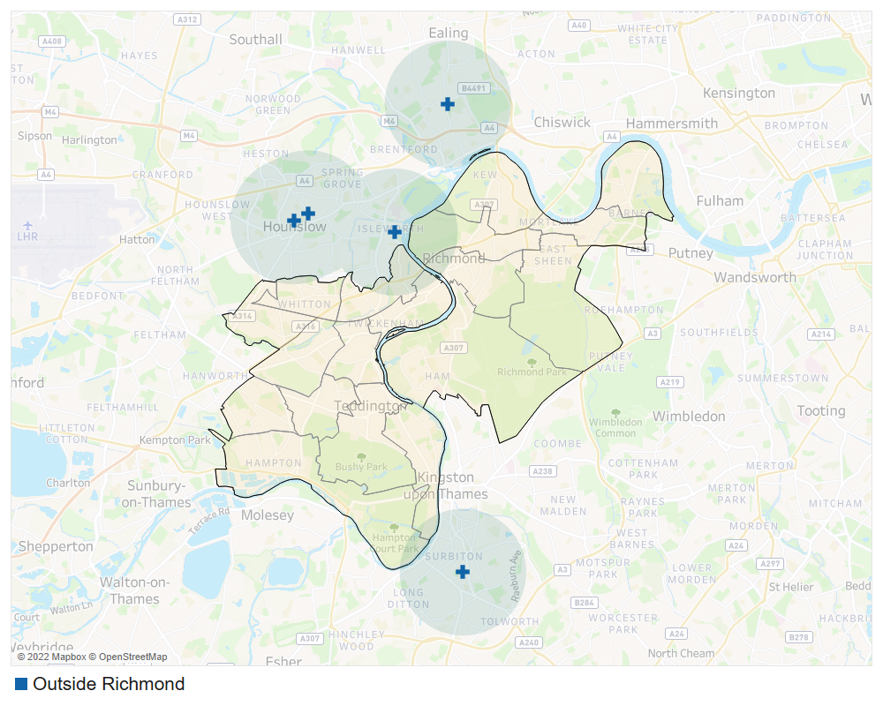
Source: NHSE, 2022

Early morning opening
              - Three pharmacies are open before 9am on weekdays within the borough, with another 29 that are within 1 mile of the borough’s border. These are shown in Figure 7.8 and Table 7.2.
Pharmacies that are open before 9am on weekdays and their 1-mile coverage, February 2023 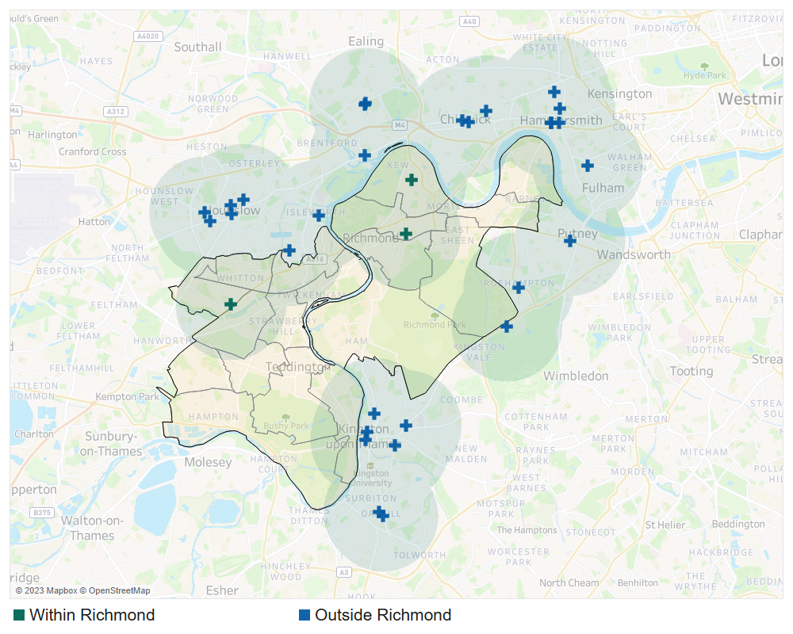
Source: NHSE, 2023
Table 7.2: Community pharmacies open before 9am on weekdays in Richmond
Pharmacy | Address | Ward
Lloydspharmacy | J Sainsbury's Store, Manor Road, Lower Richmond Road | North Richmond
Whitton Corner Pharmacy | Whitton Community H/C, Percy Road, Whitton, Twickenham | Heathfield
Pyramid Pharmacy | 19-21 Station Parade, Kew, Richmond | Kew
Source: NHSE, 2023

Late evening closure
              - There are three pharmacies in the borough that are still open after 7pm on weekdays, with 14 other pharmacies within 1 mile of Richmond (Figure 7.9 and Table 7.3).
Figure 7.9: Community Pharmacies that are open after 7pm on weekdays and their 1-mile coverage, February 2023
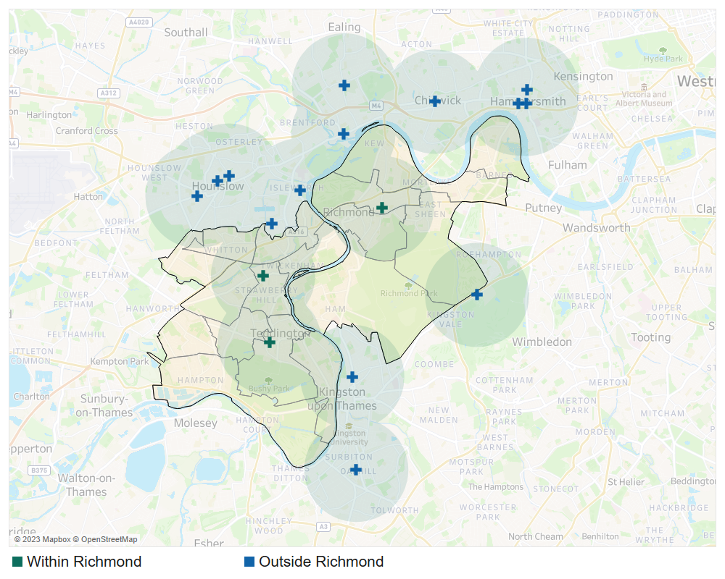
NHSE, 2023
Table 7.3: Community pharmacies closing after 7pm on weekdays in Richmond
Pharmacy | Address | Ward
Lloydspharmacy | J Sainsbury's Store, Manor Road, Lower Richmond Road | North Richmond
Kc Pharmacy | 23 Broad Street, Teddington, Middlesex | Teddington
Maple Leaf Pharmacy | 20 The Green, Twickenham | South Twickenham
Source: NHSE, 2023
              - In terms of travel distance, 100% of Richmond residents live within 20-minute’s reach of an early opening and late closing pharmacy by public transport (OHID, SHAPE Atlas Tool, 2022).

Saturday opening
              - A vast majority of the community pharmacies in Richmond (42/45) have Saturday opening hours. There are an additional 80 near the borough’s borders that are also open on Saturday (Figure 7.10 and Table 7.4).
Figure 7.10: Community Pharmacies open on Saturday and their 1-mile coverage, February 2023
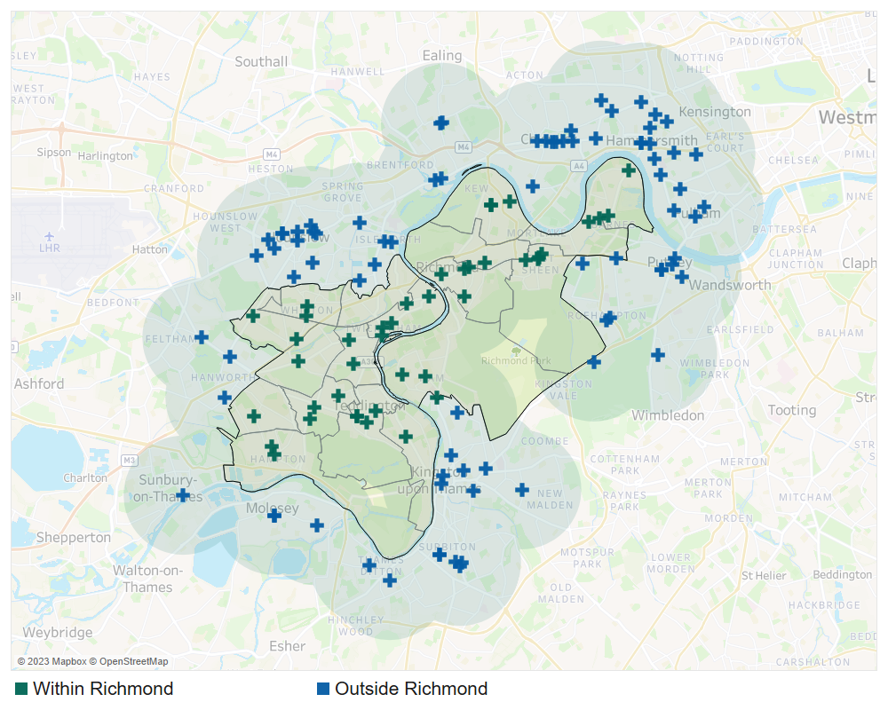
Source: NHSE, 2023
Table 7.4: Number of Community Pharmacies open on Saturday in Richmond by Ward, February 2023
Ward | Number of Community Pharmacies
Twickenham Riverside | 4
Teddington | 4
South Richmond | 4
East Sheen | 4
Kew | 3
Ham, Petersham & Richmond Riverside | 3
Fulwell & Hampton Hill | 3
Barnes | 3
South Twickenham | 2
Whitton | 2
Heathfield | 2
Hampton | 2
West Twickenham | 1
St Margarets & North Twickenham | 1
North Richmond | 1
Mortlake & Barnes Common | 1
Hampton Wick & South Teddington | 1
Hampton North | 1
Source: NHSE, 2023

Sunday opening
              - Nine pharmacies are open on a Sunday within the borough, with another 20 open in boroughs around Richmond within 1 mile of its border (Figure 7.11 and Table 7.5).

Figure 7.11: Pharmacies open on a Sunday and their 1-mile coverage, February 2023
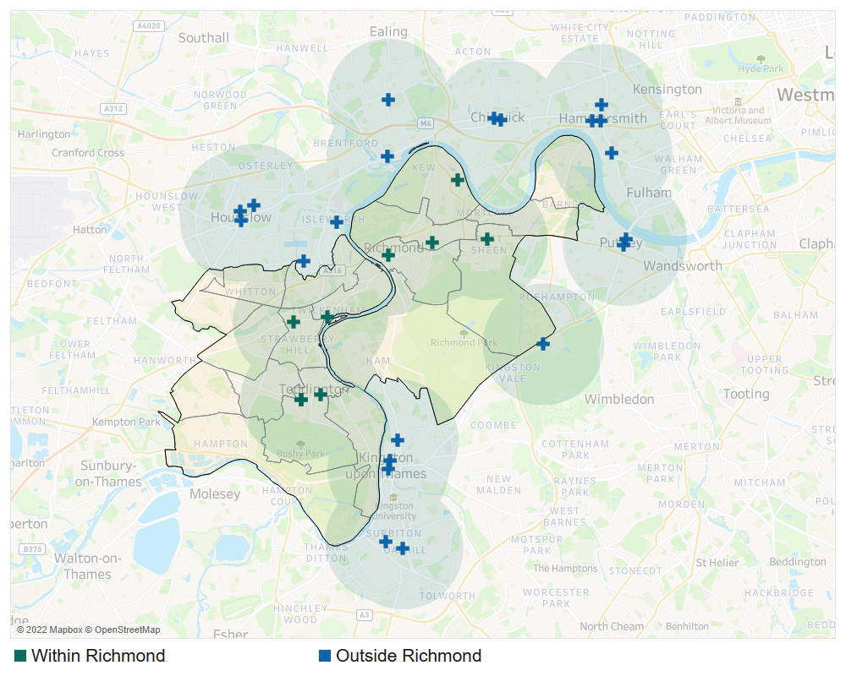

Source: NHSE, 2023
Table 7.5: Community Pharmacies open on Sunday in Richmond, February 2023
Pharmacy | Address | Ward
Boots | 381-383 Upper Richmond Rd, East Sheen | East Sheen
Boots | 61/64 George Street, Richmond, Surrey | South Richmond
Lloydspharmacy | J Sainsbury’s Store, Manor Road, Lower Richmond Road | North Richmond
Kirby Chemist | 53 High Street, Teddington, Middlesex | Teddington
Boots | Unit 4, Kew Retail Park, Bessant Drive, Kew, Richmond | Kew
Kc Pharmacy | 23 Broad Street, Teddington, Middlesex | Teddington
Boots | 3 King Street, Twickenham, Middlesex | Twickenham Riverside
Boots | 59 Broad Street, Teddington | Teddington
Maple Leaf Pharmacy | 20 The Green, Twickenham | South Twickenham
Source: NHSE, 2023
              - Overall, as shown in Figure 7.12, there is a good range of Sunday opening hours offered to Richmond residents.
Figure 7.12: Sunday opening times of community pharmacies
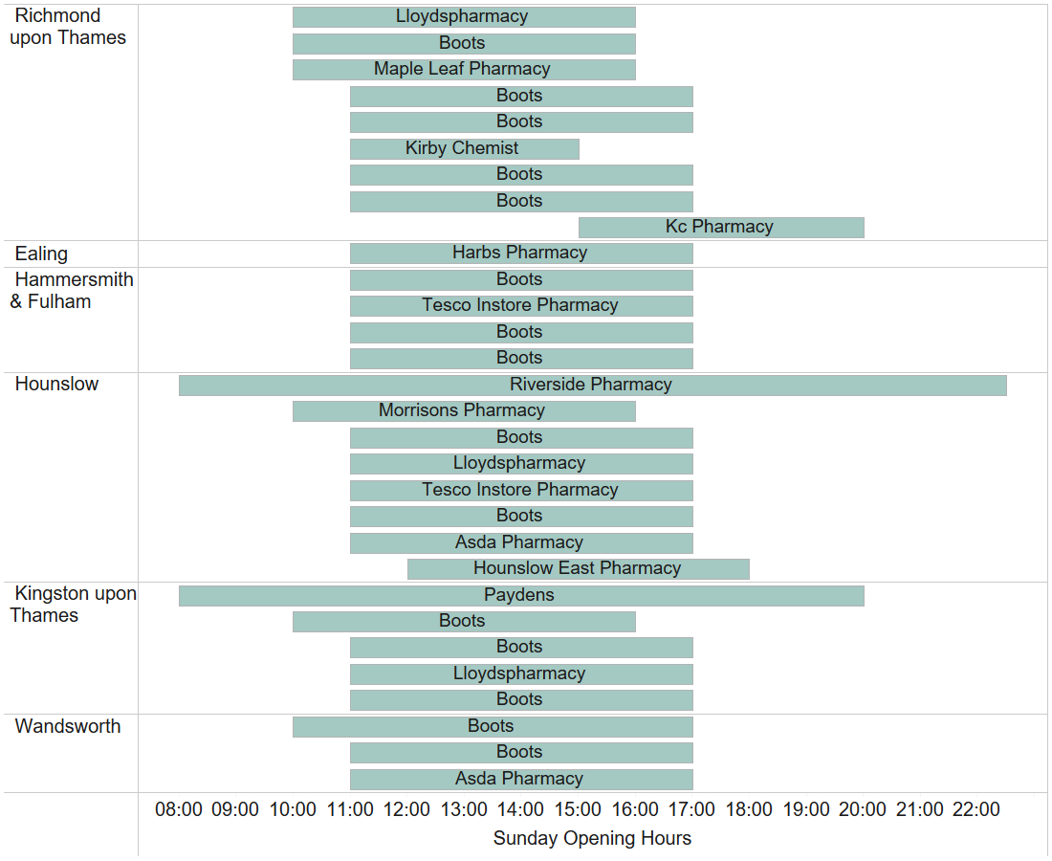
Source: NHSE, 2023
              - All Richmond residents can reach a Saturday and Sunday opening pharmacy in 20 minutes if travelling by public transport (OHID, SHAPE Atlas Tool, 2022).

Essential services
              - Essential services are offered by all pharmacy contractors as part of the NHS Community Pharmacy Contractual Framework. All pharmacy contractors are required to deliver and comply with the specifications for all essential services. These are:
- Dispensing Medicines
- Dispensing Appliances
- Repeat Dispensing
- Clinical governance
- Discharge Medicines Service
- Promotion of Healthy Lifestyles
- Signposting
- Support for self-care
- Disposal of Unwanted Medicines

Dispensing
              - Richmond pharmacies dispense an average of 4,987 items per month (based on NHS Business Services Authority, 2021/22 financial year data). This is below both the London average of 5,295 per month as well as the England average of 6,675 per month, indicating there is good capacity amongst Richmond pharmacies to fulfil current and anticipated need in the lifetime of the PNA.

Summary of the accessibility pharmacy services and of essential services
Overall, there is good pharmacy coverage to provide essential services across the borough both inside working hours and outside normal working hours.

Advanced pharmacy services
              - Advanced services are NHS England commissioned services that community pharmacy contractors and dispensing appliance contractors can provide subject to accreditation as necessary. The following services may be provided by pharmacies:
- new medicine service
- community pharmacy seasonal influenza vaccination
- community pharmacist consultation service
- hypertension case-finding service
- community pharmacy hepatitis C antibody testing service, and
- community pharmacy smoking cessation service
              - There are two appliance advanced services that pharmacies and dispensing appliance contractors may choose to provide:
- appliance use reviews, and
- stoma appliance customisation

New medicines service
              - The new medicine service (NMS) supports patients with long-term conditions, who are taking a newly prescribed medicine, to help improve medicines adherence.
              - This service is designed to improve patients’ understanding of a newly prescribed medicine for their long-term condition, and to help them get the most from the medicine. It aims to improve adherence to new medication, focusing on people with specific conditions, including (to name a few):
- Asthma and COPD
- Type 2 diabetes
- Antiplatelet or anticoagulation therapy
- Hypertension
              - New Medicines Service can only be provided by pharmacies and is conducted in a private consultation area to ensure patient confidentiality.
              - 40 pharmacies in Richmond provided NMS in 2021/22. There were an additional 77 pharmacies in bordering boroughs that provided the service. All of these pharmacies are shown in Figure 7.13 and table 7.6 below.
Figure 7.13: Pharmacies providing NMS and their 1-mile coverage, February 2023 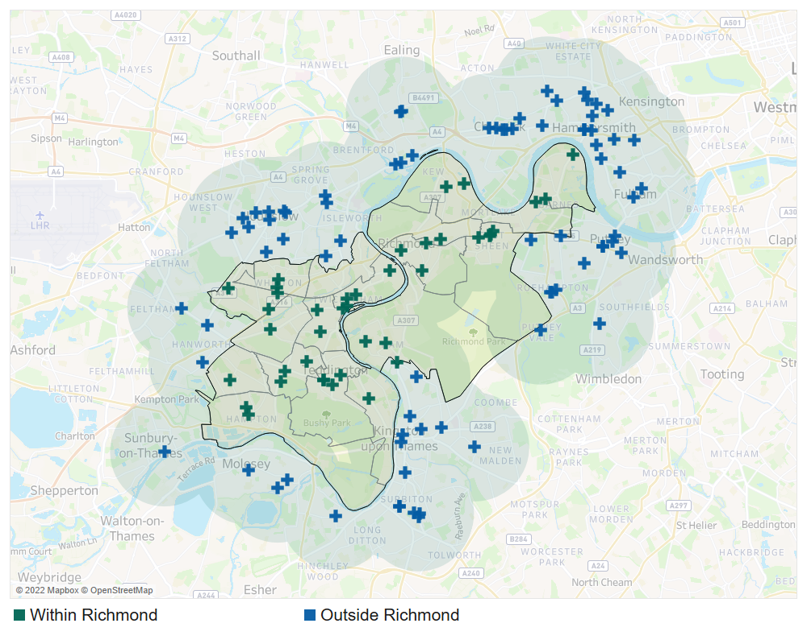
Source: NHSE, 2023
Table 7.6: Number of NMS provided by Richmond pharmacies by ward, 2021/22
Ward | Number of Pharmacies | Total Number of NMSs provided | Average Number per pharmacy
South Twickenham | 3 | 609 | 203
South Richmond | 3 | 604 | 201
Ham, Petersham & Richmond Riverside | 3 | 395 | 132
Heathfield | 3 | 315 | 105
Teddington | 4 | 275 | 69
Twickenham Riverside | 4 | 232 | 58
East Sheen | 4 | 221 | 55
West Twickenham | 1 | 170 | 170
Hampton | 2 | 169 | 85
Whitton | 2 | 154 | 77
Mortlake & Barnes Common | 1 | 126 | 126
Barnes | 2 | 107 | 54
Kew | 2 | 102 | 51
Fulwell & Hampton Hill | 3 | 85 | 28
Hampton Wick & South Teddington | 1 | 65 | 65
Hampton North | 1 | 50 | 50
North Richmond | 1 | 26 | 26
Total | 40 | 3,705 | 93
Source: NHSE, 2023
              - NMS is supplied widely across the borough within areas of high density and need; therefore, the current provision of NMS is sufficient to meet the needs of Richmond’s population.

Community pharmacy seasonal influenza vaccination
              - Flu vaccination by injection, commonly known as the "flu jab" is available every year on the NHS to protect certain groups who are at risk of developing potentially serious complications, such as:
- anyone over the age of 65
- pregnant women
- children and adults with an underlying health condition (particularly long-term heart or respiratory disease)
- children and adults with weakened immune systems
              - GPs currently provide majority of the flu vaccinations, and pharmacies can help improve access to this service given their convenient locations, extended opening hours and walk-in service. The National Advanced Flu Service is an advanced service commissioned by NHS England to maximise the uptake of the flu vaccine by those who are ‘at-risk’ due to ill-health or long terms condition.
              - A large proportion of community pharmacies in the borough provided flu vaccines (38/45) in Richmond in 2021/22. Another 72 outside but bordering the borough provided the service. The distribution of these pharmacies is shown in Figure 7.14 and Table 7.7.
Figure 7.14: Pharmacies providing Flu vaccination and their 1-mile coverage October 2022 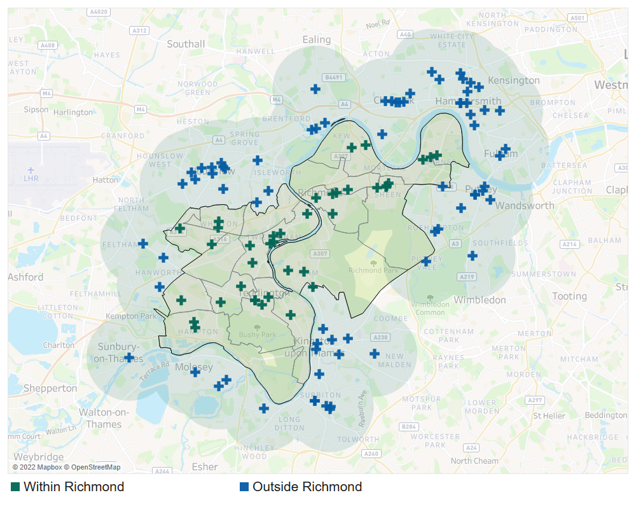
Source: NHSE, 2022
Table 7.7: Pharmacies that provide Flu vaccinations in Richmond by ward, February 2023
Ward | Number of Pharmacies
Twickenham Riverside | 4
Teddington | 4
South Richmond | 4
East Sheen | 4
South Twickenham | 3
Ham, Petersham & Richmond Riverside | 3
Whitton | 2
Kew | 2
Heathfield | 2
Hampton | 2
Fulwell & Hampton Hill | 2
Barnes | 2
North Richmond | 1
Mortlake & Barnes Common | 1
Hampton Wick & South Teddington | 1
Hampton North | 1
Total | 38
 | Source: NHSE, 2023

              - Overall, there is strong coverage of this service across Richmond. Therefore, the current provision Advanced Flu Service is sufficient to meet the needs of this borough.

Community pharmacist consultation service
              - The community pharmacist consultation service (CPCS) is a new service provided by pharmacies, launched in October 2019. The aims of the service are to support the integration of community pharmacy into the urgent care system, and to divert patients with lower acuity conditions or who require urgent prescriptions from the urgent care system to community pharmacies.
              - It also offers patients who contact NHS 111 the opportunity to access appropriate urgent care services in a convenient and easily accessible community pharmacy setting, on referral from an NHS 111 call advisor and via the NHS 111 Online service.
              - There is strong coverage of CPCS in Richmond. 30 pharmacies in the borough provided CPCS in 2021/22. There are an additional 70 pharmacies in neighbouring boroughs that provided the service (Figure 7.15 and Table 7.8).
Figure 7.15: Pharmacies providing CPCS and their 1-mile coverage, February 2023 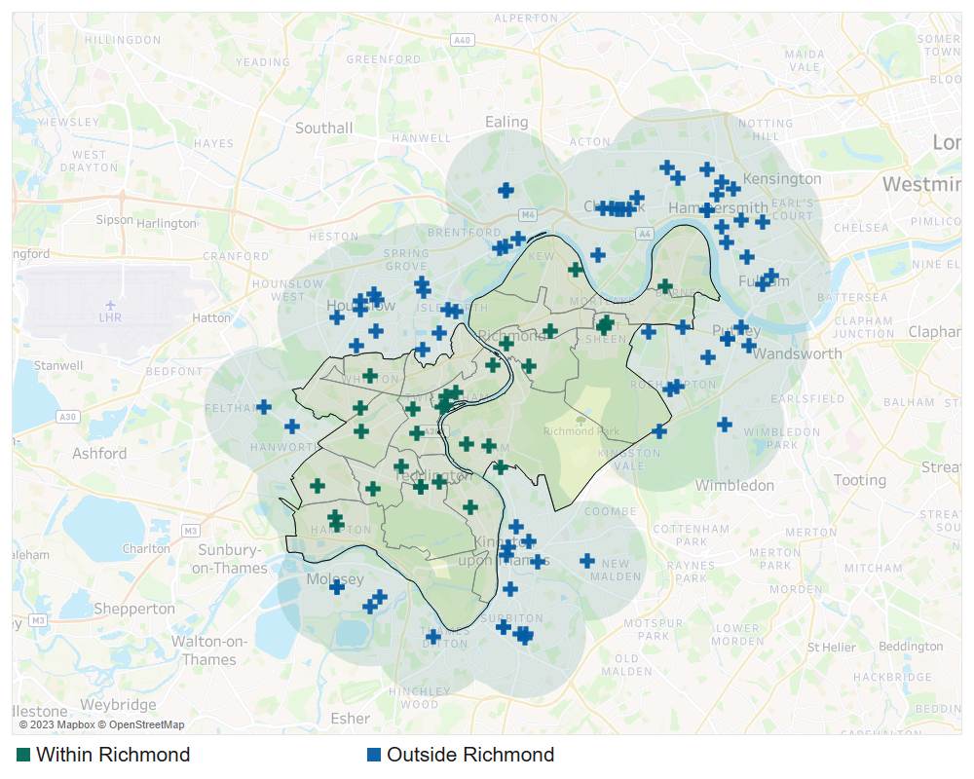
Source: NHSE, 2023

Table 7.8: Pharmacies that provide CPCS in Richmond by ward, October 2022
Ward | Number of Pharmacies
Twickenham Riverside | 4
South Twickenham | 3
Teddington | 3
Ham, Petersham & Richmond Riverside | 3
East Sheen | 3
South Richmond | 2
Hampton | 2
Fulwell & Hampton Hill | 2
Whitton | 1
West Twickenham | 1
North Richmond | 1
Kew | 1
Heathfield | 1
Hampton Wick & South Teddington | 1
Hampton North | 1
Barnes | 1
Total | 30
Source: NHSE, 2022

Hypertension case-finding service
              - Hypertension case-finding service is a relatively new service and at the time of publication, 16 pharmacies indicated in the contractor survey that they deliver this service.

Community pharmacy hepatitis C antibody testing service
              - NHSE data did not show any pharmacy offering community pharmacy hepatitis C antibody testing service as of the time of publication as this is a new service. However, all pharmacies can deliver this service if they choose to.

Community pharmacy smoking cessation service
              - This service was introduced in March 2022 as an Advanced Service for patients who started their stop-smoking journey in hospital. This service is identified as a key service to improve the prevention of avoidable illness.
              - Nine pharmacies indicated in the contractor survey that they deliver this service. A further 14 indicated a willingness to provide this service.

Appliance use reviews
              - Appliance use reviews (AUR) is another advanced service that community pharmacy and appliance contractors can choose to provide, so long as they fulfil certain criteria.
              - AURs can be carried out by a pharmacist or a specialist nurse, either at the contractor’s premises or at the patient's home. AURs help patients to better understand and use their prescribed appliances by:
- Establishing, the way the patient uses the appliance and the patient's experience of such use
- Identifying, discussing, and assisting in the resolution of poor or ineffective use of the appliance by the patient
- Advising the patient on the safe and appropriate storage of the appliance
- Advising the patient on the safe and proper disposal of the appliances that are used or unwanted.
              - Two pharmacies indicated in the contractor survey that they provide this service in Richmond and a further 11 pharmacies indicated they would be willing to provide this service if there is a need. AURs are also typically provided by prescribing health and social care providers.

Stoma appliance customisation service
              - The stoma appliance customisation (SAC) service involves the customisation of a quantity of more than one stoma appliance, based on the patient's measurements or a template. The aim of the service is to ensure proper use and comfortable fitting of the stoma appliance and to improve the duration of usage, thereby reducing waste.
              - Two pharmacies, Charles Harry Pharmacy on Richmond Road, and Lloyds Pharmacy on Station Parade, Kew, provided SACs within Richmond in 2021/22.
              - Residents can also access the SAC service either from non-pharmacy providers within the borough (e.g., community health services) or from dispensing appliance contractors outside of the borough. Therefore, the current provision of SAC service is sufficient to meet the needs of this borough.

Summary of the Advanced Pharmacy Services
It is concluded that there is currently sufficient provision for the following advanced services to meet the likely needs of residents in Richmond:
- New medicine service
- Community pharmacy seasonal influenza vaccination
- Community pharmacist consultation service
- Hypertension case-finding service
- Community pharmacy hepatitis C antibody testing service
- Community pharmacy smoking cessation service
- Appliance use reviews
- Stoma Appliance Customisation service

Enhanced pharmacy services
              - NHSE&I currently commission three locally enhanced services in the London Region. These are the London Seasonal Influenza Vaccination Service, the Bank Holiday Rota Service, and the COVID-19 Vaccination Service.

London seasonal influenza vaccination service
              - This service is commissioned by NHSE&I London Region to enhance the delivery of flu vaccination coverage already delivered by the Advanced Flu Service. Any pharmacy in London can chose to deliver this service. They also offer provision for pneumococcal vaccination to eligible cohorts and MenACWY for 18–24-year-olds living permanently or temporarily in London.
              - The aims of the service are to:
- sustain and maximise uptake of flu vaccine in at-risk groups by continuing to build the capacity of community pharmacies as an alternative to general practice attendance
- to provide more opportunities and improve convenience for eligible patients to access flu vaccinations
- include provision of flu vaccinations to a wider patient group, including carers, asylum seekers and the homeless and children from 2 to 18 years.
              - As at the time of publication, NHSE data was not yet available for this service. However, as identified in Chapter 5, the uptake of flu vaccination by the ‘at risk’ population is low in Richmond. Commissioners should work with existing pharmacy provision to improve vaccination coverage with this group.

Bank holiday rota service
              - To ensure pharmacy services are available during bank holidays, NHSE&I commission pharmacies to open during bank holidays on a rota basis as an enhanced service. This also ensures pharmacies are accessible to other out-of-hours providers, thus enabling patients to easily access medication if required.
              - One pharmacy provides this service in Richmond: K C Pharmacy, Teddington.

COVID-19 vaccination service
              - NHSE&I commissioned pharmacies to provide the COVID-19 vaccine service. The purpose of this commissioned service is to maximise uptake of the COVID-19 vaccine and improve availability of choice and convenience for patients, in their accessible locations. This service is commissioned as and when required. At the time of the production of this PNA, three pharmacies in Richmond provide COVID-19 vaccinations.

Summary of other NHS pharmacy services
It is concluded that there is currently sufficient provision for the following Enhanced pharmacy services to meet the likely needs of residents in Richmond:
- London Seasonal Influenza Vaccination Service
- Bank Holiday Rota Service
- COVID-19 Vaccination Service

Other NHS pharmacy services
              - Other NHS pharmacy services are services commissioned by the London Borough of Richmond upon Thames and Southwest London (SWL) ICB to fulfil a local population health and wellbeing need. The Richmond enhanced services are listed below:
- Local authority commissioned services:
  - Needle exchange service
  - Supervised consumption service
  - Emergency contraception service
  - Chlamydia screening service
  - Chlamydia treatment service
- SWL ICB commissioned services:
  - Out of Hours Palliative Care Dispensing & Medicines Advice
The provision of these services is explored below.

Needle exchange service
              - The London Boroughs of Richmond commissioned this service to address the needs of problematic drug users and improve their health and social outcomes.
              - Community based needle exchanges are an important and easily accessible public health intervention. They help prevent the spread of blood borne diseases such as HIV and hepatitis and other drug related harm, including drug related deaths. Drug users who use this service are often not in touch with other specialist treatment drug services.
              - The overall aim of the service is to contribute to health protection and health improvement needs of individuals who inject drugs (including but not restricted to opiates, stimulants, new psychoactive substances and performance and image enhancing drugs). Minimising wider community harms linked to unsafe use and disposal of injecting equipment is an integral component of national and local harm reduction strategies.
              - The service objective is to provide a comprehensive open access healthcare package through the provision of needle exchange outlets through community pharmacies, by:
- Embracing and addressing the principles of harm reduction, including the education and training of service users and their significant others on overdose prevention and management, the use of Naloxone and the availability of injecting paraphernalia
- Providing service users with a fair and dignified service, irrespective of their ethnic/cultural background, gender, sexual orientation, employment status, religious beliefs, HIV/Hepatitis status or current drug treatment status
- Providing value for money, with the “best value” principle being applied to each decision about care. This will not override a service user’s social or healthcare needs, but will work in conjunction with these
- ensuring that all participating services are resourced in a timely fashion and that public health alerts are disseminated rapidly and effectively, and
- ensuring that the manner and content of service delivery is based upon sound research, best practice principles and practitioner experience.
              - There are six pharmacies in Richmond that provide this service. These are presented in Figure 7.16 and listed in Table 7.7. They are all based in South Richmond. There is opportunity for commissioners to work with existing pharmacy provision to widen the offer of the needle exchange service in North Richmond.
Figure 7.16: Location of pharmacies that provide the needle exchange service in Richmond, 2022
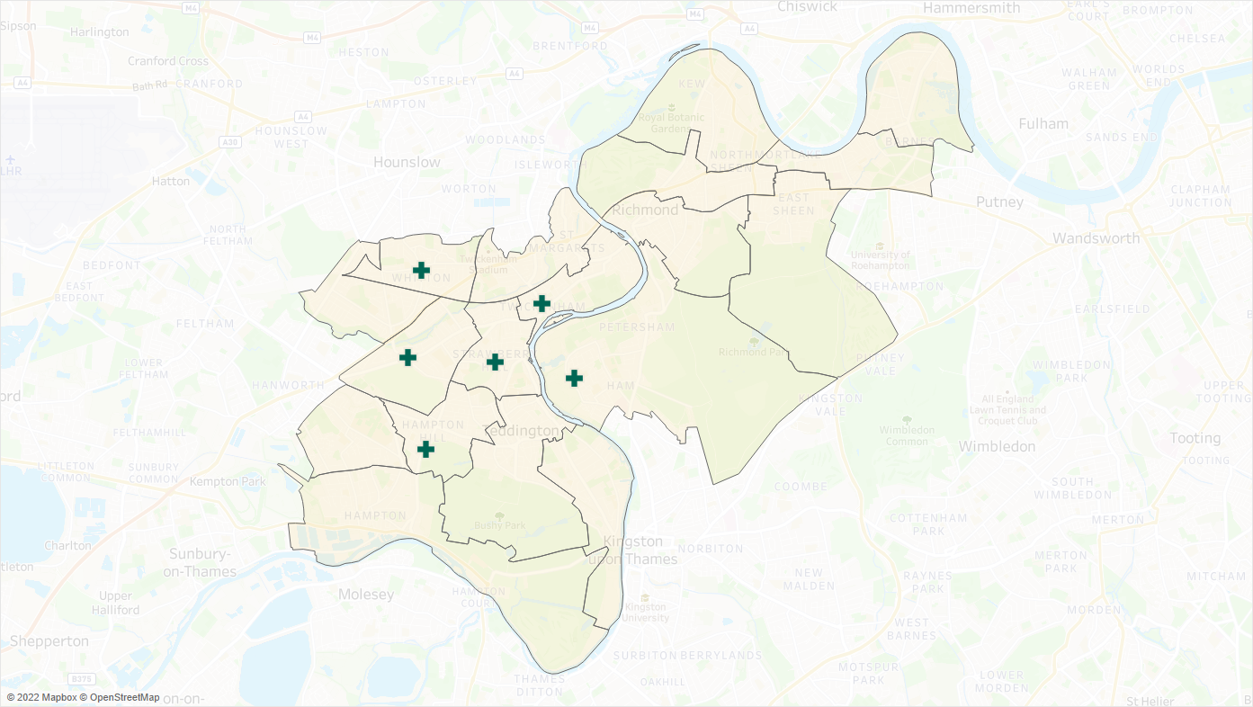
Source: London Borough of Richmond, 2022
Table 7.7: Pharmacies that provide the needle exchange services in Richmond, 2022
Pharmacy | Address | Ward
Cross Roads Pharmacy | 334 Staines Road, Twickenham, Middlesex | West Twickenham
Brightlife Chemist | 3 Wellesley Parade, Strawberry Hill, Twickenham, Middlesex | South Twickenham
Minal Pharmacy | 9 High Street, Whitton, Middlesex, | Whitton
Kanset Pharmacy | 177 Ashburnham Road, Ham, Richmond, Surrey | Ham, Petersham & Richmond Riverside
Goode C Pharmacy | 22 London Road, Twickenham, Middlesex | Twickenham Riverside
Health On The Hill | 62 High Street, Hampton Hill, Middlesex, | Fulwell & Hampton Hill
Source: London Borough of Richmond, 2022

Supervised consumption service
              - The London Borough of Richmond also commission pharmacies to deliver a supervised consumption service. This service enables drug users to access pharmacologically assisted treatment, to aid their recovery from addiction to opioids. It supports service-user compliance with a prescribed regime by supervised consumption of Methadone, Buprenorphine and Buprenorphine with Naloxone / Buprenorphine Oral Lyophilisate (Espranor) and other prescribed medicines.
              - The purpose of this service is to minimise misuse of controlled drugs leading to a reduction of drug related deaths in the community due to opioid toxicity.
              - Eleven pharmacies in Richmond provide this service. These are presented in Figure 7.17 and Table 7.8.
Figure 7.17: Location of pharmacies that provide the supervised consumption service in Richmond, 2022
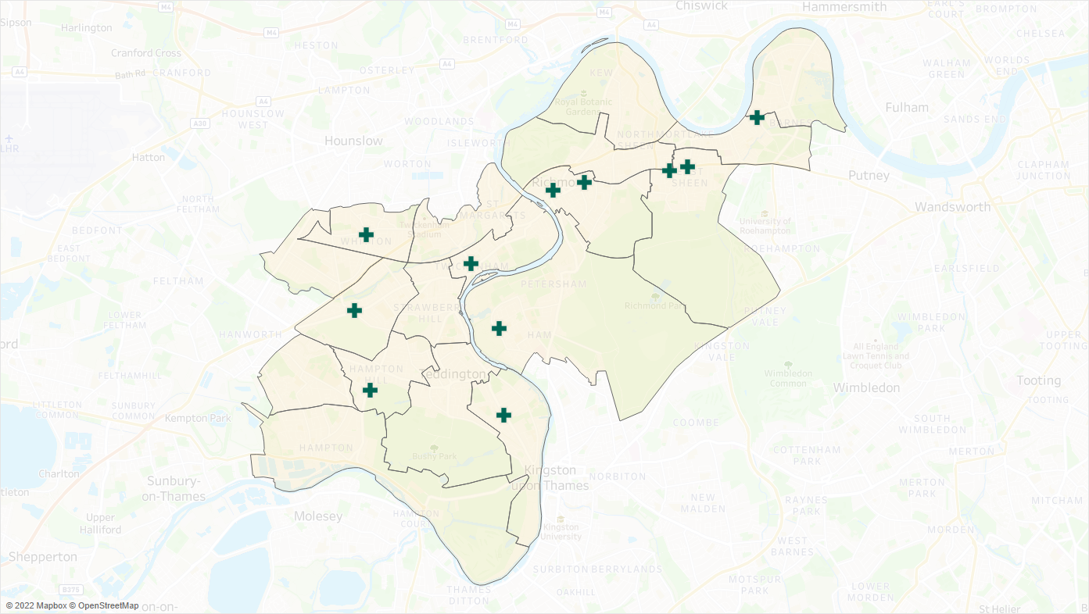Source: London Borough of Richmond, 2022

Table 7.8: Pharmacies that provide the supervised consumption services in Richmond, 2022
Pharmacy | Address | Ward
Cross Roads Pharmacy | 334 Staines Road, Twickenham, Middlesex | West Twickenham
Superdrug Pharmacy | Unit 2 The Bull, 262 Upper Richmond Road, East Sheen, London | East Sheen
Herbert & Shrive | 208 Kingston Road, Teddington, Middlesex | Hampton Wick & South Teddington
Boots | 61/64 George Street, Richmond, Surrey | South Richmond
Minal Pharmacy | 9 High Street, Whitton, Middlesex, | Whitton
Dumlers Pharmacy | 495-497 Upper Richmond, Road West, East Sheen, London | East Sheen
Barnes Pharmacy | 5 High Street, Barnes, London | Mortlake & Barnes Common
Kanset Pharmacy | 177 Ashburnham Road, Ham, Richmond, Surrey | Ham, Petersham & Richmond Riverside
Richmond Pharmacy | 82-86 Sheen Road, Richmond, Surrey | South Richmond
Goode C Pharmacy | 22 London Road, Twickenham, Middlesex | Twickenham Riverside
Health On The Hill | 62 High Street, Hampton Hill, Middlesex, | Fulwell & Hampton Hill
Source: London Borough of Richmond, 2022

Emergency contraception service
              - The provision of Emergency Contraception (EC) to women plays an important role in the prevention of unplanned pregnancies by reducing the risk of pregnancy after unprotected sexual intercourse.
              - Pharmacies provide an excellent opportunity to reach young people due to their high street location, long opening hours and non-medical setting.
              - The aim of the service is to improve access to emergency contraception via Patient Group Directions (PGD) in community pharmacies to support work to reduce unplanned pregnancies in Richmond. Its objectives include:
- To increase access to emergency contraception to people aged 13 and above.
- To increase knowledge, especially among young people, of all types of contraception, including EC and Long-Acting Reversible Contraception (LARC).
- To reach sexually active young people who do not access their General Practitioner or Integrated Sexual Health Services (ISH).
- Improve the sexual health of young people by integrating EC with other related services including chlamydia and gonorrhoea screening / treatment and provision of free condoms.
- To safeguard children and vulnerable adults who are experiencing or may have experienced abuse and/or sexual exploitation.
- To situate the provision of EC in community pharmacies within the wider landscape of sexual health and contraception provision in the borough to ensure smooth pathways both to and from ISH including Sexual Health London so that patients get the appropriate level of care to meet their needs at the right level of service.
- To increase partnership working between community pharmacists and other providers including general practitioners, ISH Services, and Safeguarding Agencies.
              - Sixteen pharmacies provide this service in Richmond. These are presented in Figure 7.18 and Table 7.9.
Figure 7.18: Location of pharmacies that provide emergency contraception service in Richmond, 2022
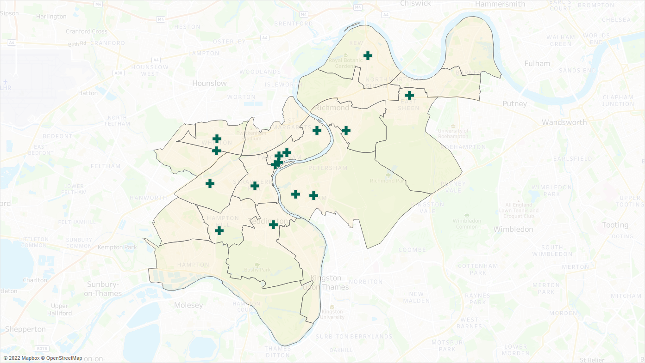
Source: London Borough of Richmond, 2022
Table 7.9: Pharmacies that provide emergency contraception services in Richmond, 2022
Pharmacy | Address | Ward
Cross Roads Pharmacy | 334 Staines Road, Twickenham, Middlesex | West Twickenham
Kew Pharmacy | 3 Station Parade, Kew Gardens, Richmond, Surrey | Kew
Brightlife Chemist | 3 Wellesley Parade, Strawberry Hill, Twickenham, Middlesex | South Twickenham
Minal Pharmacy | 9 High Street, Whitton, Middlesex, | Whitton
Twickenham Pharmacy | 17 Richmond Road, Twickenham, Middlesex | Twickenham Riverside
Pharmacare | 12 Back Lane, Ham, Richmond, Surrey | Ham, Petersham & Richmond Riverside
Spatetree Pharmacy | 113 Sheen Lane, East Sheen, London | East Sheen
Kirby Chemist | 53 High Street, Teddington, Middlesex | Teddington
Kanset Pharmacy | 177 Ashburnham Road, Ham, Richmond, Surrey | Ham, Petersham & Richmond Riverside
Day Lewis Pharmacy | 1 Cross Deep Court, Heath Road, Twickenham, Middlesex | South Twickenham
Charles Harry Pharmacy | 366 Richmond Road, Twickenham, Middlesex, London | Twickenham Riverside
Boots | 3 King Street, Twickenham, Middlesex, | Twickenham Riverside
Goode C Pharmacy | 22 London Road, Twickenham, Middlesex | Twickenham Riverside
Health On The Hill | 62 High Street, Hampton Hill, Middlesex, | Fulwell & Hampton Hill
Nima (Malden) Ltd | 50 Friars Stile Road, Richmond, Surrey, | South Richmond
Percy Road Pharmacy | 133 Percy Road, Whitton, Twickenham, Middlesex | Heathfield
Source: London Borough of Richmond, 2022

Chlamydia screening service

              - In line with the National Chlamydia Screening Programme the London Borough of Richmond commission pharmacies to deliver chlamydia screening to improve screening coverage in under 25s. The aim of this service is to provide easy access to chlamydia screening to prevent and control chlamydia and gonorrhoea through early detection and treatment of asymptomatic infection. Its objectives are to:
- To increase the number of young people aged under 25 who are screened - including young men who are not accessing sexual health services - in a safe and confidential environment.
- To offer chlamydia screening opportunistically to young people accessing community pharmacies for related reasons, e.g., condoms, contraceptive pills, EHC and LARC.
- To increase early detection and treatment of chlamydia and gonorrhoea and therefore reduce transmission and related health complications.
- To respond faster to client needs by:
  - strengthening and increasing partnership work between local services
  - improving referral and signposting
- To increase understanding - and raise awareness - of the importance of chlamydia and other sexually transmitted infections in sexually active young people.
- To de-stigmatise chlamydia infection, raise awareness of safer sexual practices and normalise sexual health screening.
- To ensure widely accessible dual screening to avoid undermining gains already made to normalise chlamydia screening and reduce stigma.
- To improve professionals’ confidence around discussing sexual health issues with young people.
              - In Richmond, 15 pharmacies provide this service. These are presented in Figure 7.19 and Table 7.10.
Figure 7.19: Location of pharmacies that provide chlamydia screening service in Richmond, 2022
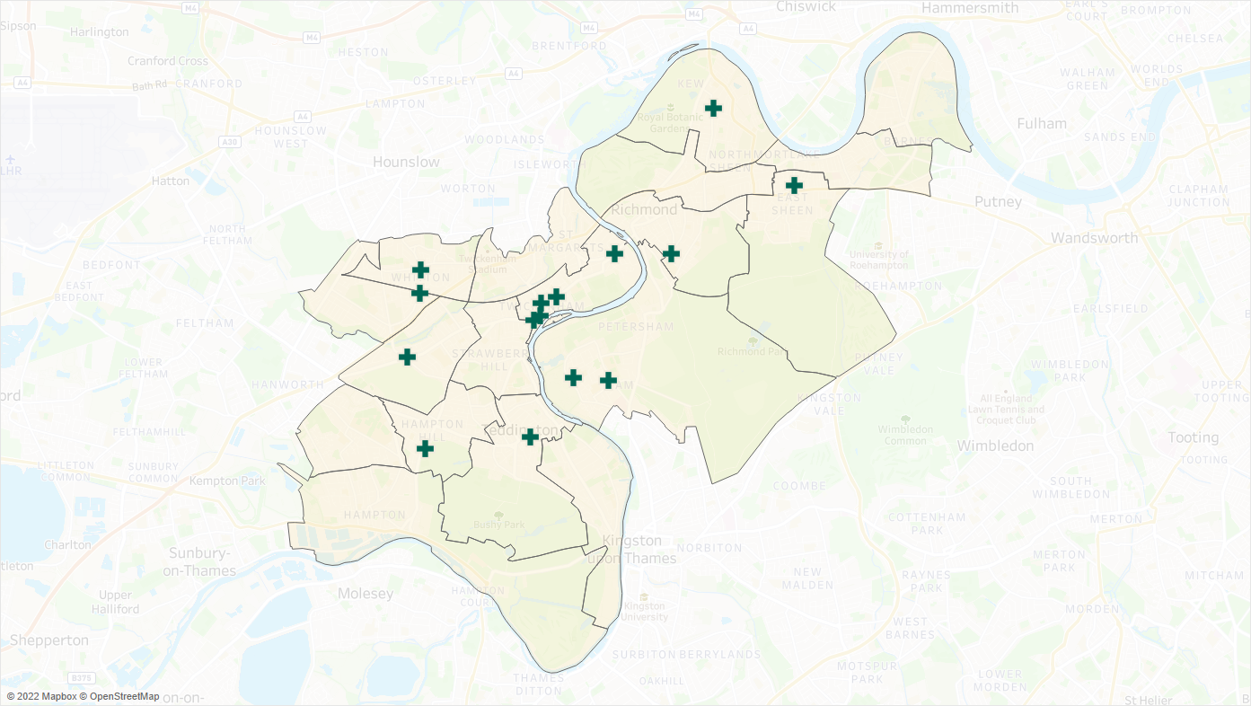
Source: London Borough of Richmond, 2022
Table 7.10: Pharmacies that provide chlamydia screening services in Richmond, 2022
Pharmacy | Address | Ward
Cross Roads Pharmacy | 334 Staines Road, Twickenham, Middlesex | West Twickenham
Kew Pharmacy | 3 Station Parade, Kew Gardens, Richmond, Surrey | Kew
Minal Pharmacy | 9 High Street, Whitton, Middlesex, | Whitton
Twickenham Pharmacy | 17 Richmond Road, Twickenham, Middlesex | Twickenham Riverside
Pharmacare | 12 Back Lane, Ham, Richmond, Surrey | Ham, Petersham & Richmond Riverside
Spatetree Pharmacy | 113 Sheen Lane, East Sheen, London | East Sheen
Kirby Chemist | 53 High Street, Teddington, Middlesex | Teddington
Kanset Pharmacy | 177 Ashburnham Road, Ham, Richmond, Surrey | Ham, Petersham & Richmond Riverside
Day Lewis Pharmacy | 1 Cross Deep Court, Heath Road, Twickenham, Middlesex | South Twickenham
Charles Harry Pharmacy | 366 Richmond Road, Twickenham, Middlesex, London | Twickenham Riverside
Boots | 3 King Street, Twickenham, Middlesex, | Twickenham Riverside
Goode C Pharmacy | 22 London Road, Twickenham, Middlesex | Twickenham Riverside
Health On The Hill | 62 High Street, Hampton Hill, Middlesex, | Fulwell & Hampton Hill
Nima (Malden) Ltd | 50 Friars Stile Road, Richmond, Surrey, | South Richmond
Percy Road Pharmacy | 133 Percy Road, Whitton, Twickenham, Middlesex | Heathfield
Source: London Borough of Richmond, 2022

Chlamydia treatment service
              - The aim of delivering Chlamydia treatment in community pharmacies is to facilitate easy and fast access to treatment for asymptomatic chlamydia as part of efforts to prevent and control chlamydia through early detection and treatment. It is delivered in conjunction with the Chlamydia Screening service in Richmond. Its objectives are to:
- Improve access to treatment of asymptomatic individuals with chlamydia infection aged 15 – 24 years old.
- Improve access to treatment of asymptomatic partners (any age) of chlamydia positive index service users.
- Increase re-testing and partner/contact notification.
- Strengthen the network of sexual health services in the community.
- Help provide easy and swift access to advice and chlamydia treatment.
              - Fifteen pharmacies provide this service in Richmond. These are presented in Figure 7.20 and Table 7.11.
Figure 7.20: Location of pharmacies that provide chlamydia screening service in Richmond, September 2022
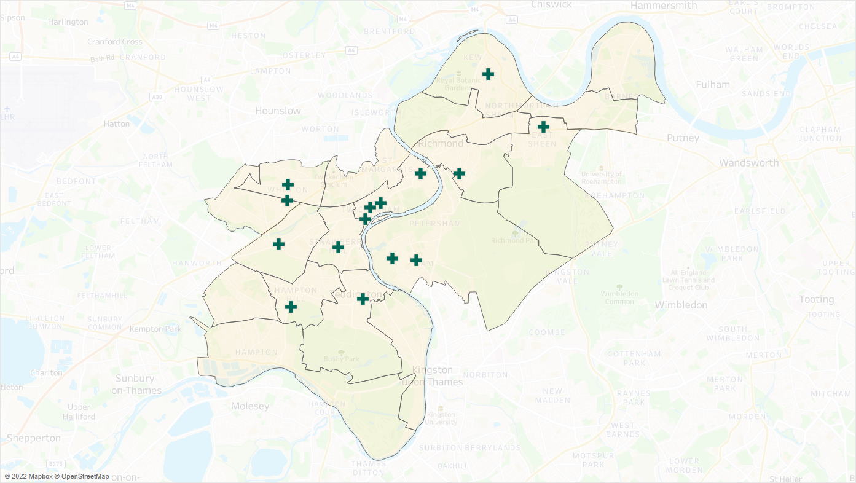
Source: London Borough of Richmond, 2022
Table 7.11: Pharmacies that provide chlamydia screening services in Richmond, 2022
Pharmacy | Address | Ward
Cross Roads Pharmacy | 334 Staines Road, Twickenham, Middlesex | West Twickenham
Kew Pharmacy | 3 Station Parade, Kew Gardens, Richmond, Surrey | Kew
Brightlife Chemist | 3 Wellesley Parade, Strawberry Hill, Twickenham, Middlesex | South Twickenham
Minal Pharmacy | 9 High Street, Whitton, Middlesex, | Whitton
Twickenham Pharmacy | 17 Richmond Road, Twickenham, Middlesex | Twickenham Riverside
Pharmacare | 12 Back Lane, Ham, Richmond, Surrey | Ham, Petersham & Richmond Riverside
Spatetree Pharmacy | 113 Sheen Lane, East Sheen, London | East Sheen
Kirby Chemist | 53 High Street, Teddington, Middlesex | Teddington
Kanset Pharmacy | 177 Ashburnham Road, Ham, Richmond, Surrey | Ham, Petersham & Richmond Riverside
Day Lewis Pharmacy | 1 Cross Deep Court, Heath Road, Twickenham, Middlesex | South Twickenham
Charles Harry Pharmacy | 366 Richmond Road, Twickenham, Middlesex, London | Twickenham Riverside
Goode C Pharmacy | 22 London Road, Twickenham, Middlesex | Twickenham Riverside
Health On The Hill | 62 High Street, Hampton Hill, Middlesex | Fulwell & Hampton Hill
Nima (Malden) Ltd | 50 Friars Stile Road, Richmond, Surrey | South Richmond
Percy Road Pharmacy | 133 Percy Road, Whitton, Twickenham, Middlesex | Heathfield
Source: London Borough of Richmond, 2022

Out of hours palliative care dispensing & medicines advice
              - This service has been developed to ensure that patients and healthcare professionals have secure access to specialist palliative care drugs in the community outside normal dispensing hours, when required.
              - It was developed to fill a gap that had been identified in Richmond out-of-hours dispensing of palliative care drugs. This service will improve dispensing and best practice in the management of end-of-life care and safe and effective symptom management for palliative care patients at home. Its aims are to deliver care closer to home and reduce unnecessary and avoidable hospital admissions.
              - One pharmacy delivers this service in Richmond: Goode Pharmacy, Twickenham.
- Sexual health services
- Community anticoagulation clinic for INR monitoring

Summary of other NHS pharmacy services
It is concluded that there is currently sufficient provision for the following other NHS services to meet the likely needs of residents in Richmond:
- Needle exchange service
- Supervised consumption service
- Emergency contraception service
- Chlamydia screening service
- Chlamydia treatment service
- Out of Hours Palliative Care Dispensing & Medicines Advice

Additional considerations from Contractor Survey Responses

Languages spoken in pharmacies
              - According to the contractor survey responses, there is a wide range of languages spoken in Richmond pharmacies. The most common languages besides English spoken by pharmacy staff are Hindi, Gujarati, and Urdu. As identified in chapter 4, the most common non-English languages for the borough’s residents are Nepalese, Polish and French.
              - No pharmacies have staff that speak Nepalese, six have staff that can speak Polish and five have staff who can speak French. Table 7.12 lists the most common languages spoken by a member of staff in Richmond pharmacies.
Table 7.12: Top 10 languages spoken by a member of staff at the pharmacies in Richmond
Language | Number of Pharmacies
Hindi | 18
Urdu | 15
Gujarati | 14
Arabic | 7
Farsi | 6
Polish | 6
French | 5
German | 3
Portugese | 2
Ukranian / Russian | 2

Conclusions and statements
              - This PNA has considered the current provision of pharmaceutical services across the London Borough of Richmond and assessed whether it meets the needs of the population. It also assesses whether there are any gaps in the provision of pharmaceutical services either now or within the lifetime of this document, 16th March 2023 to 15th March 2026.
              - This chapter will summarise the provision of these services in Richmond and its surrounding local authorities.

Current provision
              - The Richmond PNA steering group has identified the following services as necessary to this PNA to meet the need for pharmaceutical services:
- Essential services provided at all premises included in the pharmaceutical lists.
              - Other Relevant Services are services provided which are not necessary to meet the need for pharmaceutical services in the area, but which nonetheless have secured improvements or better access to medicines. The Richmond PNA steering group has identified the following as Other Relevant Services:
- Adequate provision of advanced, enhanced, and other NHS pharmacy services to meet the need of the local population.

Current access to essential services
              - In assessing the provision of essential services against the needs of the population, the PNA steering group considered access as the most important factor in determining the extent to which the current provision of essential services meets the needs of the population. To determine the level of access within the borough to pharmaceutical services, the following criteria were considered:
- Distance and travel time to pharmacies
- Opening hours of pharmacies
- Proximity of pharmacies to GP practices
              - There are 2.3 community pharmacies per 10,000 residents in Richmond. This ratio is above the national average of 2.2. Additionally, as indicated by the contractor survey, the pharmacies have capacity to offer more services.
              - All of the borough’s population reside within 1 mile of a pharmacy. Additionally, all residents are within a 20-minute commute of a pharmacy via public transport. All GP practices are also within 1 mile of a pharmacy.
              - Considering all this, the residents of the borough are well served in terms of the number and location of pharmacies.

Current access to essential services during normal working hours
              - All pharmacies are open for at least 40 hours each week. There are 45 community pharmacies in the borough, and a further 90 within a mile of the border of Richmond, providing good access as determined in Chapter 7.
The results of the PNA conclude that there are no current gaps in the provision of essential services inside normal working hours in the lifetime of this PNA.

Current access to essential services outside normal working hours
              - On weekdays, three pharmacies are open before 9am and three are open after 7pm. These are mapped out on Chapter 7 and show good coverage of services available on weekdays outside normal working hours.
              - Forty-two of the borough’s 45 community pharmacies are open on Saturday. Nine pharmacies in the borough are open on Sunday. Considering these pharmacies and those in neighbouring local authorities, as shown in the maps in Chapter 7, there is adequate accessibility of pharmacies to residents on weekends.
The results of the PNA conclude that there are no current gaps in the provision of essential services outside normal working hours in the lifetime of this PNA.

Current access to advanced services
              - The following advanced services are currently available for provision by community pharmacies: new medicine service, community pharmacy seasonal influenza vaccination, community pharmacist consultation service, hypertension case-finding service, community pharmacy hepatitis C antibody testing service, community pharmacy smoking cessation service, appliance use reviews and stoma appliance customisation.
              - NMS is widely available with 40 pharmacies in the borough providing it.
              - Flu vaccinations are also widely provided, with 38 pharmacies in the borough offering them.
              - Thirty of the borough’s community pharmacies offer the Community Pharmacy Consultation Service.
              - Sixteen pharmacies provide the Hypertension case-finding service.
              - The hepatitis C antibody testing service is a new service which all pharmacies can deliver.
              - Nine indicated that they provide the community pharmacy smoking cessation service in the contractor survey.
              - Two pharmacies indicate that they provide AURs and 11 indicate they would be willing to provide AURs if there is a need. Advice on the use of appliances is also offered by the hospital or clinic prescribing appliances or from a DAC.
              - Two pharmacies provided the Stoma Appliance Customisation service in the past year, the service is also available from non-pharmacy providers within the borough such as community health services.
              - It is therefore concluded that there is sufficient provision of advanced services to meet the needs of the residents of Richmond.
The results of the PNA conclude that there are no current gaps in the provision of advanced services for the lifetime of this PNA.

Current access to enhanced pharmacy services
              - There are currently three enhanced services commissioned by the London region of NHSE&I. These are the London Seasonal Influenza Vaccination Service, the Bank Holiday Rota Service (provided by one pharmacy) and the COVID-19 Vaccination Service (delivered by one pharmacy). These are commissioned as and when required.
The results of the PNA conclude that there are no gaps in the provision of enhanced pharmacy services for the lifetime of this PNA.

              - As noted in Chapter 5 and 7, the flu vaccination uptake in the ‘at risk’ population in the borough is low. Commissioners should explore with providers ways of working with existing contractors to promote the services to increase vaccination uptake.

Current access to Other NHS pharmacy services
              - These services are commissioned by the London Borough of Richmond upon Thames and South West London ICB. Pharmacies are commissioned to deliver these services to fulfil the specific health and wellbeing of the Richmond population. These services include needle exchange, supervised consumption, emergency contraception, chlamydia screening, chlamydia treatment and Community Pharmacy Out of Hours Palliative Care Dispensing & Medicines Advice services.
              - Six pharmacies offer the needle exchange while 11 offer supervised consumption services. Emergency contraception service is available from 16 pharmacies, and both chlamydia screening and testing services from 15 pharmacies. One pharmacy delivers the Community Pharmacy Out of Hours Palliative Care Dispensing & Medicines Advice service.
              - Overall, there is very good availability of Other NHS pharmacy services in the borough.
The results of the PNA conclude that there are no current gaps in the provision of other NHS pharmacy services in the lifetime of this PNA

Future Provision
              - The Health and Wellbeing Board has considered the following future developments:
- Forecasted population growth
- Housing Development information
- Regeneration projects
- Changes in the provision of health and social care services
- Other changes to the demand for services

Future access to essential services

Future access to essential services during normal working hours
              - The PNA is not aware of any firm plans for changes in the provision of Health and Social Care services within the lifetime of this PNA.
              - The PNA is aware of and has considered the proposed new housing developments in Richmond, particularly within wards where there are larger number of new dwelling developments planned, namely within St. Margarets and North Twickenham Ward and Mortlake and Barnes Common Ward.
              - The analysis has considered these developments, and other causes of population increases, and concluded that pharmacy provision within Richmond is well placed to support these during the lifetime of the PNA.
The results of the PNA conclude that there are no gaps in the future provision of essential services during normal working hours in the lifetime of this PNA.

Future access to essential services outside normal working hours
              - The Health and Wellbeing Board is not aware of any notifications to change the supplementary opening hours for pharmacies at the time of publication.
The results of the PNA conclude that there are no gaps in the future provision of essential services outside of normal working hours in the lifetime of this PNA

Future access to advanced services
              - Through the contractor survey, local pharmacies have indicated that they have capacity to meet future increases in demand for advanced services.
The results of the PNA conclude that there are no gaps in the future provision of advanced services in the lifetime of this PNA.

Future access to enhanced services
              - Through the contractor survey, local pharmacies have indicated that they have capacity to meet future increases in demand for enhanced services.
The results of the PNA conclude that there are no gaps in the future provision of enhanced services in the lifetime of this PNA.

Future access to other NHS pharmacy services
              - Through the contractor survey, local pharmacies have indicated that they have capacity to meet future increases in demand for other NHS pharmacy services.
The results of the PNA conclude no gaps in the future provision of locally commissioned Other NHS services in the lifetime of this PNA.

Improvements and better access

Current and future access to essential services
              - In consideration of population health and wellbeing needs and needs of those who share protected characteristics, the PNA did not identify any services, that if provided, either now or in future, would secure improvements or better access to essential services. Further, there is sufficient capacity to meet any increased future demand.
The results of the PNA conclude are no unmet pharmaceutical needs in essential services, that if provided, either now or in the future, would secure improvements or better access to essential services, in the lifetime of this PNA.

Current and future access to advanced services
              - NMS, flu vaccination, CPCS, hypertension case finding, hepatitis C antibody testing and smoking cessation services are all widely available throughout Richmond and there is sufficient capacity for more the pharmacies to provide them.
              - While there are no pharmacies delivering AURs, these are provided by prescribing health and social care providers and pharmacies have indicated willingness to provide this service.
              - Two pharmacies provide SAC. SACs can also be provided by other health care providers such as community health services.
              - The PNA analysis has concluded that there is sufficient capacity to meet any increased demand of advanced services.
The results of the PNA conclude that there is no additional need in the provision of advanced services at present or in the future, that would secure improvements or better access to advanced services in the lifetime of this PNA.

Current and future access to enhanced pharmacy services
              - There is good provision of services commissioned by NHE&I, the London Region. The PNA did not find any evidence to conclude that the services these pharmacies offer should be expanded.
The results of the PNA conclude that there are no gaps, either now or in the future, that if provided would secure improvements or better access to Enhanced Pharmacy Services in the area.

Current and future access to other NHS pharmacy services
              - These are commissioned as and when required. The PNA did not identify any services, that if provided either now or in future would secure improvements or better access to the enhanced services offered. Local pharmacies have also indicated that they have capacity for future increases in demand for other NHS pharmacy services through the contractor survey.
The results of the PNA conclude that there is no additional need, either now or in the future, that if provided would secure improvements or better access to other locally commissioned services in the area in the lifetime of this PNA.

Appendix A - PNA Steering Group Terms of Reference

RICHMOND AND WANDSWORTH

PHARMACEUTICAL NEEDS ASSESSMENT STEERING GROUP

TERMS OF REFERENCE

Purpose:
The purpose of this steering group is to support the production of the Pharmaceutical Needs Assessments on behalf of Richmond and Wandsworth Health and Wellbeing Boards.
The team will be a task and finish group, meeting over a period of approximately 1 year, beginning May 2022.

Membership:
The steering group contains representatives from: -
- The Public Health Team
- Local Pharmaceutical Committees
- Local Medical Committees
- Healthwatch
- South West London CCG/Integrated Care Board
- NHS England/NHS Improvement
- Insight and Analytics Team
- Communication and Engagement Team
- Others can be co-opted as required

Quoracy
The Steering Group shall be quorate if there are one or more representatives from the following groups in attendance:
- The Public Health Team
- Local Pharmaceutical Committee for each borough
- SW London CCG/Integrated Care Board

Frequency of meetings
The group will initially meet monthly, followed by less frequent meetings as required.

Governance and accountability
- The steering group will report to the Director of Public Health, Shannon Katiyo.
- We will request the HWB to delegate the sign-off of the pre-consultation version of the PNA to the steering group.
- We will request the HWB to sign off the final version of the PNA for publication.
- Papers will be circulated at least 5 days before the meeting, and notes of meeting to go out within 4 working days of the meeting.

Key responsibilities
- To oversee PNA production including developing processes and advising on project timeline and document structure.
- To ensure that development of the PNA meets the statutory responsibilities of the HWBs.
- To ensure active engagement from stakeholders.
- To support public and contractor engagement e.g. advise on questionnaires.
- To agree how the areas will be divided up into localities.
- To review information on health and demographic data and pharmaceutical service provision.
- To consider any current or future gaps in provision of pharmaceutical services and ensure the needs of the populations are articulated in the PNAs.
- To sign off the pre-consultation version of the PNA document.
- To review responses to the formal consultation and agree the response and any amendments required to the PNA.
- To sign off a final draft of PNA to go to the HWB for approval prior to publication.

Individual Members
- Representatives from Healthwatch will work in a purely advisory capacity and will not contribute to decision making/sign-off of PNA documents.
- The meeting will be administered by the provider and will be co-chaired by the consultant in public health
Updated June 2022

Appendix B – Pharmacy provision within Richmond and one mile of its border
HWB | Contract Type | ODS Code | Pharmacy Name | Address | Post Code | Early Opening | Late Closing | Open on Saturday | Open on Sunday
Richmond upon Thames | Community | FA683 | Ham Parade Pharmacy | 305 Richmond Road, Kingston-Upon-Thames, Surrey, | KT2 5QU | No | No | Yes | No
 |  | FAR56 | Cross Roads Pharmacy | 334 Staines Road, Twickenham, Middlesex | TW2 5AT | No | No | Yes | No
 |  | FCN10 | Superdrug Pharmacy | Unit 2 The Bull, 262 Upper Richmond Road, East Sheen, London | SW14 7JE | No | No | Yes | No
 |  | FD680 | Kew Pharmacy | 3 Station Parade, Kew Gardens, Richmond, Surrey | TW9 3PS | No | No | Yes | No
 |  | FDD84 | Herbert & Shrive | 208 Kingston Road, Teddington, Middlesex | TW11 9JD | No | No | Yes | No
 |  | FDM96 | Prime Pharmacy | 198 Castelnau, Barnes, London | SW13 9DW | No | No | Yes | No
 |  | FDN22 | Boots | 381-383 Upper Richmond Rd, East Sheen, London | SW14 7NX | No | No | Yes | Yes
 |  | FEW32 | Hampton Hill Pharmacy | 173B High Street, Hampton Hill, Middlesex | TW12 1NL | No | No | Yes | No
 |  | FF674 | Brightlife Chemist | 3 Wellesley Parade, Strawberry Hill, Twickenham, Middlesex | TW2 5SQ | No | No | Yes | No
 |  | FF832 | Boots | 61/64 George Street, Richmond, Surrey | TW9 1HF | No | No | Yes | Yes
 |  | FG716 | Lloydspharmacy | J Sainsbury'S Store, Manor Road, Lower Richmond Road, Richmond | TW9 1YB | Yes | Yes | Yes | Yes
 |  | FGG42 | Boots | 28B Priory Road, Hampton, Middlesex | TW12 2NT | No | No | Yes | No
 |  | FJ123 | Richmond Pharmacy | 213 Lower Mortlake Road, Richmond Upon Thames, Surrey | TW9 2LN | No | No | No | No
 |  | FJ778 | Minal Pharmacy | 9 High Street, Whitton, Middlesex, | TW2 7LA | No | No | Yes | No
 |  | FK726 | Springfield Pharmacy | 124 Sheen Road, Richmond, Surrey, | TW9 1UR | No | No | Yes | No
 |  | FKA42 | Twickenham Pharmacy | 17 Richmond Road, Twickenham, Middlesex | TW1 3AB | No | No | Yes | No
 |  | FKK28 | Boots | 3 Station Approach, Ashley Road, Hampton, Middlesex | TW12 2HZ | No | No | Yes | No
 |  | FLD67 | Dumlers Pharmacy | 495-497 Upper Richmond, Road West, East Sheen, London | SW14 7PU | No | No | Yes | No
 |  | FLJ40 | Barnes Pharmacy | 5 High Street, , Barnes, London | SW13 9LB | No | No | Yes | No
 |  | FLM25 | Pharmacare | 12 Back Lane, Ham, Richmond, Surrey | TW10 7LF | No | No | Yes | No
 |  | FLW92 | Spatetree Pharmacy | 113 Sheen Lane, East Sheen, London | SW14 8AE | No | No | Yes | No
 |  | FM474 | St Margarets Pharmacy | 38 Crown Road, St. Margarets, Twickenham, Middlesex | TW1 3EH | No | No | Yes | No
 |  | FM522 | Kirby Chemist | 53 High Street, Teddington, Middlesex | TW11 8HA | No | No | Yes | Yes
 |  | FMW04 | Whitton Corner Pharmacy | Whitton Community H/C, Percy Road, Whitton, Twickenham, Middlesex | TW2 6JL | Yes | No | Yes | No
 |  | FN708 | Kanset Pharmacy | 177 Ashburnham Road, Ham, Richmond, Surrey | TW10 7NR | No | No | Yes | No
 |  | FNM74 | Boots | Unit 4, Kew Retail Park, Bessant Drive, Kew, Richmond, Surrey | TW9 4AD | No | No | Yes | Yes
 |  | FP266 | Round The Clock Pharmacy | 69 Church Road, Barnes, London, | SW13 9HH | No | No | Yes | No
 |  | FPG04 | Forward Pharmacy | 90 Church Road, , Barnes, London | SW13 0DQ | No | No | Yes | No
 |  | FPV82 | Herbert And Herbert Pharmacy | 658 Hanworth Road, Hounslow, Middlesex | TW4 5NP | No | No | Yes | No
 |  | FQA52 | Day Lewis Pharmacy | 1 Cross Deep Court, Heath Road, Twickenham, Middlesex | TW1 4AG | No | No | No | No
 |  | FQT44 | Boots | 100 High Street, Whitton, Middlesex | TW2 7LN | No | No | Yes | No
 |  | FQT67 | Kc Pharmacy | 23 Broad Street, Teddington, Middlesex | TW11 8QZ | No | Yes | Yes | Yes
 |  | FR011 | Charles Harry Pharmacy | 366 Richmond Road, Twickenham, Middlesex, London | TW1 2DX | No | No | Yes | No
 |  | FR291 | Pyramid Pharmacy | 19-21 Station Parade, Kew, Richmond, Surrey | TW9 3PS | Yes | No | Yes | No
 |  | FRF19 | Richmond Pharmacy | 82-86 Sheen Road, Richmond, Surrey | TW9 1UF | No | No | Yes | No
 |  | FT792 | Boots | 3 King Street, Twickenham, Middlesex | TW1 3SD | No | No | Yes | Yes
 |  | FT997 | Goode C Pharmacy | 22 London Road, , Twickenham, Middlesex | TW1 3RR | No | No | Yes | No
 |  | FTT52 | Boots | 59 Broad Street, , Teddington, Middlesex | TW11 8QZ | No | No | Yes | Yes
 |  | FV599 | Boots | 29 Tangley Park Road, Hampton, Middlesex, | TW12 3YH | No | No | Yes | No
 |  | FV843 | Health On The Hill | 62 High Street, Hampton Hill, Middlesex, | TW12 1PD | No | No | Yes | No
 |  | FV875 | Teddington Pharmacy | 113 Stanley Road, , Teddington, Middlesex | TW11 8UB | No | No | Yes | No
 |  | FVH60 | Nima (Malden) Ltd | 50 Friars Stile Road, Richmond, Surrey, | TW10 6NQ | No | No | Yes | No
 |  | FWL31 | Medco Pharmacy | 31-33 Park Road, Teddington, Middlesex | TW11 0AB | No | No | Yes | No
 |  | FWX77 | Percy Road Pharmacy | 133 Percy Road, Whitton, Twickenham, Middlesex | TW2 6HT | No | No | No | No
 |  | FXL13 | Maple Leaf Pharmacy | 20 The Green, Twickenham, Middlesex | TW2 5AB | No | Yes | Yes | Yes
 | DSP | FFN37 | Green Cross Health Limited | Citibase, Mortlake Bus Ctr, 20 Mortlake High Street | SW14 8JN | No | No | No | No
 |  | FHC56 | Meds & Pills Ltd | Office 3 64 Wellington Rd, Hampton Hill, London | TW12 1JT | No | No | Yes | No
 |  | FNR02 | Verdun Pharmacy | 1 Verdun Road, Barnes | SW13 9AN | No | No | Yes | No
Ealing | Community | FHJ50 | Harbs Pharmacy | 193 South Ealing Road, Ealing, London | W5 4RH | Yes | Yes | Yes | Yes
 |  | FPM91 | South Ealing Pharmacy | 186 South Ealing Road, Ealing, London | W5 4RJ | Yes | No | Yes | No
Elmbridge | Community | FDR31 | Courts Pharmacy | 10 High Street, West Molesey, Surrey | KT8 2NA | No | No | Yes | No
 |  | FKK08 | Boots | 14 High Street, Thames Ditton, Surrey, | KT7 0RY | No | No | Yes | No
 |  | FKT27 | Lalys Pharmacy | 10 High Street, West Molesey, Surrey | KT8 2NA | No | No | Yes | No
 |  | FL234 | Thorkhill Pharmacy | 94 Thorkhill Road, Thames Ditton, Surrey, | KT7 0UQ | No | No | Yes | No
 |  | FT437 | Molesey Park Pharmacy | Glenlyn Medical Centre, 115 Molesey Park Road, East Molesey, Surrey | KT8 0JX | No | No | No | No
 |  | FTG42 | Kent Pharmacy | 104 Walton Road, East Molesey, Surrey, | KT8 0DL | No | No | Yes | No
 | DSP | FPD83 | Ips Extemp Labs | 41 Central Avenue, West Molesey, Surrey | KT8 2QZ | No | No | No | No
Hammersmith & Fulham | Community | FC883 | Lime Grove Pharmacy | 66 Goldhawk Road, Shepherds Bush, London | W12 8HA | No | No | Yes | No
 |  | FD872 | Palace Pharmacy | 331 Fulham Palace Road, London | SW6 6TE | No | No | Yes | No
 |  | FD905 | Fontain Pharmacy | 290 Munster Road, London, | SW6 6BQ | Yes | No | Yes | No
 |  | FE803 | Hammersmith Pharmacy | 109-111 Fulham Palace Rd, Hammersmith, London | W6 8JA | No | No | Yes | No
 |  | FEX79 | North End Pharmacy | 100A North End Road, , West Kensington, London | W14 9EX | No | No | Yes | No
 |  | FG861 | Healthside Pharmacy | 90 Shepherds Bush Road, London | W6 7PD | No | No | Yes | No
 |  | FHK84 | Jhoots Pharmacy | Richford Gate Health Ctr, 49 Richford Gate, Richford Street, London | W6 7HY | Yes | No | No | No
 |  | FL310 | Boots | 43 King Street, Hammersmith, London | W6 9HW | Yes | Yes | Yes | Yes
 |  | FL905 | Winwood Chemist | 96 Askew Road, London, | W12 9BL | No | No | Yes | No
 |  | FLR27 | Forrest Pharmacy | 67 Blythe Road, , , London | W14 0HP | No | No | Yes | No
 |  | FMF82 | Superdrug Pharmacy | 65-69 King Street, , Hammersmith, London | W6 9HW | Yes | No | Yes | No
 |  | FQ417 | Globe Chemist | 8 Kings Parade, Askew Road, Shepherds Bush, London | W12 9BA | No | No | Yes | No
 |  | FRQ66 | Barons Pharmacy | 3 Margravine Gardens, Barons Court, London | W6 8RL | No | No | Yes | No
 |  | FT809 | Tesco Instore Pharmacy | 180 Shepherds Bush Road, London | W6 7NL | Yes | Yes | Yes | Yes
 |  | FWC05 | Fulham Pharmacy | 608 Fulham Road, London | SW6 5RP | No | No | Yes | No
 |  | FXQ10 | Kanari Pharmacy | 682-684 Fulham Road, London | SW6 5SA | No | No | Yes | No
 |  | FY324 | Boots | 198-200 Fulham Palace Rd, Hammersmith, London, | W6 9PA | No | No | Yes | Yes
 |  | FY620 | Boots | 31 Broadway Shopping Ctr., Hammersmith, London | W6 9YD | Yes | Yes | Yes | Yes
 | DSP | FCR61 | Pharmacy On Wheels | 86 Goldhawk Road, White City, London | W12 8HD | No | No | No | No
Hounslow | Community | FAM74 | Hounslow East Pharmacy | 84 Kingsley Road, , Hounslow, Middlesex | TW3 1QA | Yes | Yes | Yes | Yes
 |  | FAY44 | Boots | 107 Bear Road, Hanworth, Middlesex | TW13 6SA | No | No | Yes | No
 |  | FC075 | Herbert & Herbert Chemist | 106 Staines Road, Hounslow, Middlesex, | TW3 3LH | Yes | Yes | Yes | No
 |  | FCG39 | Morrisons Pharmacy | Morrisons Store, 228-238 High Street, Brentford, Middlesex | TW8 0JG | Yes | Yes | Yes | Yes
 |  | FCY76 | B.A.Williams Chemist | 15 Albany Parade, High Street, Brentford, Middlesex | TW8 0JW | No | No | No | No
 |  | FDQ48 | Boots | 3 Market Parade, Hampton Road West, Hanworth, Middlesex | TW13 6AJ | No | No | Yes | No
 |  | FH544 | Brent Pharmacy | 214 High Street, , Brentford, Middlesex | TW8 8AH | No | No | Yes | No
 |  | FHL23 | Bath Road Pharmacy | 115-117 Bath Road, Hounslow, Middlesex | TW3 3BT | Yes | No | Yes | No
 |  | FHN27 | Sabel Pharmacy Ltd | 446 Chiswick High Road, Chiswick, London | W4 5TT | No | No | Yes | No
 |  | FHW98 | Bedford Park Pharmacy | 5 Bedford Park Corner, Chiswick, London | W4 1LS | Yes | No | Yes | No
 |  | FJ888 | A.C. Curd Pharmacy | 55 South Street, Isleworth, Middlesex, | TW7 7AA | No | No | Yes | No
 |  | FJG94 | Azchem Pharmacy | 258 Twickenham Road, Isleworth, Middlesex | TW7 7DT | No | No | Yes | No
 |  | FK550 | Campbells Chemist | 300-302 Chiswick High Rd, Chiswick, London, | W4 1NP | No | No | Yes | No
 |  | FKN08 | Tigris Pharmacy | 38 Lampton Road, Hounslow, Middlesex, London | TW3 1JH | No | No | Yes | No
 |  | FKW46 | Churchills Pharmacy | 202 Chiswick High Road, Chiswick, London | W4 1PD | No | No | Yes | No
 |  | FL691 | Herbert & Herbert Chemist | 280 Staines Road, Hounslow, Middlesex, | TW3 3LX | No | No | Yes | No
 |  | FLL05 | Busbys Pharmacy | 9 Grove Park Road, Chiswick, London, | W4 3RS | No | No | Yes | No
 |  | FMF27 | Boots | 193-199 High Street, Hounslow, Middlesex, | TW3 1BL | Yes | No | Yes | Yes
 |  | FNM38 | West London Pharmacy | 154 Chiswick High Road, , , London | W4 1PR | No | No | Yes | No
 |  | FQM17 | Ram Dispensing Chemist | 99 Whitton Road, Hounslow, Middlesex, | TW3 2EW | No | No | Yes | No
 |  | FR307 | Amin Pharmacy | 10 Kingsley Road, Hounslow, Middlesex, | TW3 1NP | No | No | Yes | No
 |  | FR387 | Jasins Dispensing Chemist | 18 St Johns Road, Isleworth, Middlesex, | TW7 6NW | No | No | Yes | No
 |  | FR465 | Lloydspharmacy | Sainsbury'S Superstore, 31 Essex Place, Chiswick, London | W4 5UT | Yes | Yes | Yes | Yes
 |  | FR874 | Tesco Instore Pharmacy | Mogden Lane, Isleworth, Middlesex | TW7 7JY | Yes | Yes | Yes | Yes
 |  | FRF81 | Boots | 332 Chiswick High Road, Chiswick, London, | W4 5TA | Yes | No | Yes | Yes
 |  | FT239 | Riverside Pharmacy | 1 Shrewsbury Walk, Isleworth, Middlesex | TW7 7DE | Yes | Yes | Yes | Yes
 |  | FTR63 | Maswell Park Pharmacy | 6 Central Avenue, , Hounslow, Middlesex | TW3 2QH | No | No | Yes | No
 |  | FV191 | Feltham Pharmacy | 186-188 Uxbridge Road, Feltham, Middlesex | TW13 5DY | No | No | Yes | No
 |  | FV337 | Clarks Pharmacy | 471 London Road, Isleworth, Middlesex, | TW7 4BX | No | No | No | No
 |  | FV669 | Pestle & Mortar | 10 High Road, Chiswick, London, | W4 1TH | No | No | Yes | No
 |  | FVC01 | Crystal Pharmacy | 39 High Street, Hounslow, Middlesex, | TW3 1RH | No | No | Yes | No
 |  | FW148 | Asda Pharmacy | Asda Stores, Off Alexandra Road, Hounslow, London | TW3 1NL | Yes | Yes | Yes | Yes
 |  | FYG02 | Hounslow Central Pharmacy | 38 Lampton Road, Hounslow, Middlesex, | TW3 1JH | No | No | Yes | No
Kingston upon Thames | Community | FCK24 | Lindsay Chemist | Clifton Road, Kingston-Upon-Thames, Surrey | KT2 6PF | Yes | No | Yes | No
 |  | FCL07 | Newman Chemist | 99 Ewell Road, Surbiton, Surrey | KT6 6AH | No | No | Yes | No
 |  | FD501 | Boots | 19/20 Victoria Road, Surbiton, Surrey, | KT6 4JZ | No | No | Yes | Yes
 |  | FG680 | Boots | Unit G34, Bentalls Shopping Centre, Kingston Upon Thames, Surrey | KT1 1TR | Yes | No | Yes | Yes
 |  | FL298 | Laurel Pharmacy | 170 Tudor Drive, Kingston-Upon-Thames, Surrey, | KT2 5QG | No | No | Yes | No
 |  | FLF25 | Lloydspharmacy | 73-81 Richmond Road, Kingston-Upon-Thames, Surrey | KT2 5BP | Yes | Yes | Yes | Yes
 |  | FM456 | Ritechem Pharmacy | 22 Victoria Road, , Surbiton, Surrey | KT6 4JZ | No | No | Yes | No
 |  | FN954 | Coombe Hill Pharmacy | 3 The Triangle, Kingston-Upon-Thames, Surrey, | KT1 3RU | No | No | Yes | No
 |  | FNK00 | Hawks Pharmacy | Regent House, Hawks Road, Kingston-Upon-Thames, Surrey | KT1 3DG | Yes | No | Yes | No
 |  | FQD93 | Eagercare The Pharmacy | The Pharmacy, 53 Surbiton Road, Kingston-Upon-Thames, Surrey | KT1 2HG | No | No | No | No
 |  | FTL85 | Paydens | Surbiton Health Centre, Ewell Road, Surbiton, Surrey | KT6 6EZ | Yes | Yes | Yes | Yes
 |  | FV188 | Laurel Pharmacy | 112A Canbury Park Road, Kingston-Upon-Thames, | KT2 6JZ | No | No | Yes | No
 |  | FYH83 | Boots | 42 Union St, Kingston-Upon-Thames, Surrey, | KT1 1RP | Yes | No | Yes | Yes
 |  | FYY52 | Shan Pharmacy | 106 Ewell Road, Surbiton, Surrey | KT6 6HA | Yes | No | Yes | No
 | DAC | FV224 | Fittleworth Medical Limited | 16 Kingsmill Business Par, Chapel Mill Road, Kingston Upon Thames, Surrey | KT1 3GZ | No | No | No | No
Spelthorne | Community | FV635 | Lloydspharmacy | 8 Avenue Parade, Sunbury-On-Thames, Middlesex, | TW16 5HS | No | No | Yes | No
Wandsworth | Community | FCK89 | Walji R | 6 Rockingham Close, Lennox Estate Putney, London | SW15 5RW | No | No | Yes | No
 |  | FCL10 | Husbands Pharmacy | 124 Upper Richmond Road, Putney, London | SW15 2SP | No | No | Yes | No
 |  | FD303 | Boots | 45/53 Putney High Street, London | SW15 1SP | No | No | Yes | Yes
 |  | FDQ20 | Medipharmacy Limited | 30 Chartfield Avenue, London | SW15 6HG | No | No | No | No
 |  | FJL27 | Paydens Pharmacy | 266A Upper Richmond Road, Putney, London | SW15 6TQ | Yes | No | Yes | No
 |  | FKE89 | East Chemist | 16 High Street, Roehampton, London, | SW15 4HJ | No | No | Yes | No
 |  | FKF82 | Asda Pharmacy | Asda Superstore, 31 Roehampton Vale, Roehampton, London | SW15 3DT | Yes | Yes | Yes | Yes
 |  | FKP46 | Boots | 109 High Street, Putney, London | SW15 1SS | No | No | Yes | No
 |  | FM656 | Putney Pharmacy | 278 Upper Richmond Road, Putney, London | SW15 6TQ | No | No | Yes | No
 |  | FNR03 | Care Chemists | 43 Danebury Avenue, Roehampton, London | SW15 4DQ | No | No | No | No
 |  | FV302 | Aura Pharmacy | 78 Inner Park Road, Wimbledon Parkside, London, | SW19 6DA | No | No | Yes | No
 |  | FVL59 | Boots | 383 Upper Richmond Rd, Putney, London | SW15 5QJ | No | No | Yes | No
 |  | FX183 | Well | 31A Danebury Avenue, Roehampton, London | SW15 4DG | Yes | No | Yes | No

Appendix C - Consultation report
This report presents the findings of the consultation for the Richmond PNA for 2023 to 2026.
For the consultation, the draft PNA was sent to a list of statutory consultees outlined in Chapter 1, paragraph 1.13. In total three people responded to the consultation via email or via our consultation survey, they represented:
- Surrey Heartlands ICS (via survey)
- Richmond Council (via survey)
- NHS England (via email)
The PNA steering group constituted the majority of the stakeholders we must consult with for this consultation who fed into this PNA before it was presented for the 60-day consultation.
The responses to the survey regarding the PNA were positive. They are presented in the table below. Additional comments received via are presented in the table that follows.
Consultation survey Question | Yes | No | Unsure or not applicable
Has the purpose of the pharmaceutical needs assessment been explained? | 2
Does the pharmaceutical needs assessment reflect the current provision of pharmaceutical services within your area? | 2
Are there any gaps in service provision i.e. when, where and which services are available that have not been identified in the pharmaceutical needs assessment? |  | 2
Does the draft pharmaceutical needs assessment reflect the needs of your area’s population? | 2
Has the pharmaceutical needs assessment provided information to inform market entry decisions i.e. decisions on applications for new pharmacies and dispensing appliance contractor premises? | 2
Has the pharmaceutical needs assessment provided information to inform how pharmaceutical services may be commissioned in the future? |  |  | 1
Has the pharmaceutical needs assessment provided enough information to inform future pharmaceutical services provision and plans for pharmacies and dispensing appliance contractors? | 2
Do you agree with the conclusions of the pharmaceutical needs assessment? | 1

The table below presents the comments received via email during the statutory 60-day consultation period and the response to those comments from the steering group.
Comments from members of the public | PNA Steering Group response
Surrey Heartlands ICS  It is not clear how much engagement there has been with PCNs and there is no mention of the Fuller stocktake that highlights opportunities for wider primary care integration. At 'neighbourhood' level there may be services that could be commissioned in the future to meet local needs.  Up to a point. Section 8.30, 8.31 and 8.32 which state that there are no gaps in the future provision of advanced, enhanced and other NHS pharmacy services refers to the contractors’ survey. However, only 57% of contractors responded, so there may be questions to be asked about the other 43%, e.g. was the reason for their failure to respond down to existing capacity issues?  The draft PNA provides a comprehensive overview of pharmaceutical needs within Richmond and we concur with the conclusions in the document. As such we have no concerns from a Surrey Heartlands perspective.  Thank you for the opportunity to feed into this consultation. | PCNs were represented the steering group by the ICB. Both the ICB and LMCs were invited to the steering group. A summary of the Fuller Stocktake has been included in Chapter 2.  While every effort was made to engage with all the contractors, it was acknowledged that in the current climate of pharmacists’ time being in great demand, it may be challenging to get a response from all of them.  Noted with thanks.  Noted with thanks.
NHS England:  Details of pharmacies where the hours are:  ODS Code Name Address Hours When changed  FF832 Boots 61/64 George Street, TW9 1HF No longer opens before 9am 27 Feb 2022  FMW04 Whitton Corner Pharmacy Whitton Community Centre, TW2 6JL No longer opens before 9am 10 Oct 2022  FNM74 Boots Unit 4, Kew Retail Park, TW9 4AD No longer opens after 7pm 24 Feb 2022  FR291 Pyramid Pharmacy 19-21 Station Parade, TW9 3PS No longer opens before 9am 1 April 2022  FT792 Boots 3-5 King Street, TW1 3SD No longer opens before 9am 27 Feb 2022  FTT52 Boots 59 Broad Street, TW11 8QZ No longer opens before 9am 27 Feb 2022  We have noted that there is one pharmacy listed which we have on the Kingston list. FA683 Ham Parade Pharmacy, this does sit right on the border and has been included in the Kingston PNA.  There is also one premises with 2 listed pharmacies, one of these is the previous owner and should be removed as this contract no longer exists. FRT54 Strawberry Hill Pharmacy.  There are also 2 DSPs missing from the list  FFN37 Green Cross Health & FNR02 Verdun Pharmacy.  We are aware that FFN37 is not trading and is subject to the removal process, however, FNR02 is an active pharmacy and should be listed.  Page 28 – reference to Woolwich Common. – this is in SE London, not Richmond?? | The updates in opening times are reflected in the latest document.  This pharmacy is geographically part of Richmond. The PNA also considers pharmacies deemed to be accessible to Richmond residents (1 mile off its borders).  This has been reflected in the latest document.  This has been reflected in the latest document.  Reference to Woolwich Common was an error, it should have stated ‘Heathfield’ which we have corrected.

Department of Health & Social Care. Policy paper: Integration and innovation: working together to improve health and social care for all (updated February 2021). Available at: https://www.gov.uk/government/publications/working-together-to-improve-health-and-social-care-for-all/integration-and-innovation-working-together-to-improve-health-and-social-care-for-all-html-version#executive-summary
NHS. The NHS Long Term Plan (2019). https://www.longtermplan.nhs.uk/
Next Cteps for Intergrated Primary Care: Fuller stocktake report (2022): https://www.england.nhs.uk/wp-content/uploads/2022/05/next-steps-for-integrating-primary-care-fuller-stocktake-report.pdf
Health Equity in London: The Marmot Review 10 years on. Executive summary (2020): https://www.health.org.uk/sites/default/files/2020-03/Health%20Equity%20in%20England_The%20Marmot%20Review%2010%20Years%20On_executive%20summary_web.pdf
NB: As of October 2021, PHE ceased to exist. Responsibilities formally undertaken by PHE are now the responsibility of OHID, UKHSA and NHS England.
Public Health England Strategy 2020-2025 (2019).
Community Pharmacy Contractual Framework (2019). https://assets.publishing.service.gov.uk/government/uploads/system/uploads/attachment_data/file/819601/cpcf-2019-to-2024.pdf
NHS Pharmacy Integration Programme. https://www.england.nhs.uk/primary-care/pharmacy/pharmacy-integration-fund/
Richmond joint strategic needs assessment (2021): https://www.richmond.gov.uk/jsna
Healthy Eating, Weight and Nutrition Plan (2022-2026): https://www.richmond.gov.uk/media/23559/healthy_eating_weight_and_nutrition_plan.pdf
Richmond upon Thames suicide and self-harm prevention strategy (2019-2022): https://www.richmond.gov.uk/media/19808/suicide_strategy_final_version_12.pdf
Richmond Public Health: Adult Physical Activity Plan (2021-2031): https://www.richmond.gov.uk/media/23243/richmond_public_health_physical_activity_plan_2021_2031.pdf
The Richmond sexual health story 2020: service delivery in primary care settings: THE RICHMOND SEXUAL HEALTH STORY 2020 - Service delivery in primary care settings[9].pdf
https://www.richmond.gov.uk/jsna
At the time of writing, the findings of the 2021 census were due for publication shortly.
NICE guideline (2018) Community pharmacies: promoting health and wellbeing [NG102]
Fair Society Healthy Lives (The Marmot Review): http://www.instituteofhealthequity.org/resources-reports/fair-society-healthy-lives-the-marmot-review
Marmot Review 10 Years On (February 2020): http://www.instituteofhealthequity.org/resources-reports/marmot-review-10-years-on
London Borough of Richmond (2020): Air Pollution and Health Richmond and Wandsworth Brief
Community Pharmacy Contractual Framework (2019). https://assets.publishing.service.gov.uk/government/uploads/system/uploads/attachment_data/file/819601/cpcf-2019-to-2024.pdf
London Borough of Richmond upon Thames and the South West London Health and Care Partnership. Live Well Richmond 2022-2024. Richmond Plan On A Page 2022-24.
Pharmacy Quality Scheme (2022/23): https://www.nhsbsa.nhs.uk/provider-assurance-pharmaceutical-services/pharmacy-quality-scheme-pqs
London Borough of Richmond (2022). Richmond Mental Health Needs Assessment.
Badenhurst J, Husband A, Ling J, Lindsey L and Todd A, Do patients with cancer alarm symptoms present at the community pharmacy? International Journal of Pharmacy Practice, volume 22, supplement 2, page 32
Public Health England (2017). Pharmacy and people with learning disabilities: making reasonable adjustments to services. https://www.gov.uk/government/publications/pharmacy-and-people-with-learning-disabilities/pharmacy-and-people-with-learning-disabilities-making-reasonable-adjustments-to-services#fn:2
Anderson E, Gerrard D. Learning disabilities: a CPPE distance learning programme. Manchester: Centre for Pharmacy Postgraduate Education; 2016.
Local Government Association: LG Inform. Ratio of pharmacies per 10,000 population (Snapshot: 29 November 2014) https://lginform.local.gov.uk/reports/lgastandard?mod-area=E92000001&mod-group=DEFRA2009_OtherUrbanList&mod-metric=3707&mod-type=namedComparisonGroup (Accessed in November 2022).

